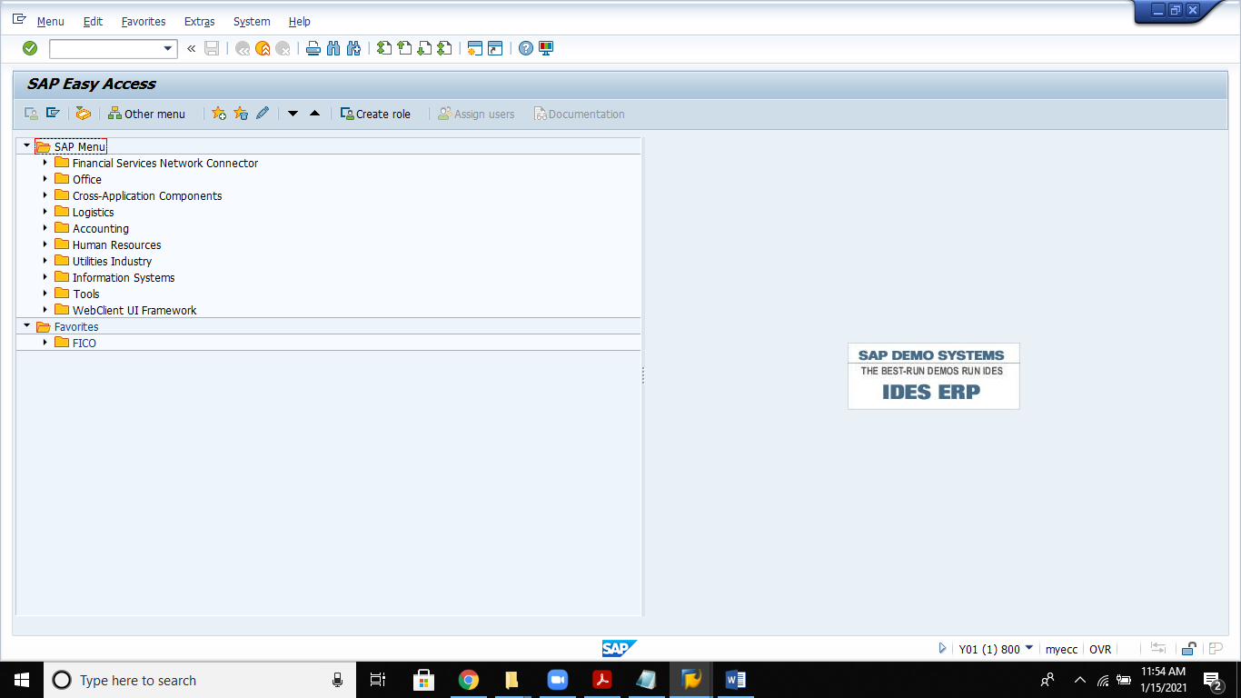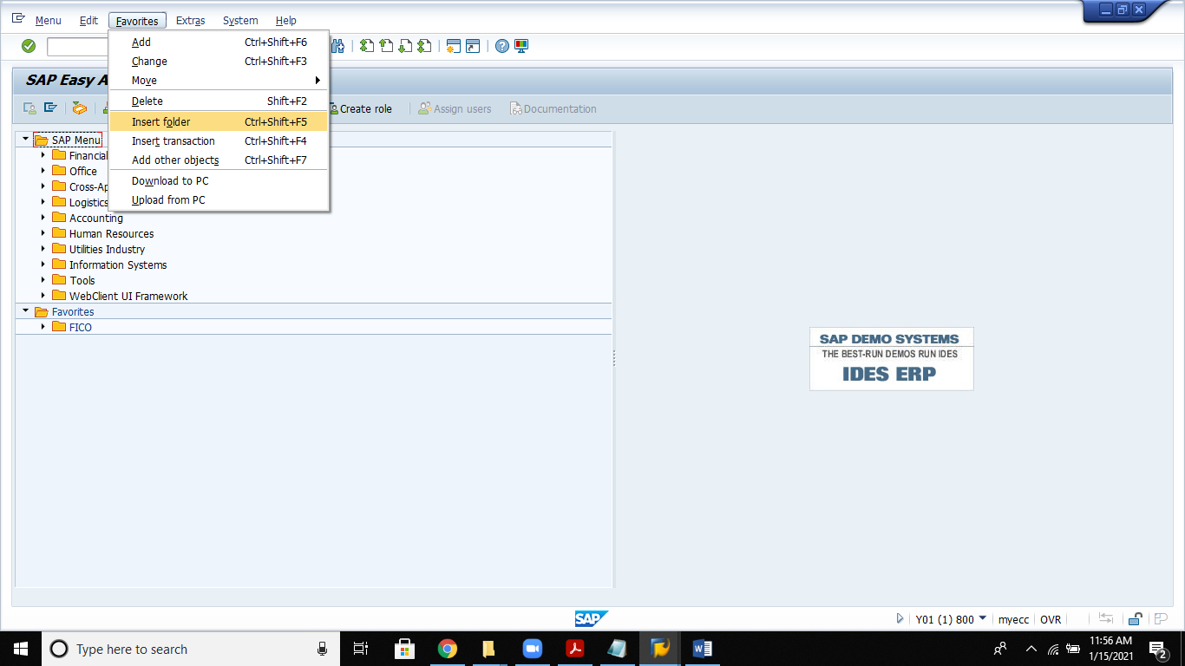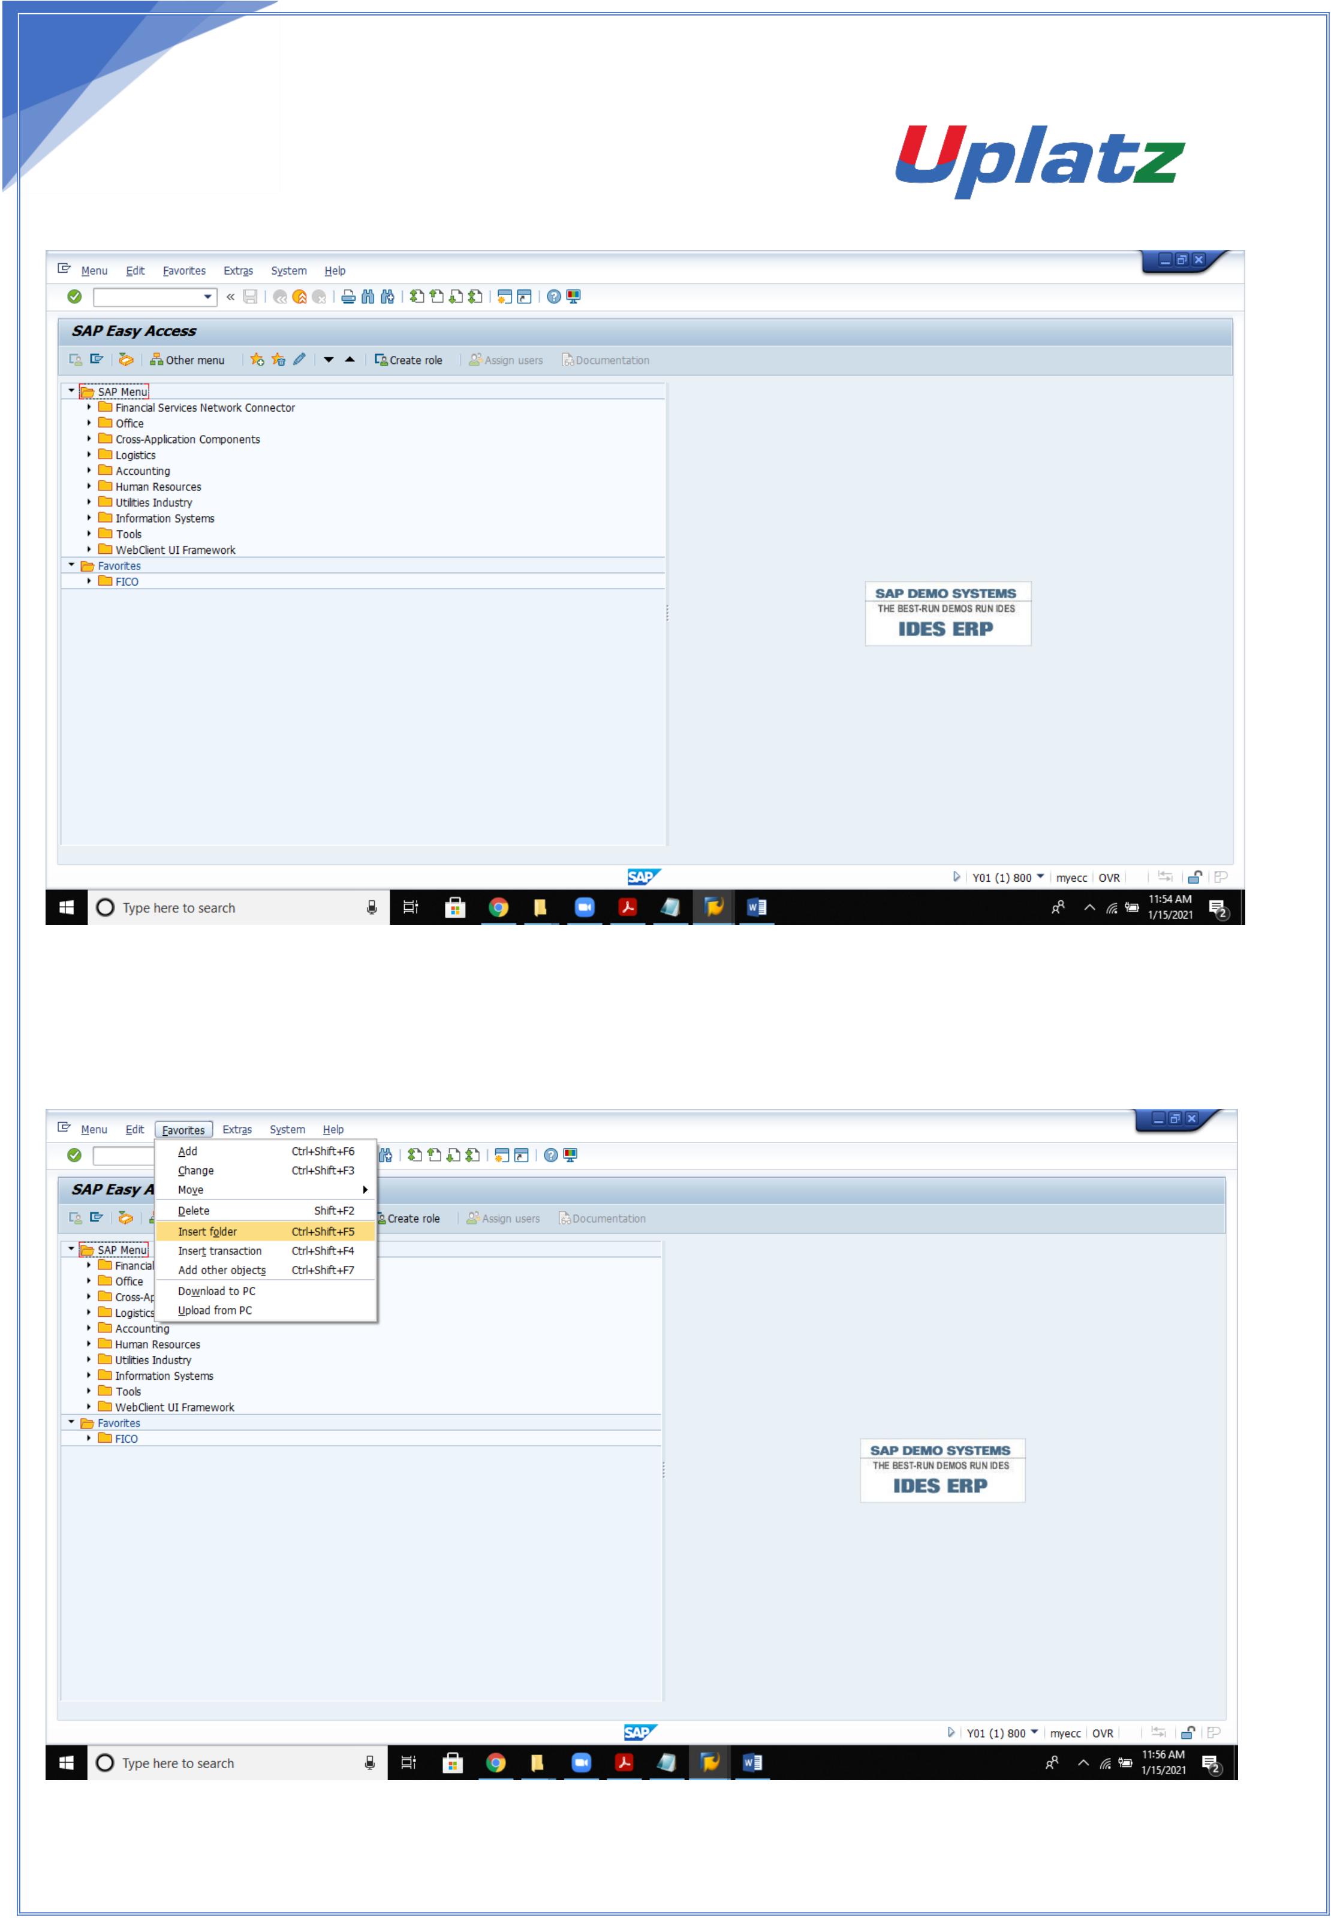

1

**Creation of Folders, Transaction codes on sap easy access:**

1

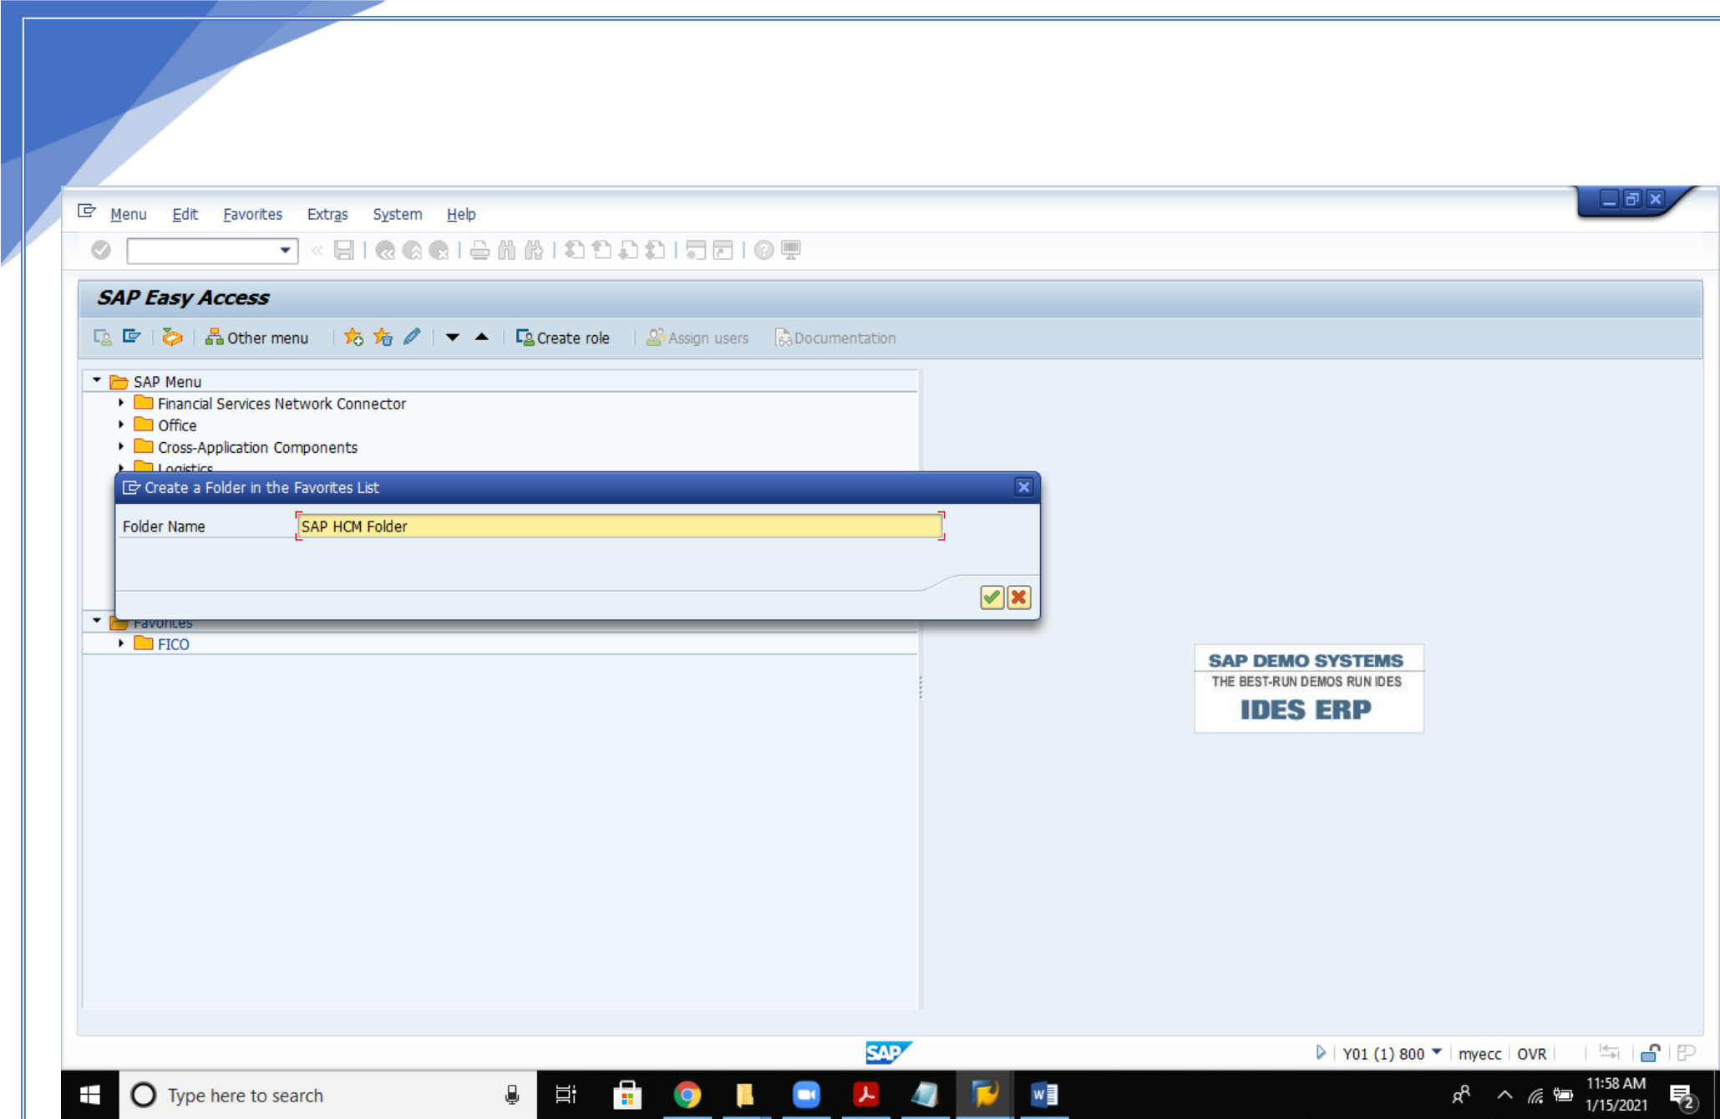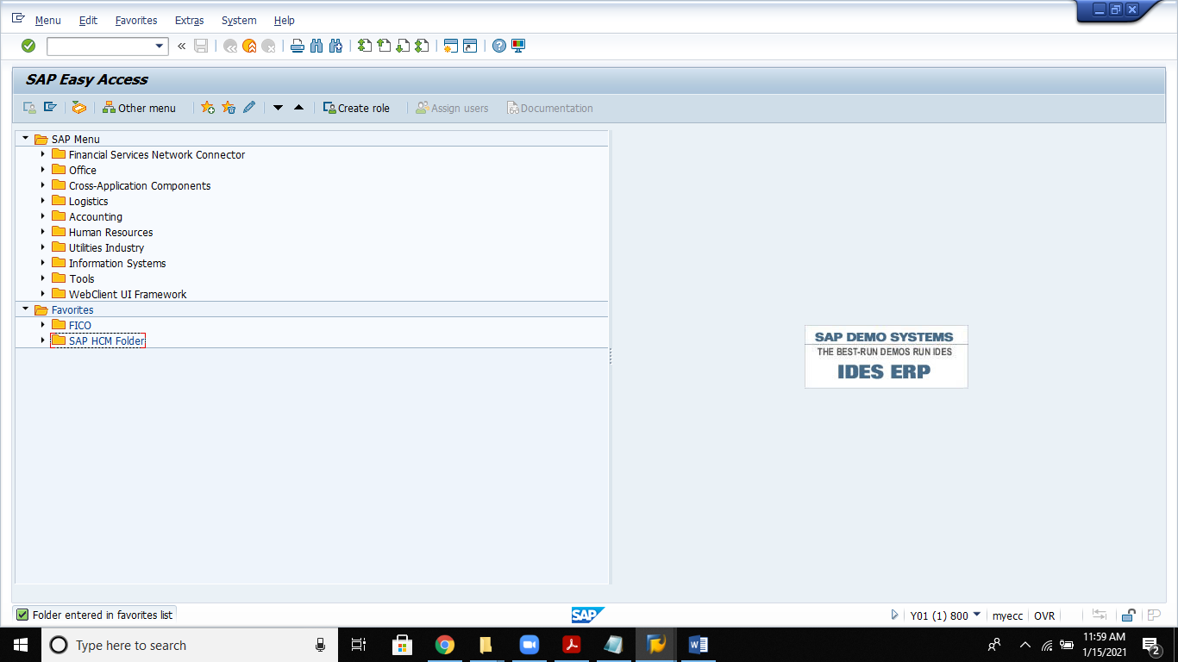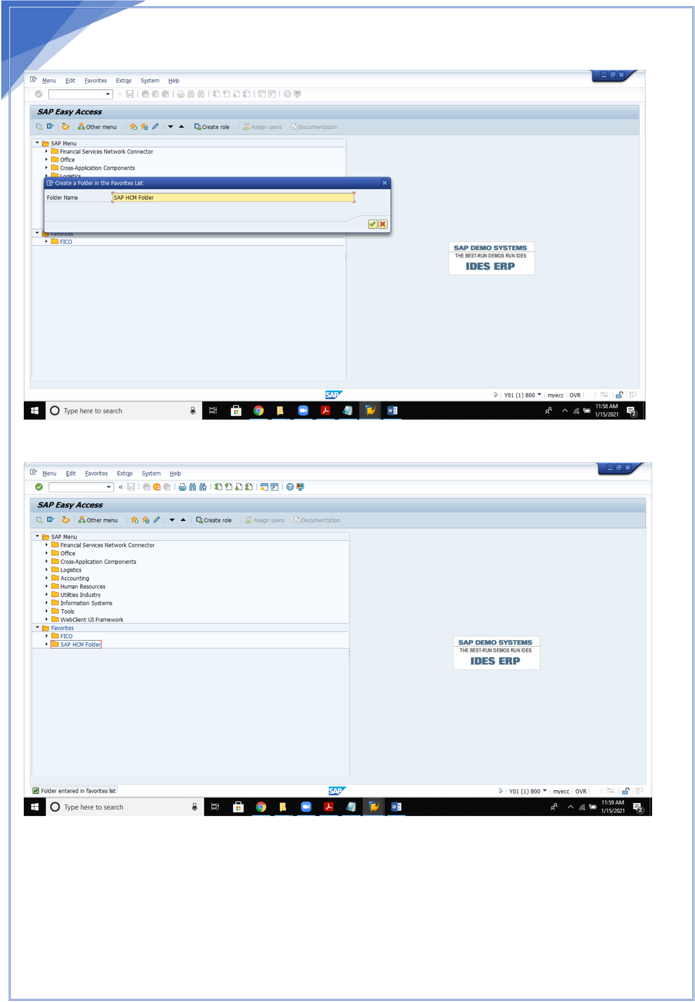

2

Hit enter

Folder is created

2

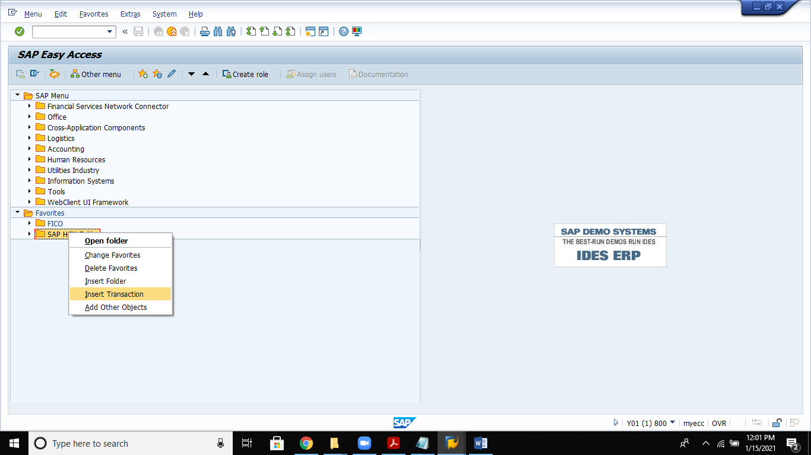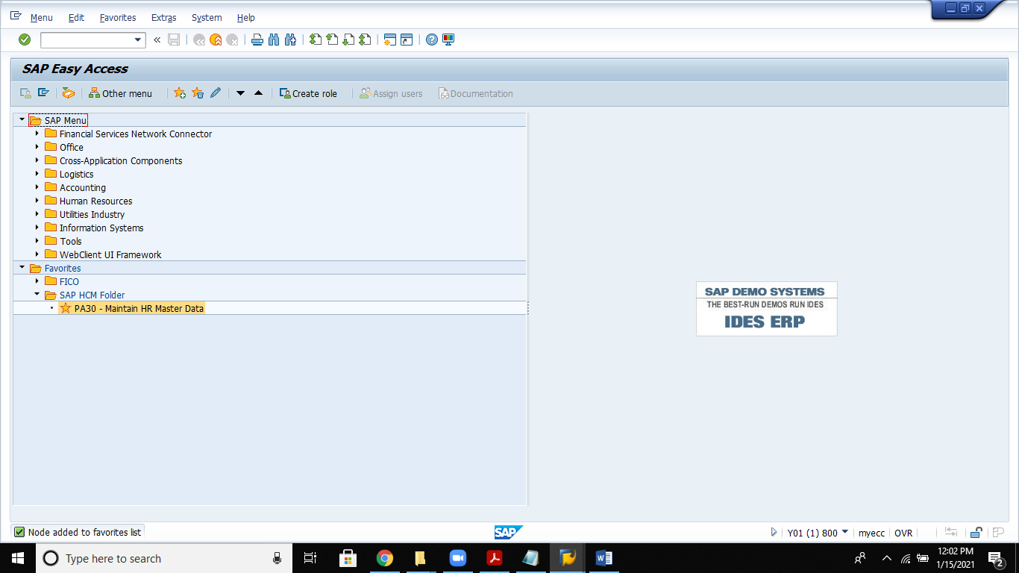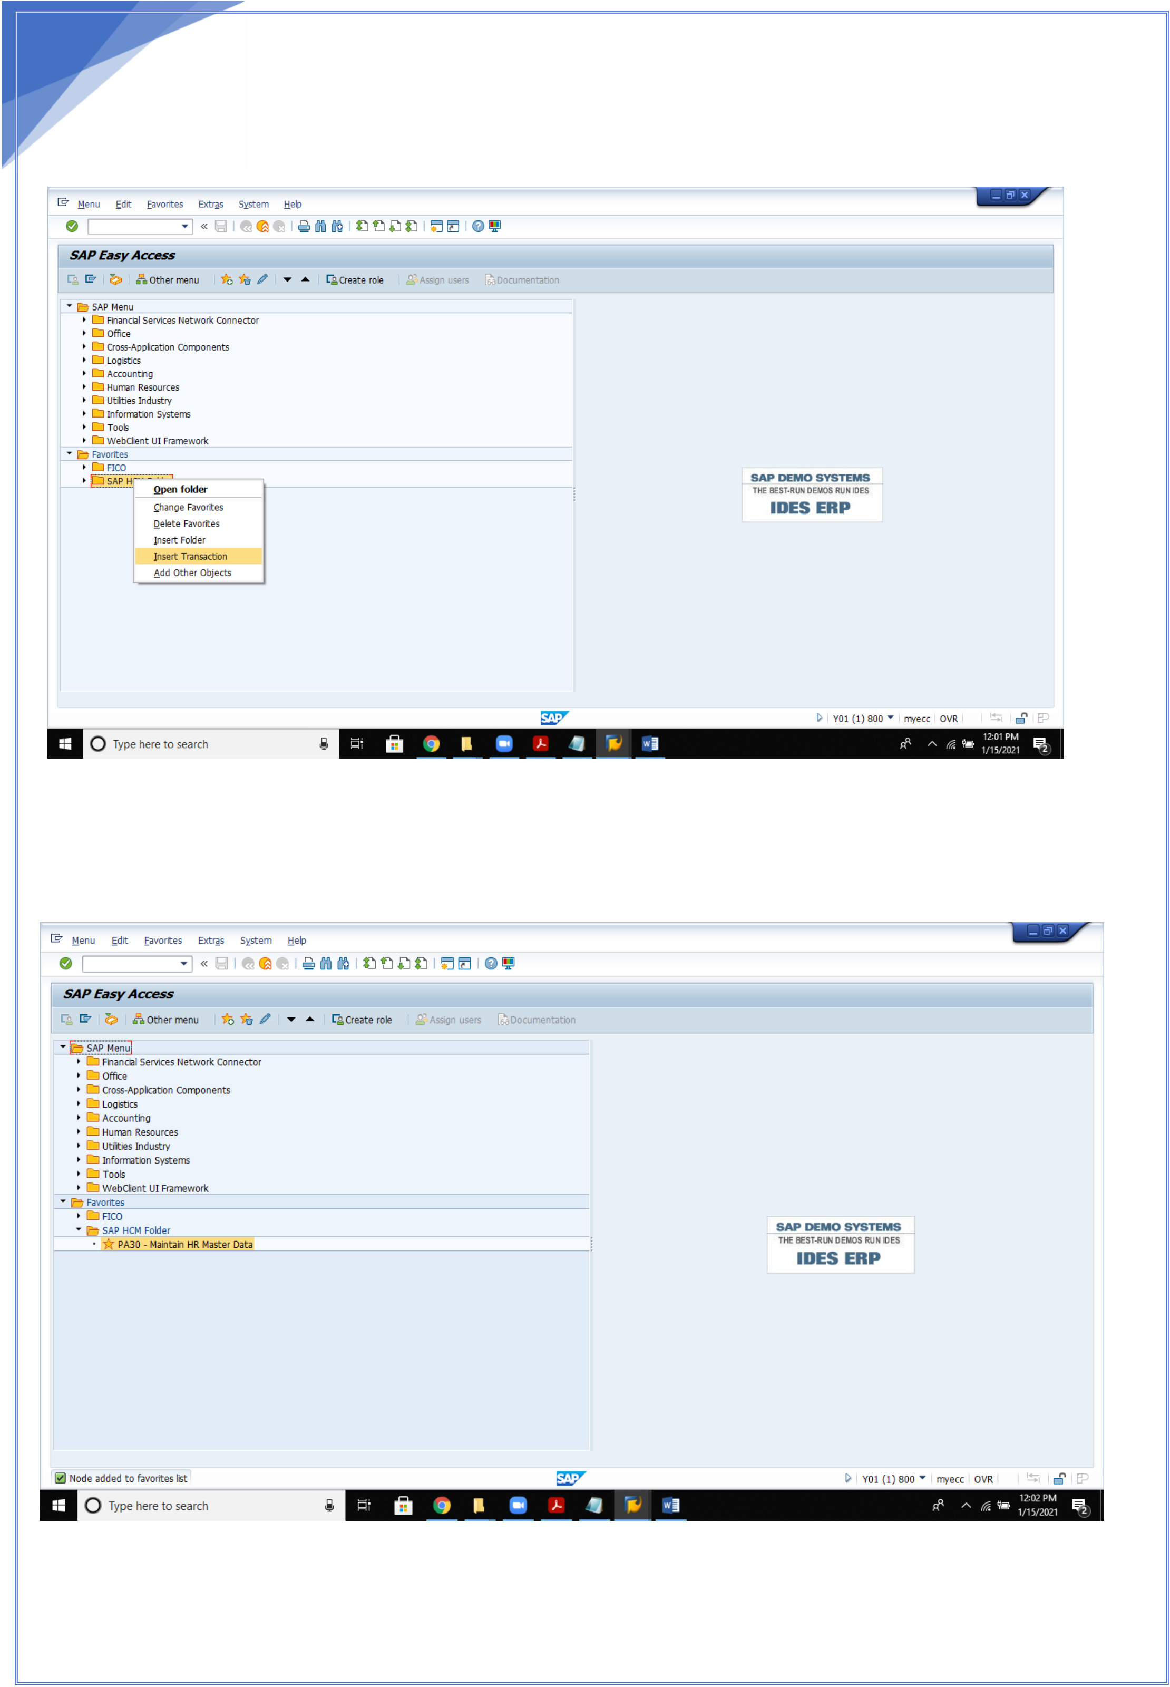

3   
**2. Create Transaction codes in Folders** Open the Folder by right clicking on ii

Select Insert Transaction

Insert the required transaction codes

For ex: PA30

3



4

**ORGANISATIONAL MANAGEMENT**

**Organizational Management**

In this step, you make the necessary system settings for the implementation of the "Organizational Management" component.

“Organizational Management" forms the base for the Personnel Planning and Development area (as well as Organizational Management, this includes the Personnel Development, Personnel Cost Planning and Training and Event Management components) and allows you to analyze and adjust your organizational plan as well as maintain structure data.

**Enterprise Structure**

We will learn how to portray the specific organizational structure of business in the R/3 System.

To help you portray your company structure, different Accounting, Logistics and Human Resources organization units are provided.

First analyze the structures and procedures in your company, and then match them to the SAP structures. There are various organization elements defined as examples in the standard version. Normally these would not cover all your needs. Extend the elements as required.

During the clarification stage, work with the structures delivered by SAP. In order to obtain a high degree of identification and acceptance from project members and user departments from the start, you may have to change some of SAP's terminology.

Enterprise structure shows the relation between 2 organizational units created.

It is the base line for every functional consultant.

4

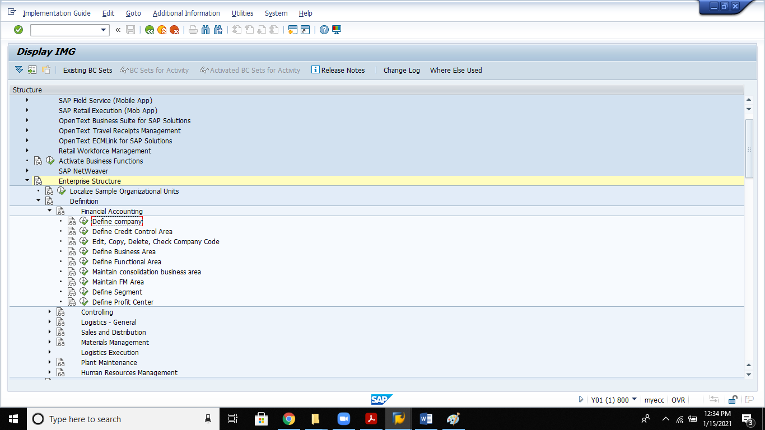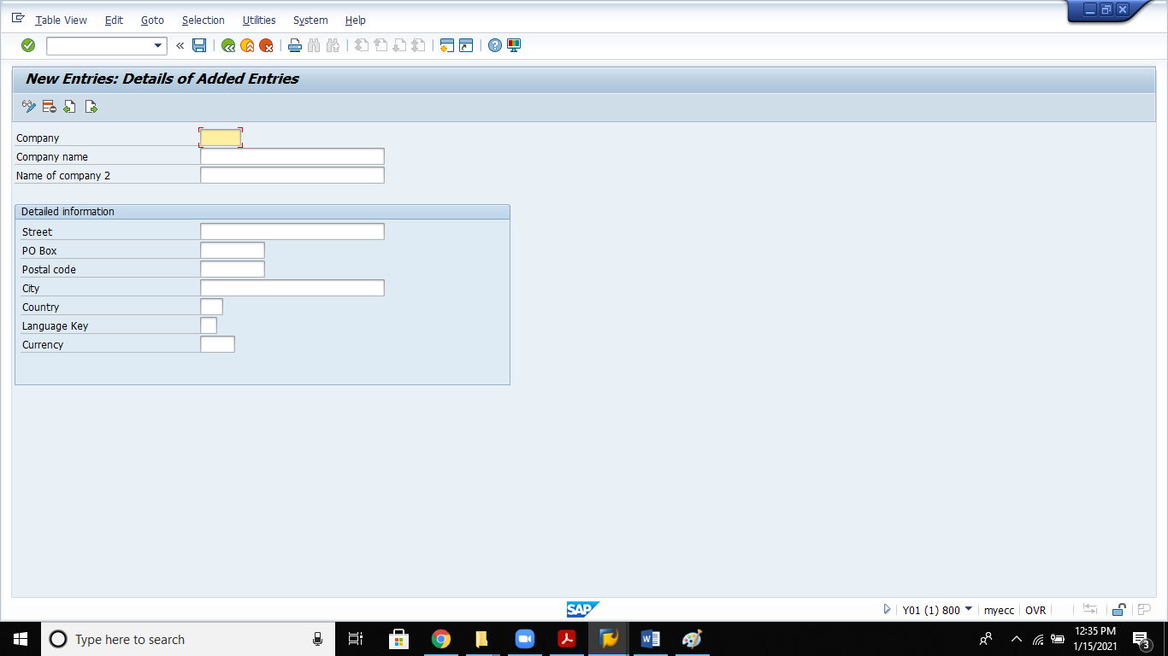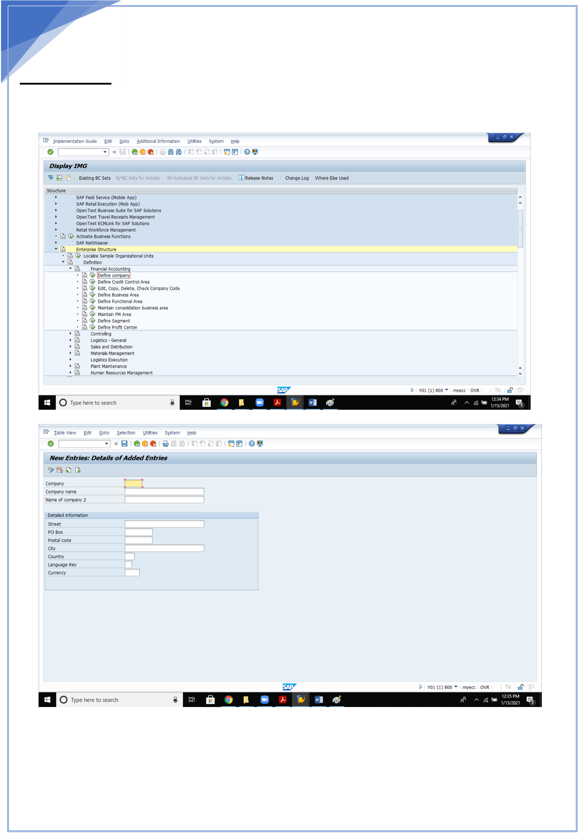

5   
 **Configurations for Enterprise structure**

**Definitions:**

**1. Define Company**

Update the required fields enter and save

5

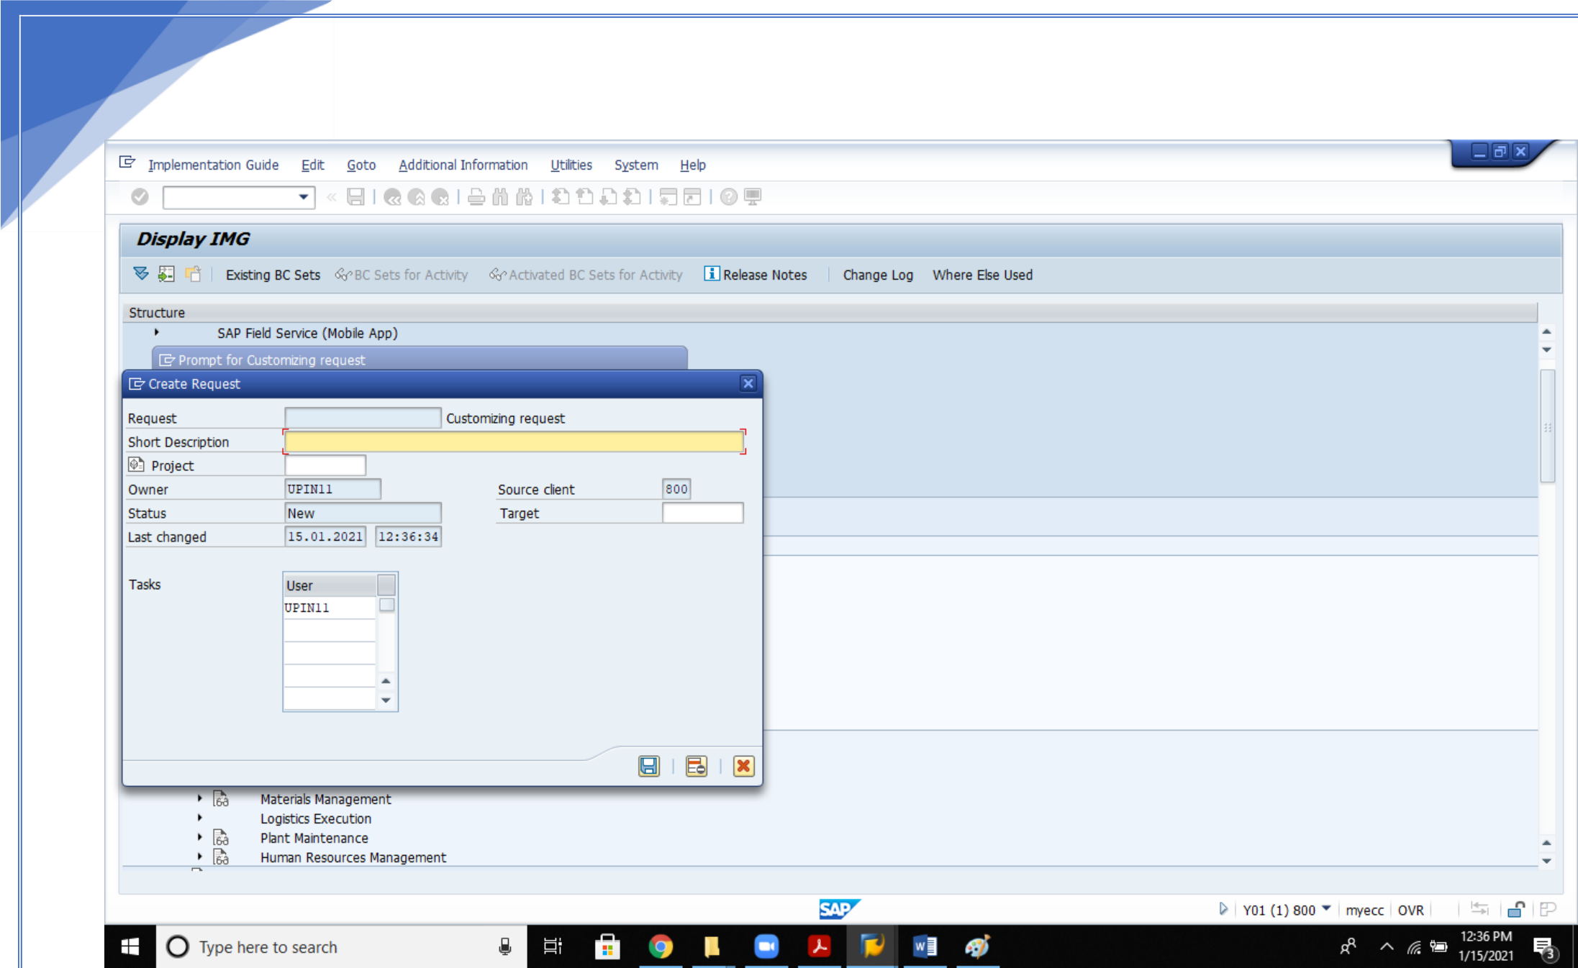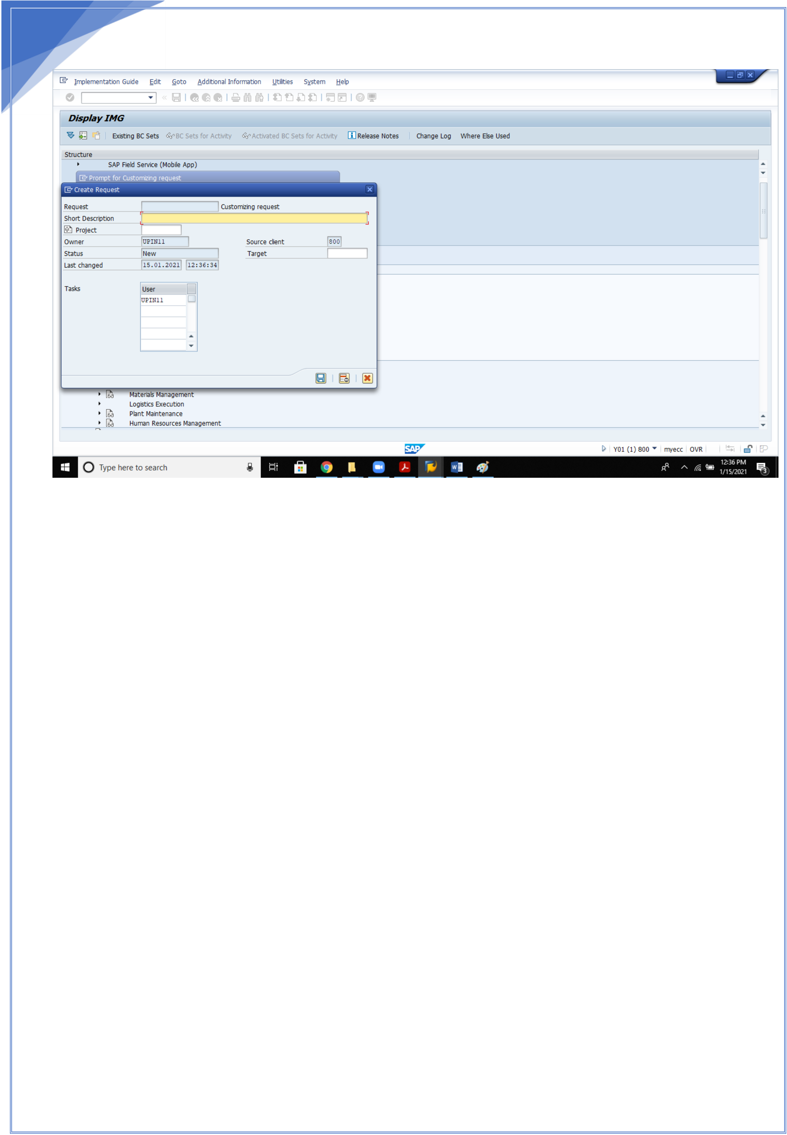

6

Save in Customising request.(TR- Transport Request)

**2. Edit, Copy , delete , check company code**

The **[company code](SAPEVENT:DOCU_LINK/GL:company_code)** is an organizational unit used in accounting. It is used to structure the **[business organization](SAPEVENT:DOCU_LINK/DS:GLOS.business_organization)** from a finan[cial accounting p](SAPEVENT:DOCU_LINK/GL:company_code)erspective.

We recommend that you copy a company code from an existing company code. This has the advantage that you also copy the existing company code-specific parameters. If necessary, you can then change certain data in the relevant application.

This is much less time-consuming than creating a new company code. See "Recommendations" for more details about copying a company code.

If you do not wish to copy an existing company code, you can create a new company code and make all the settings yourself. You define your company codes by specifying the following information:

• Company code key

You can select a four-character alpha-numeric key as the company code key. This key identifies the company code and must be entered when posting business transactions or creating company code-specific master data, for example.

• Company code name

• Address data

The address data is necessary for correspondence and is printed on reports, such as the advance return for tax on sales/purchases.

• Country currency

6

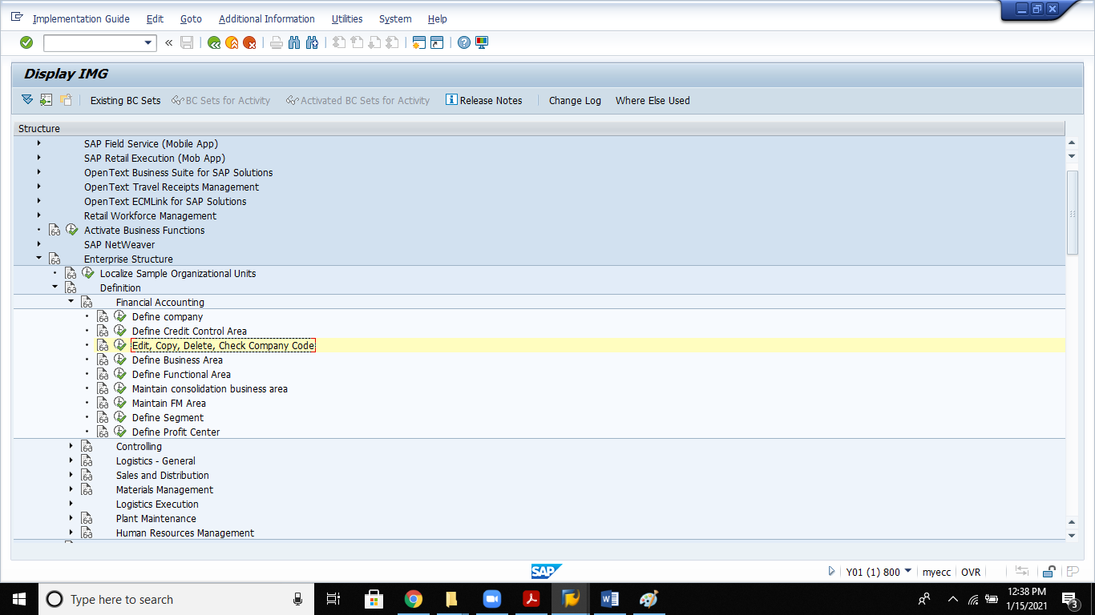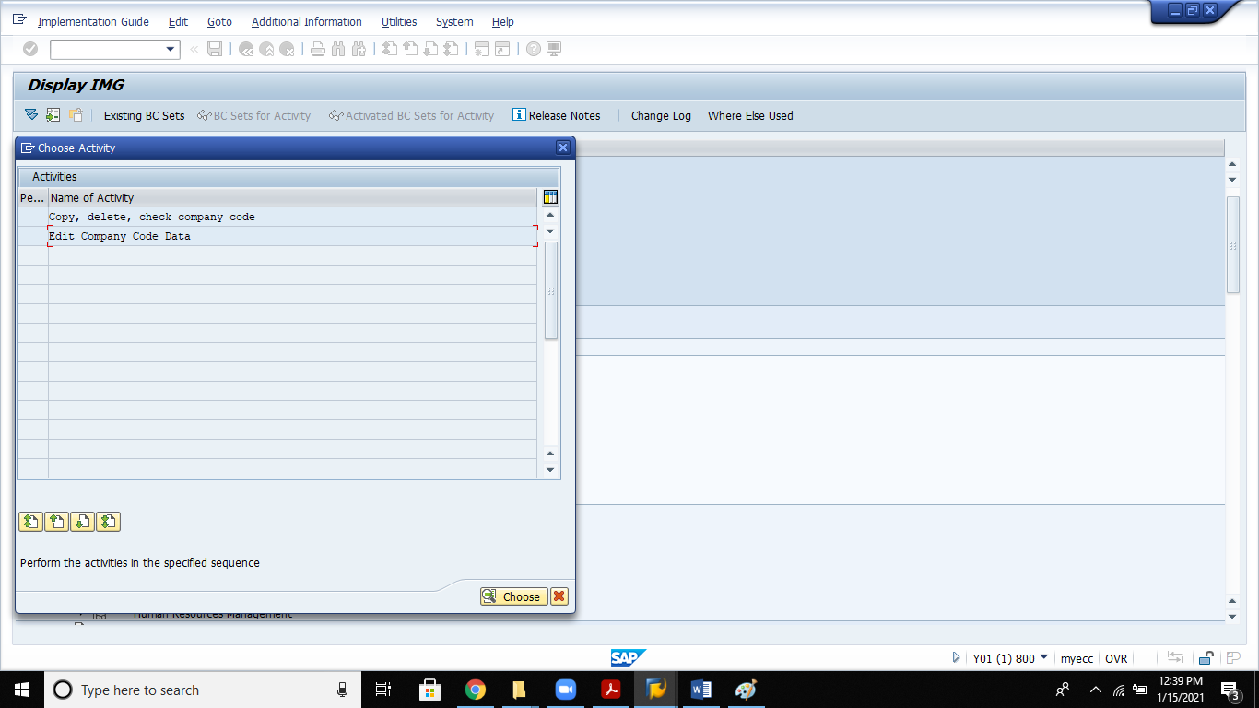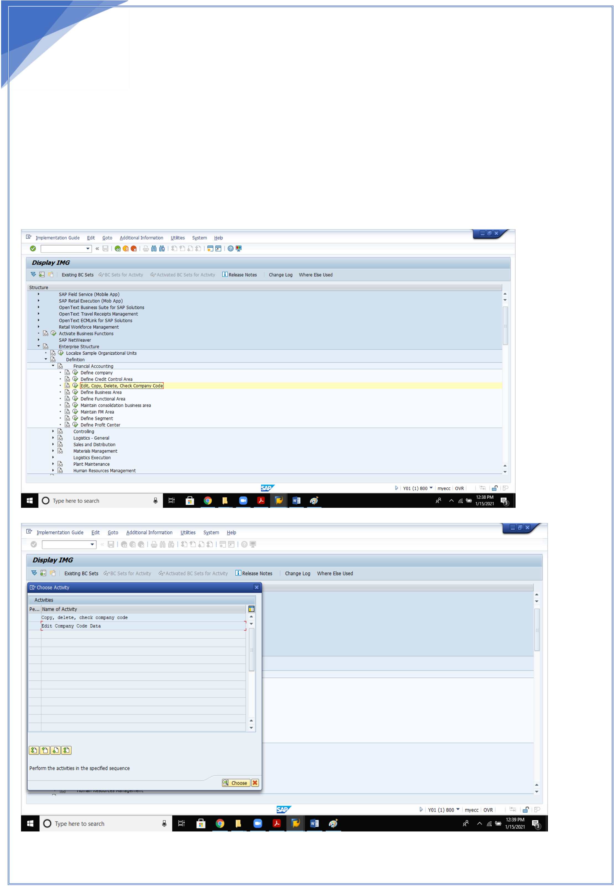

7

Your accounts must be managed in the national currency. This currency is also known as the local currency or the company code currency. Amounts that are posted in foreign currency are translated into local currency.

• Country key

The country key specifies which country is to be seen as the home country; all other countries are interpreted as "abroad". This is significant for business and payment transactions because different forms are used for foreign payment transactions. This setting also enables you to use different address formatting for foreign correspondence.

• Language key

The system uses the language key to determine text automatically in the language of the relevant country. This is necessary when creating checks, for example

7

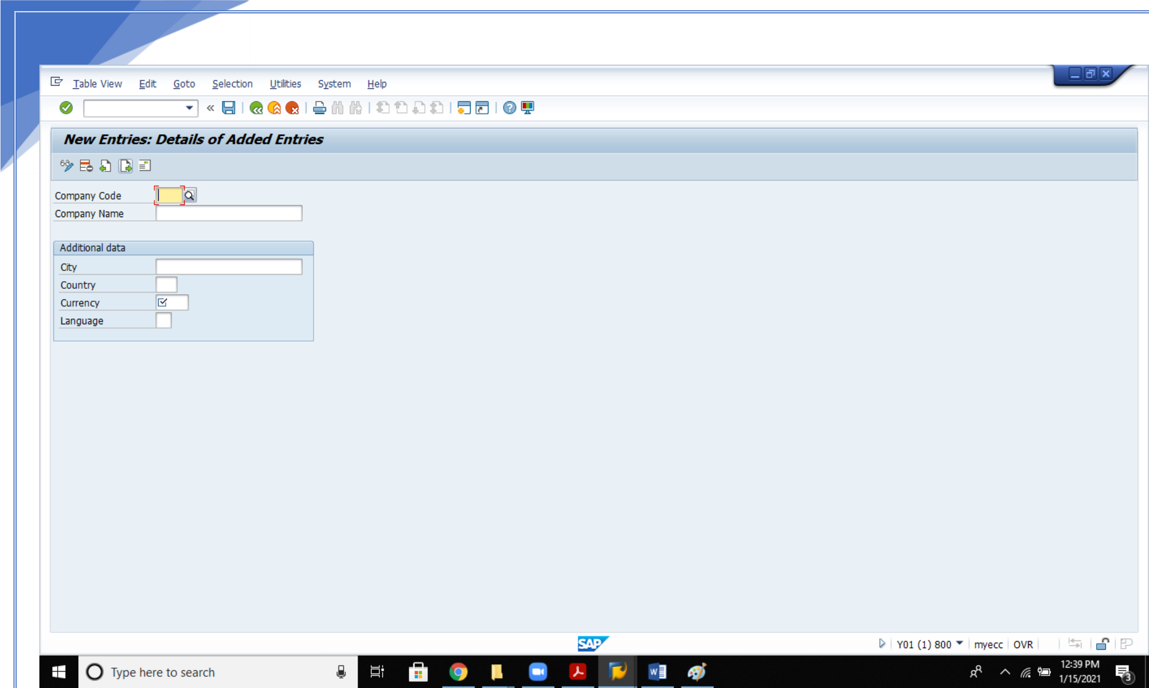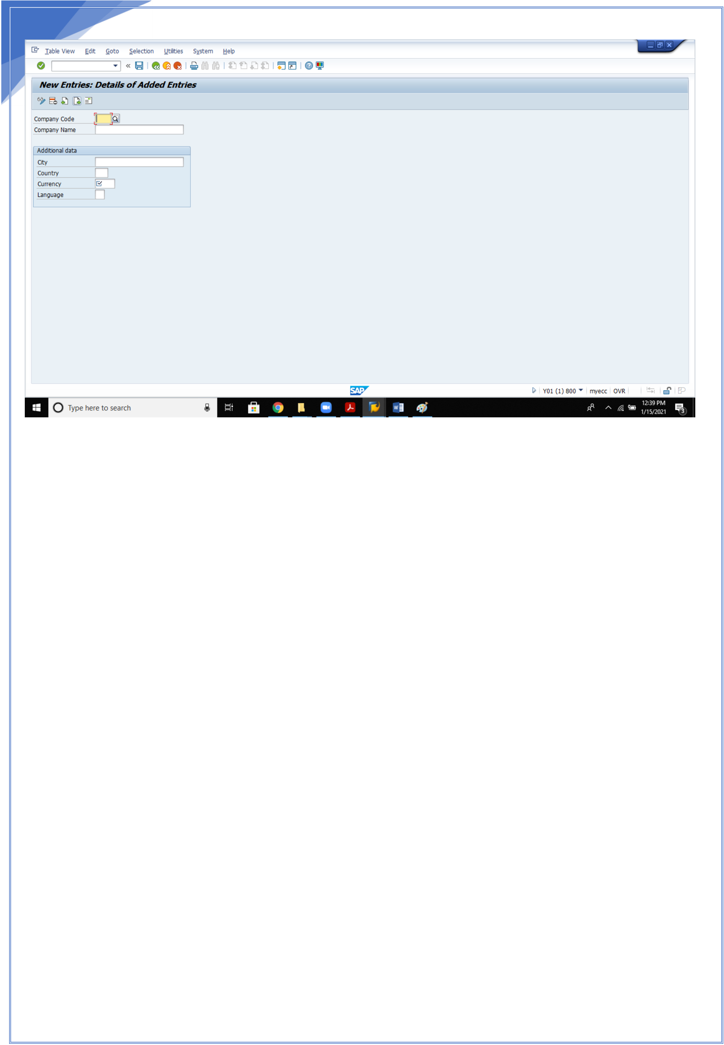

8

Update the required details and save.

**3. Define Personnel Area**

The personnel area is an organizational unit that represents a   
specific area of the enterprise and is organized according to aspects of personnel, time management and payroll. A personnel area is divided into several personnel subareas. the personnel subareas contain the business characteristics. To assign the business   
characteristics, you must have set up at least one personnel subarea for each of your personnel areas even if you do not use personnel subareas in your enterprise structure.

**Example**

Company Ford has three production plants in

Germany:

Hamburg,

Cologne and Berlin.

8

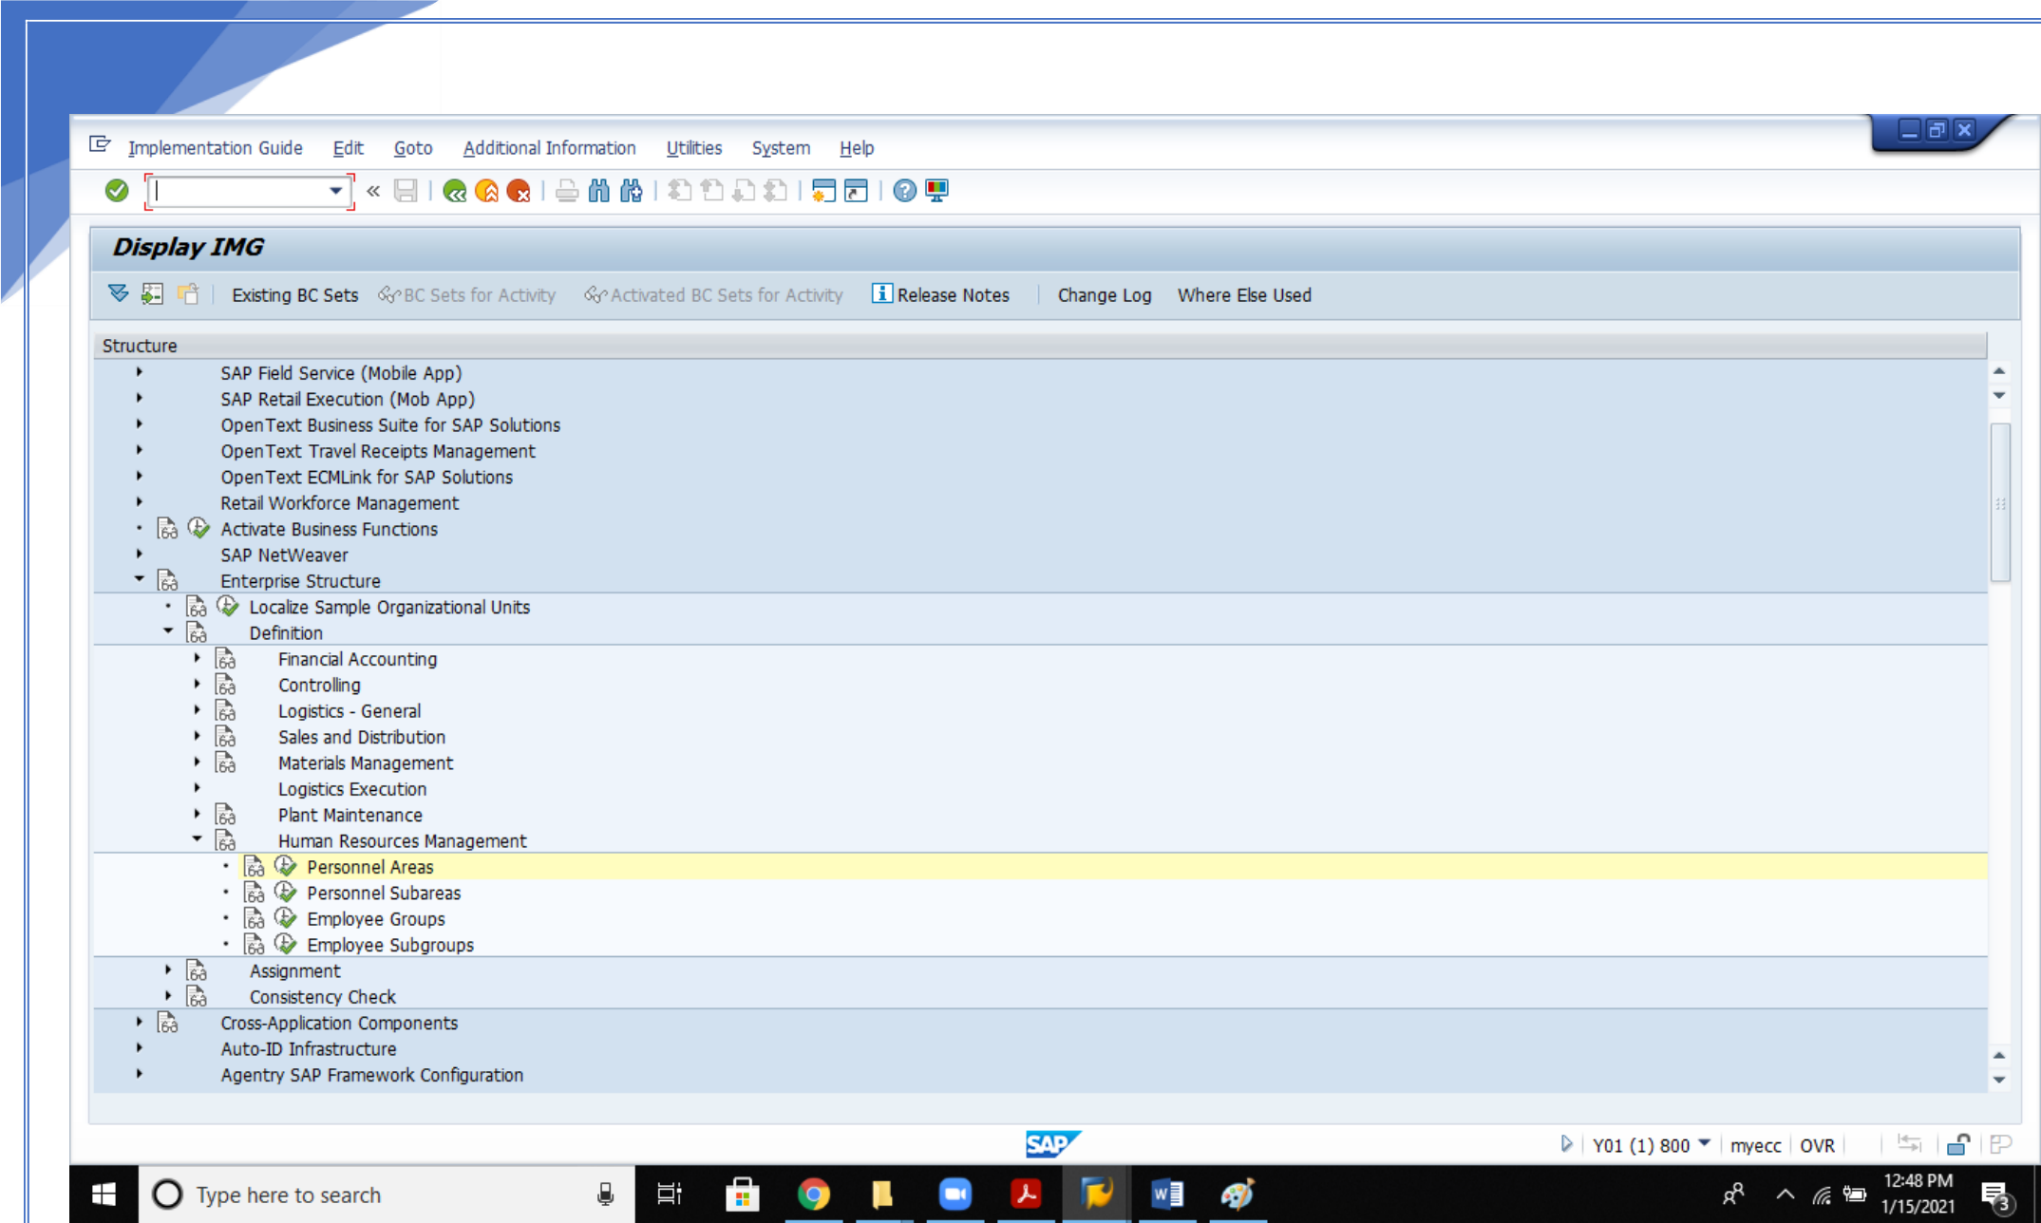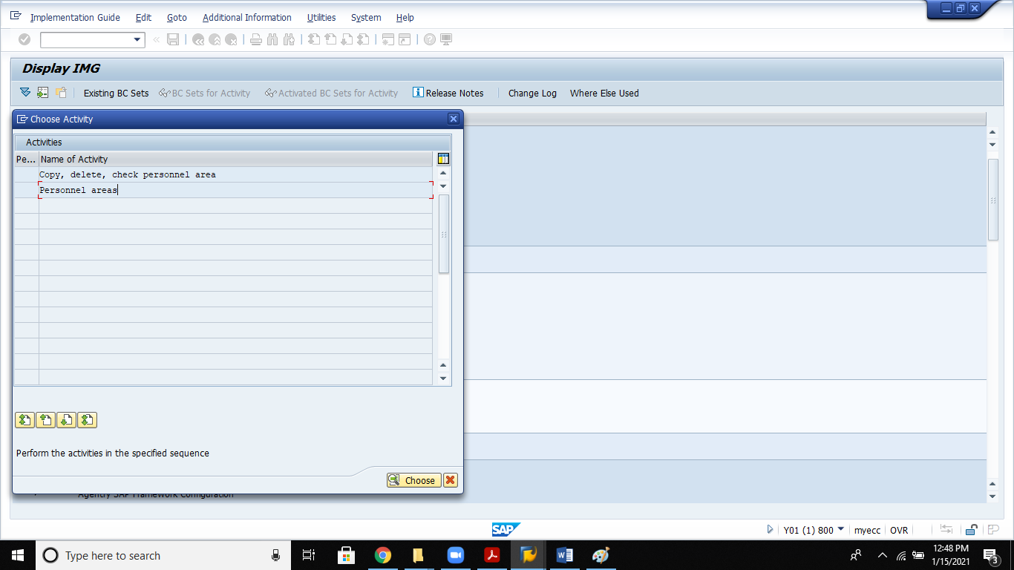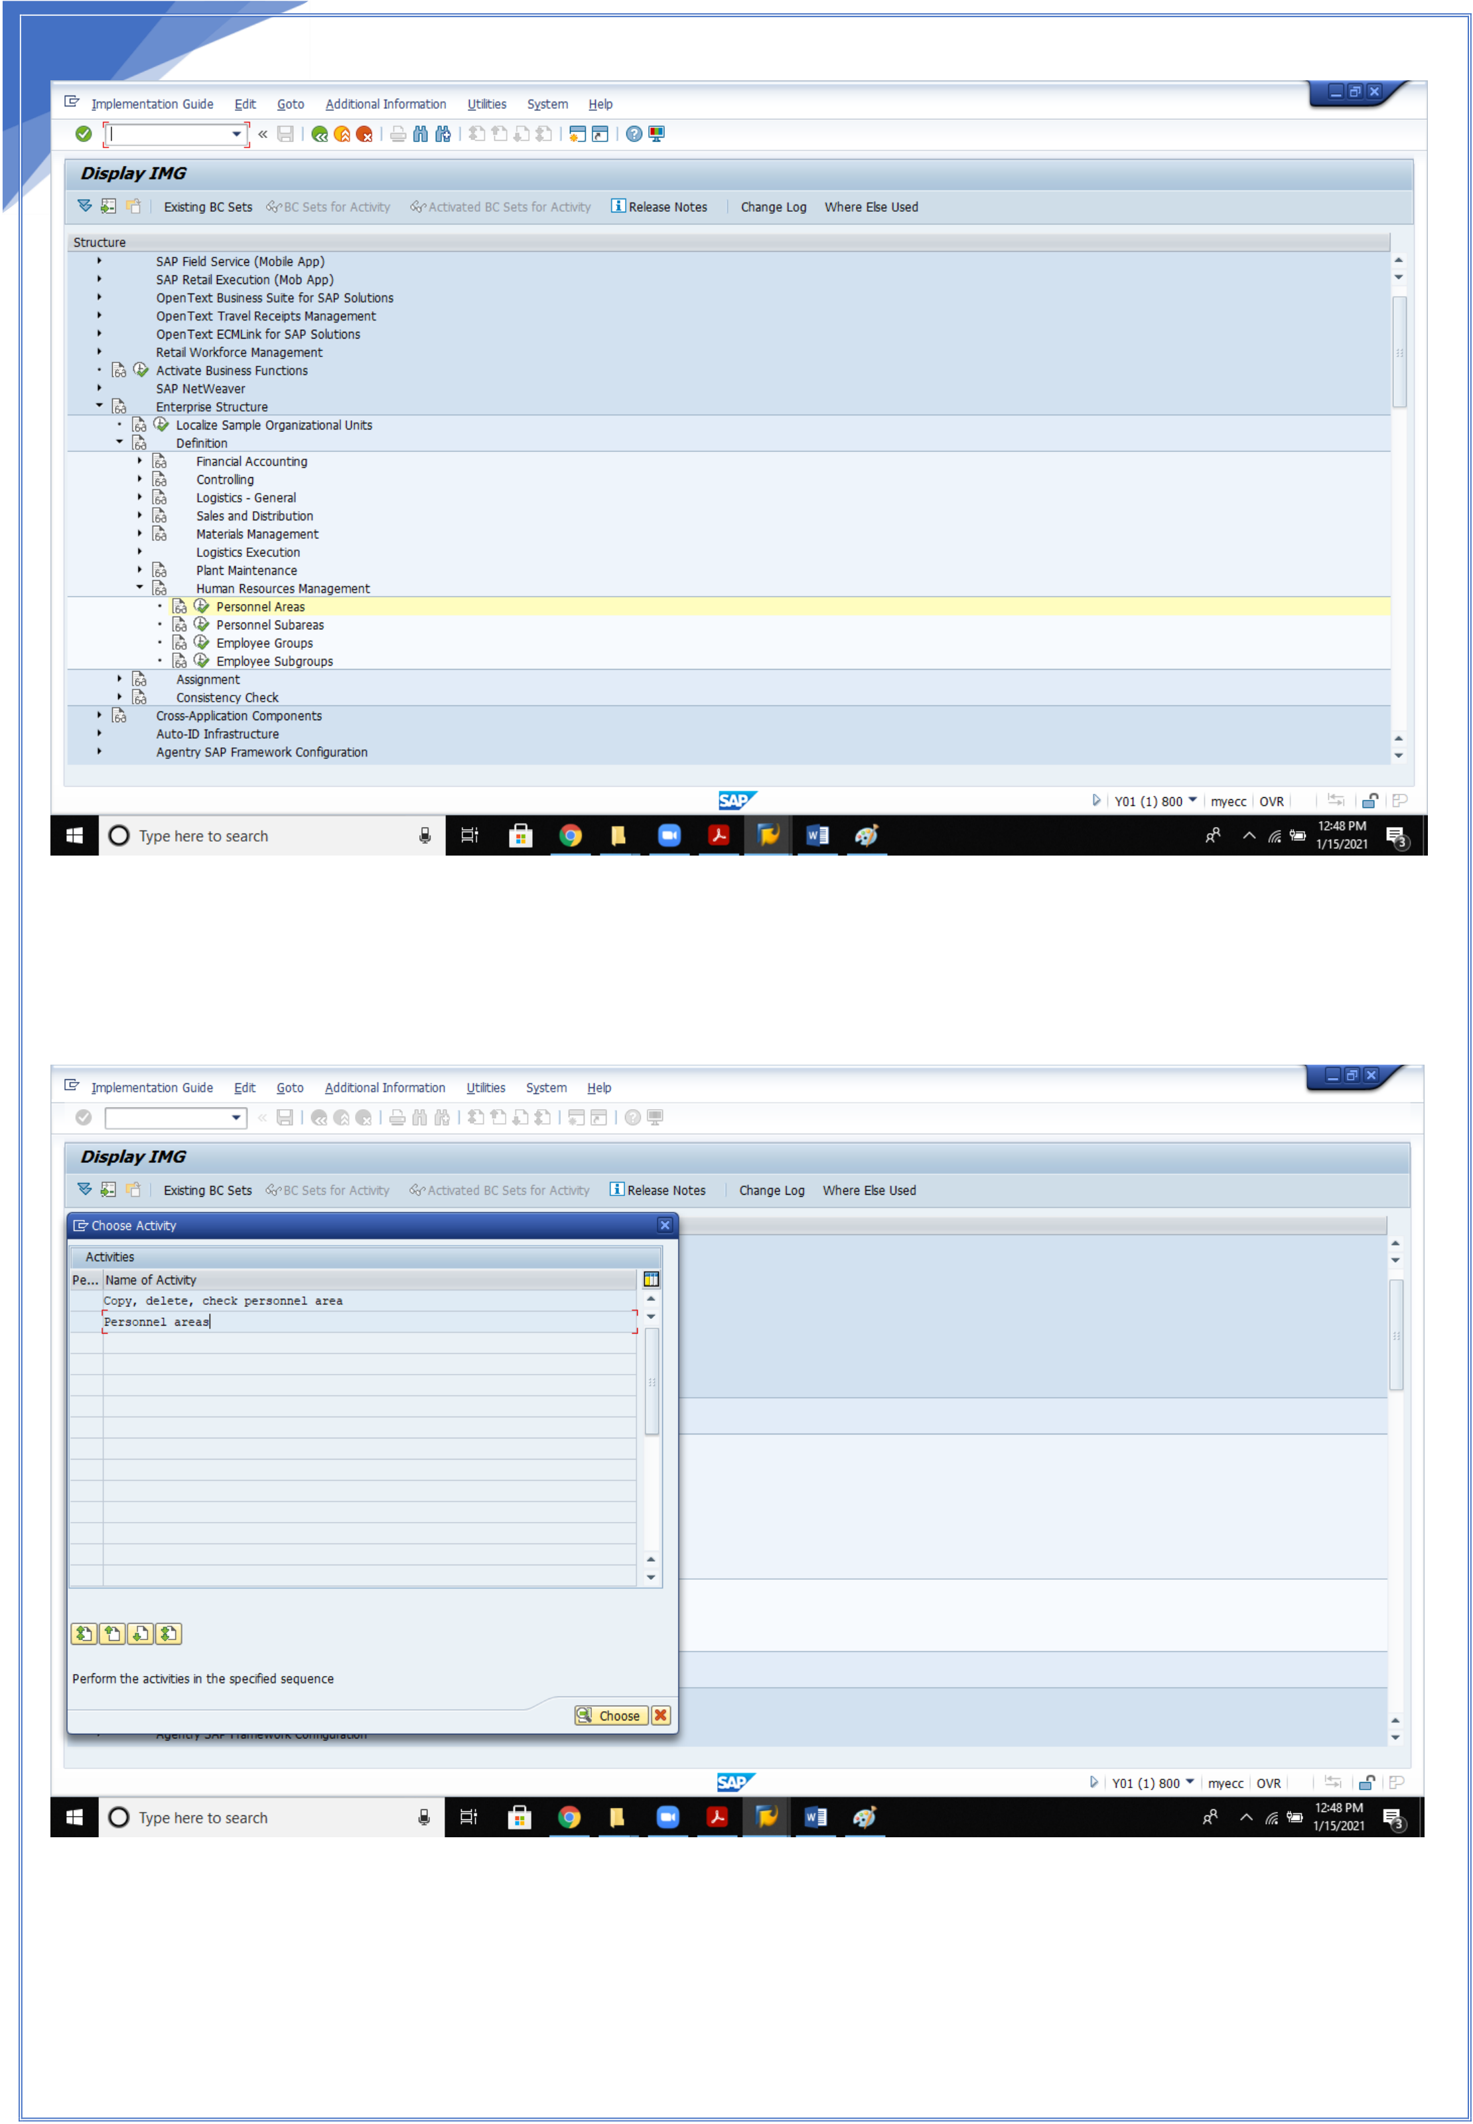

9

9

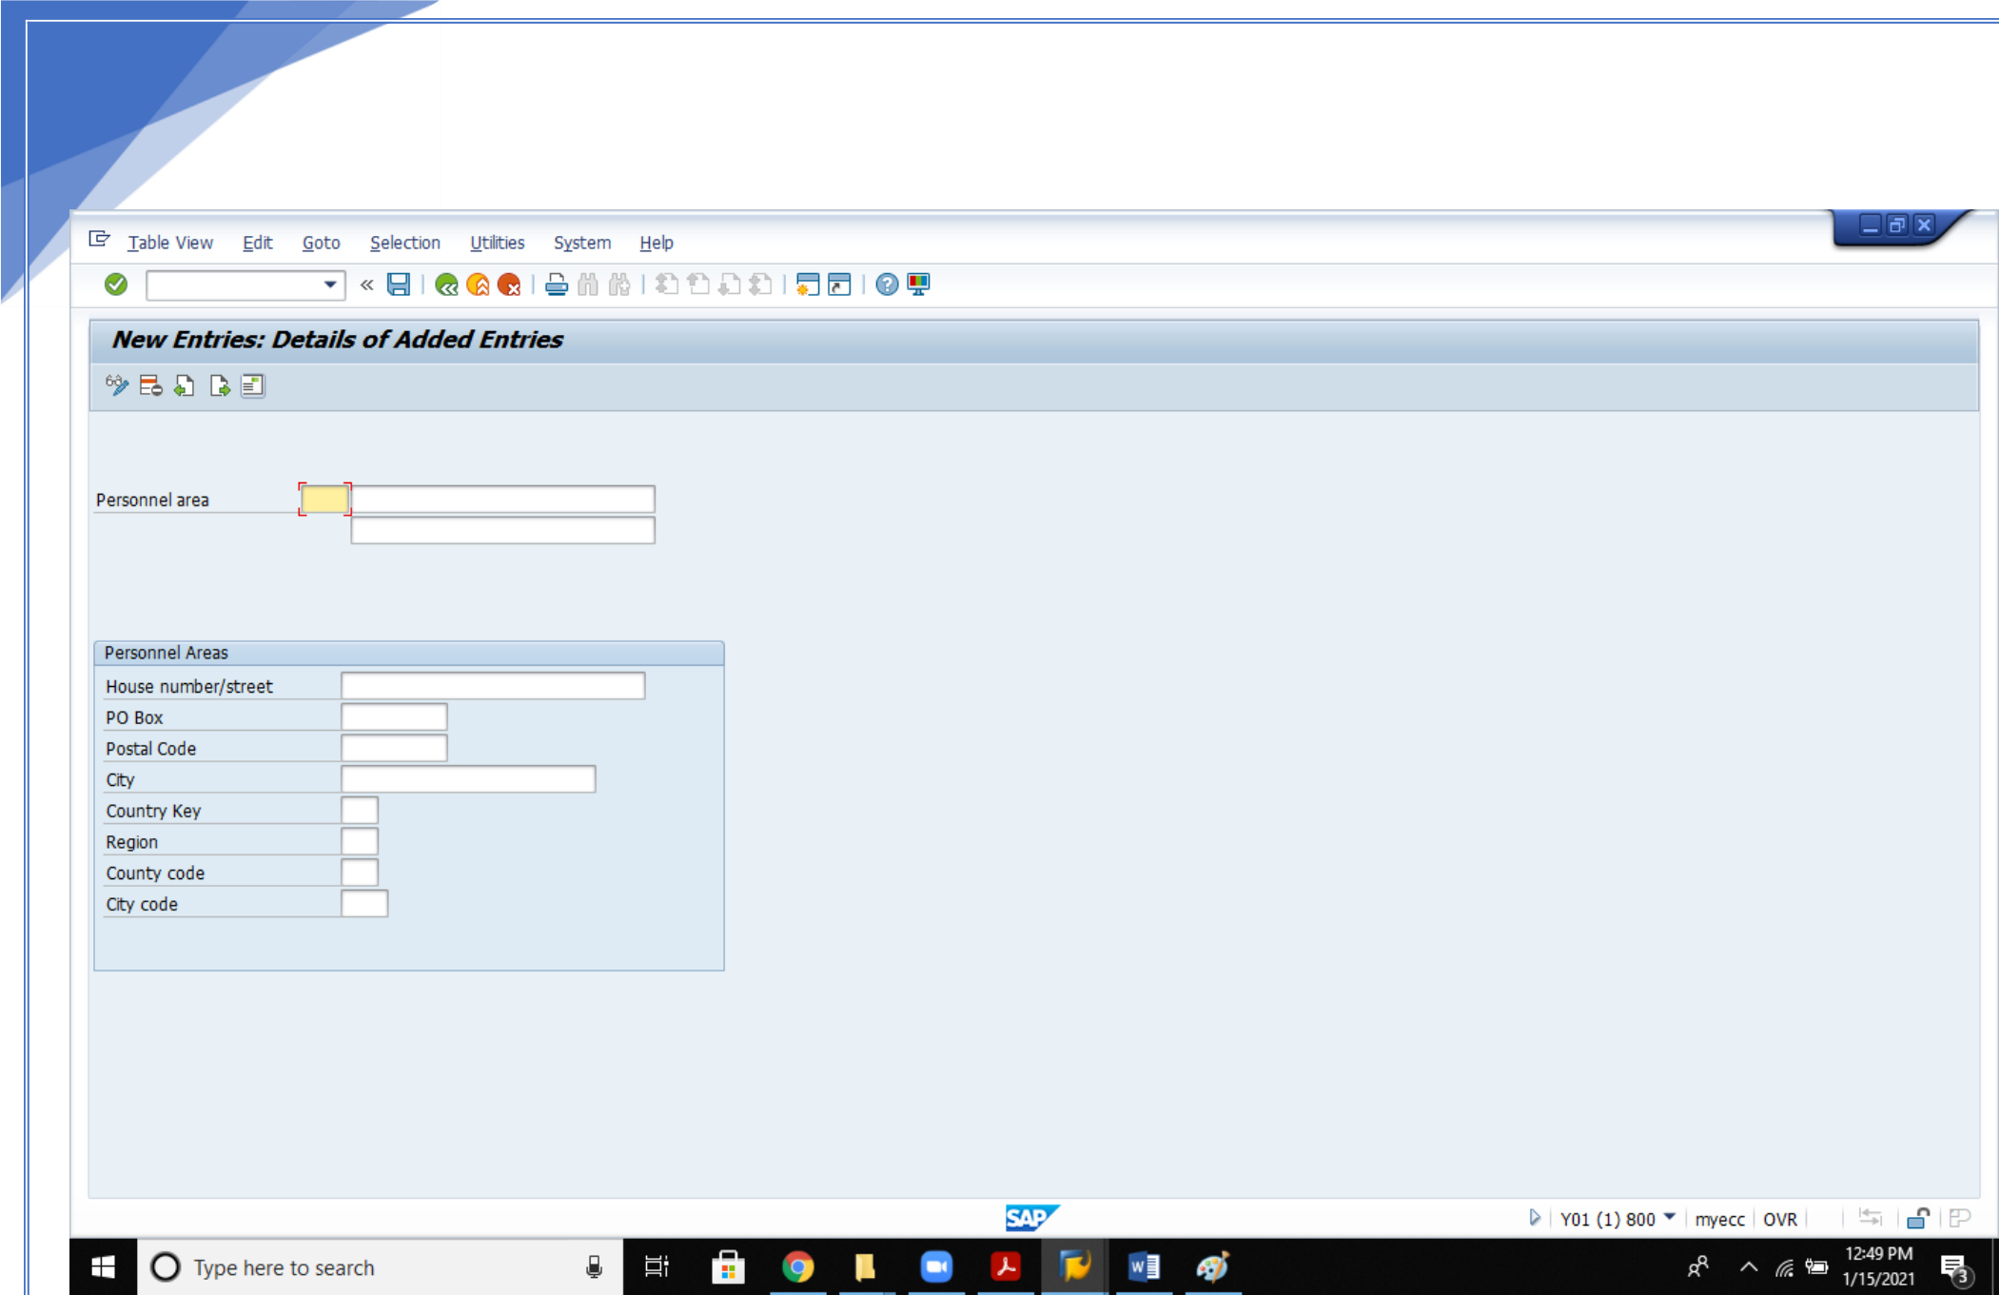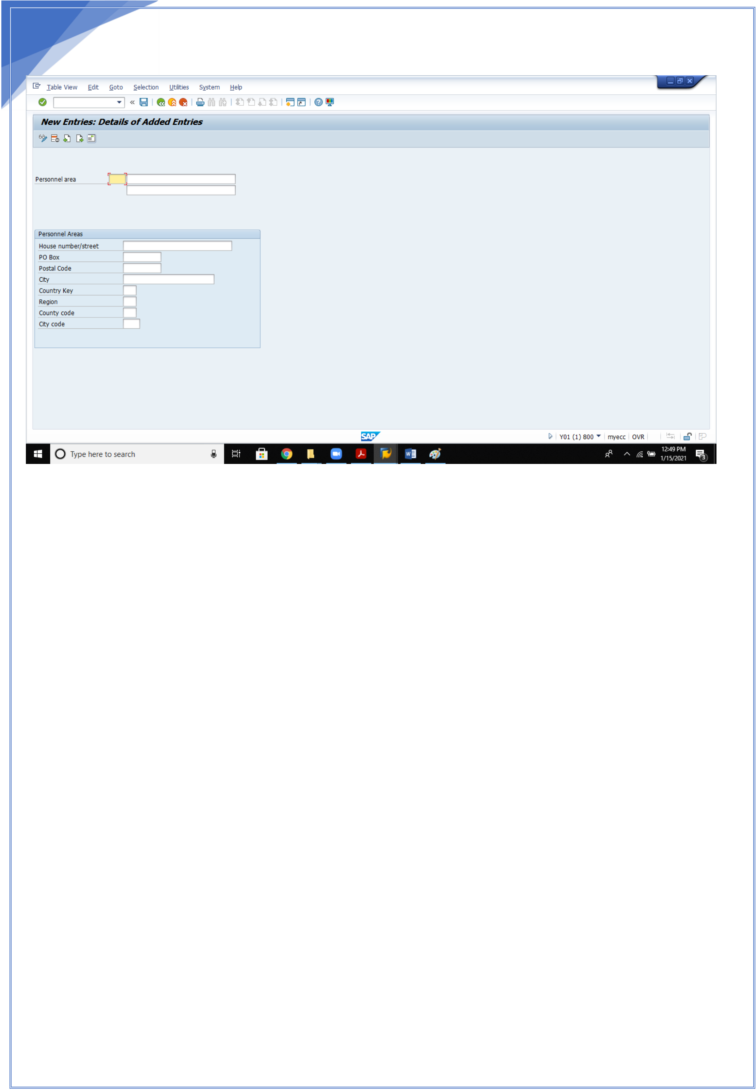

10

Update the personnel areas, enter and save

4.**Define Personnel sub areas**:   
A personnel subarea is an organizational unit that represents a specific area of the company organized according to certain aspects of personnel, time management and payroll. The following business subtasks belong to the personnel subarea:   
 •Defining of pay scale and wage type structure   
 •Defining planned working hours   
 •Defining appraisal criteria   
Example   
The Germany site of Company Ford is physically separated by a railroad line. This could mean that two different tax or employment offices are responsible for the respective areas. In this case, you would define a personnel area "Berlin" and two personnel subareas.

10

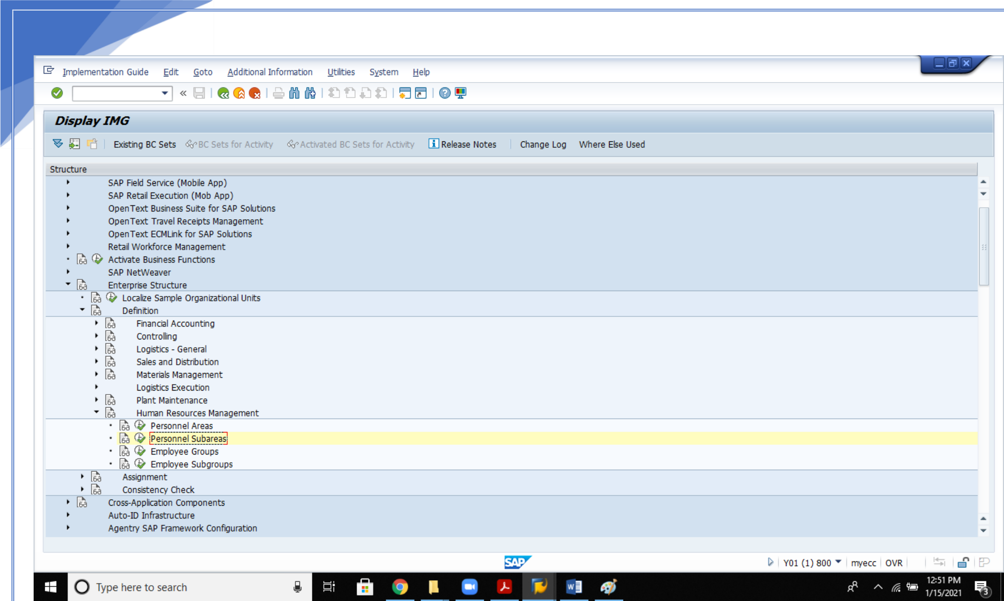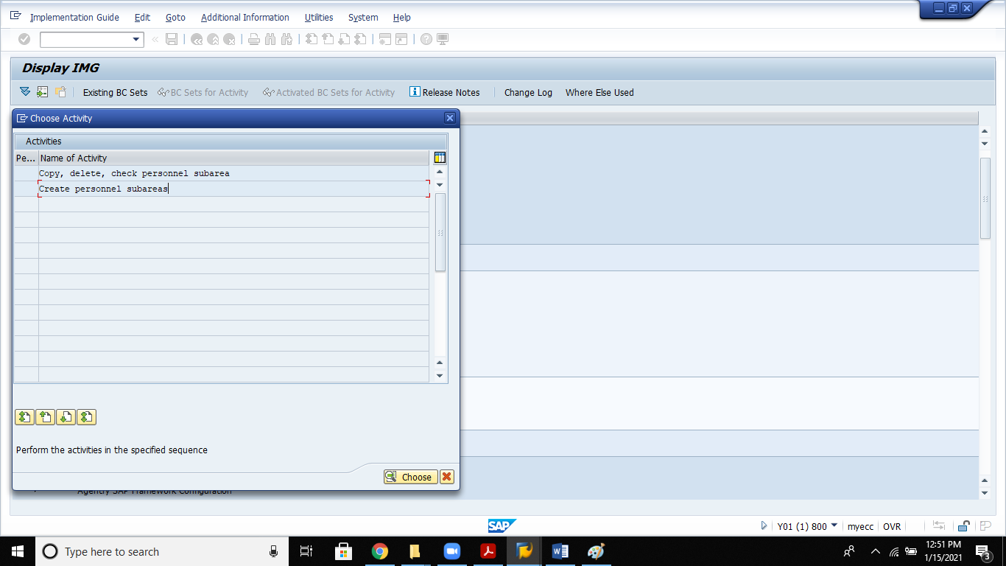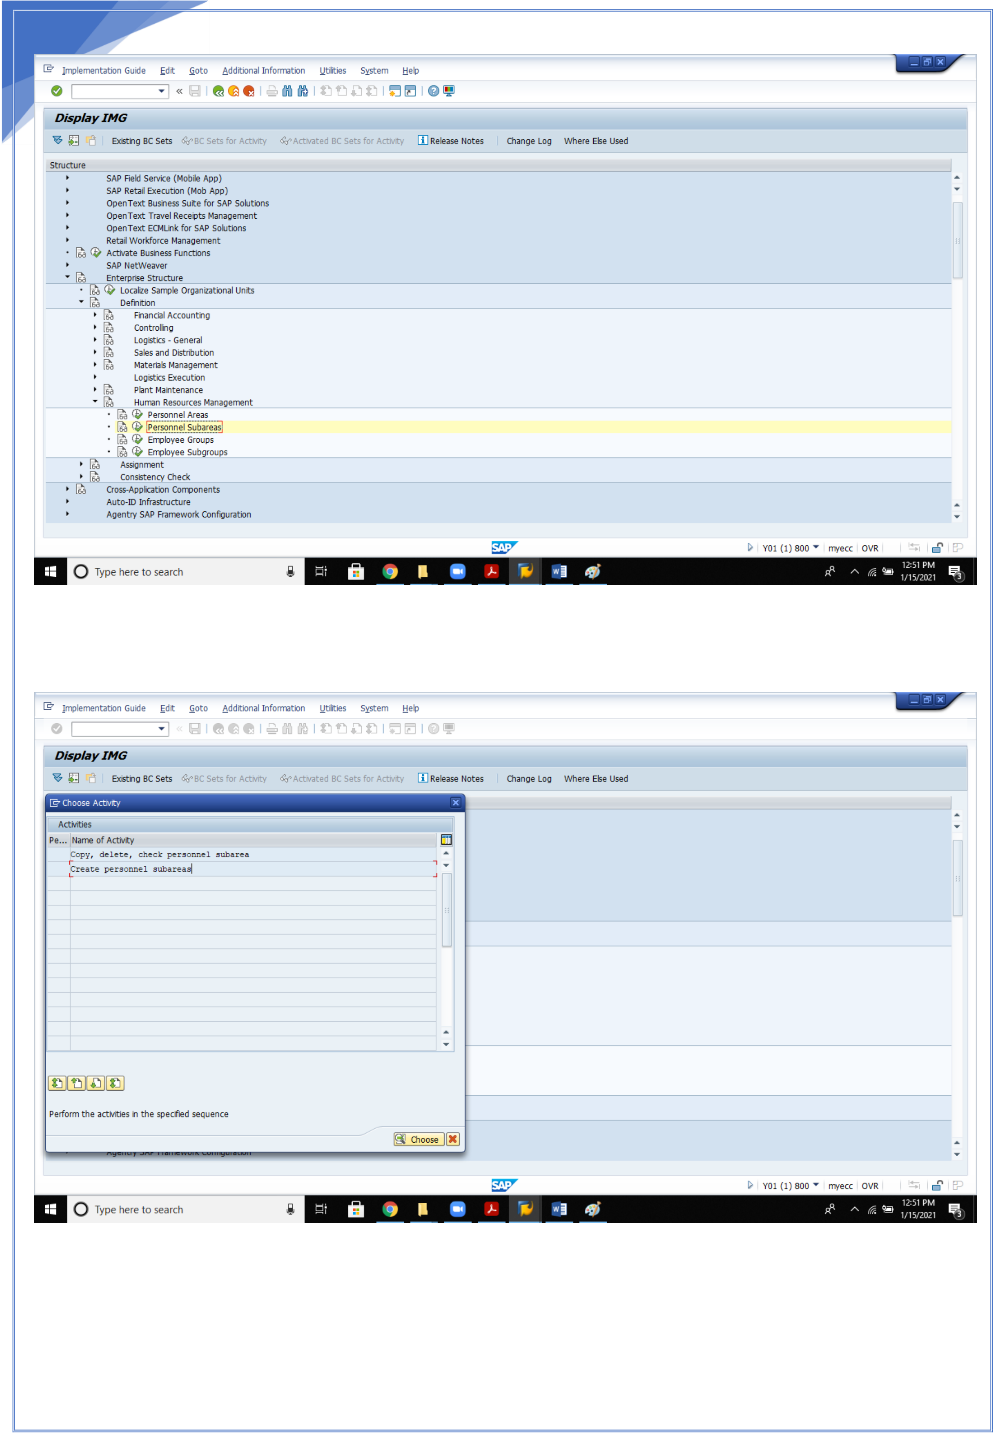

11

11

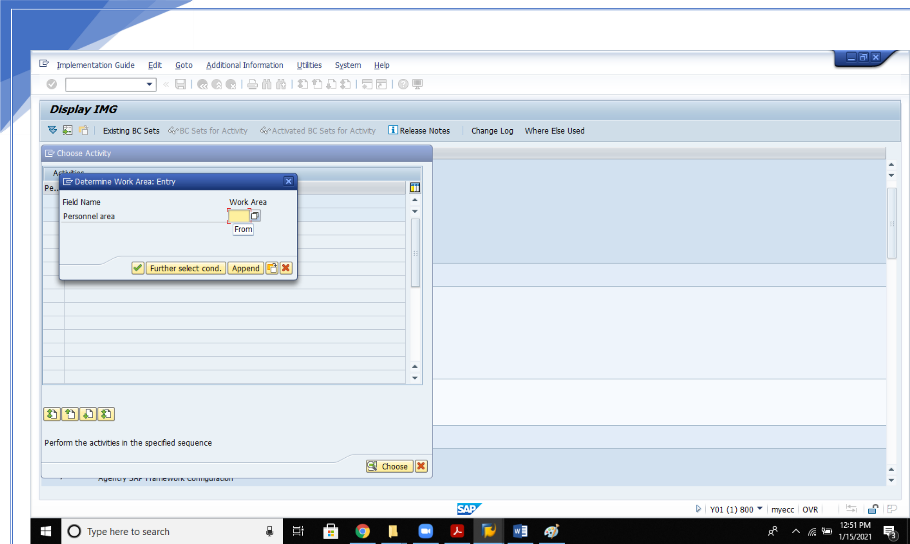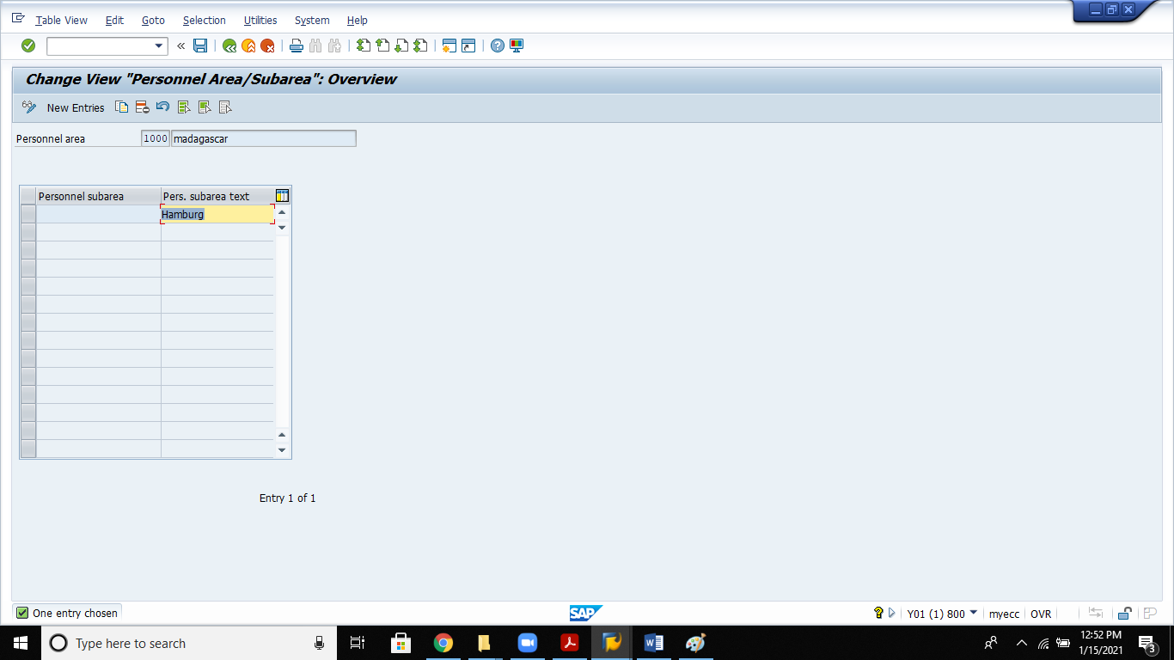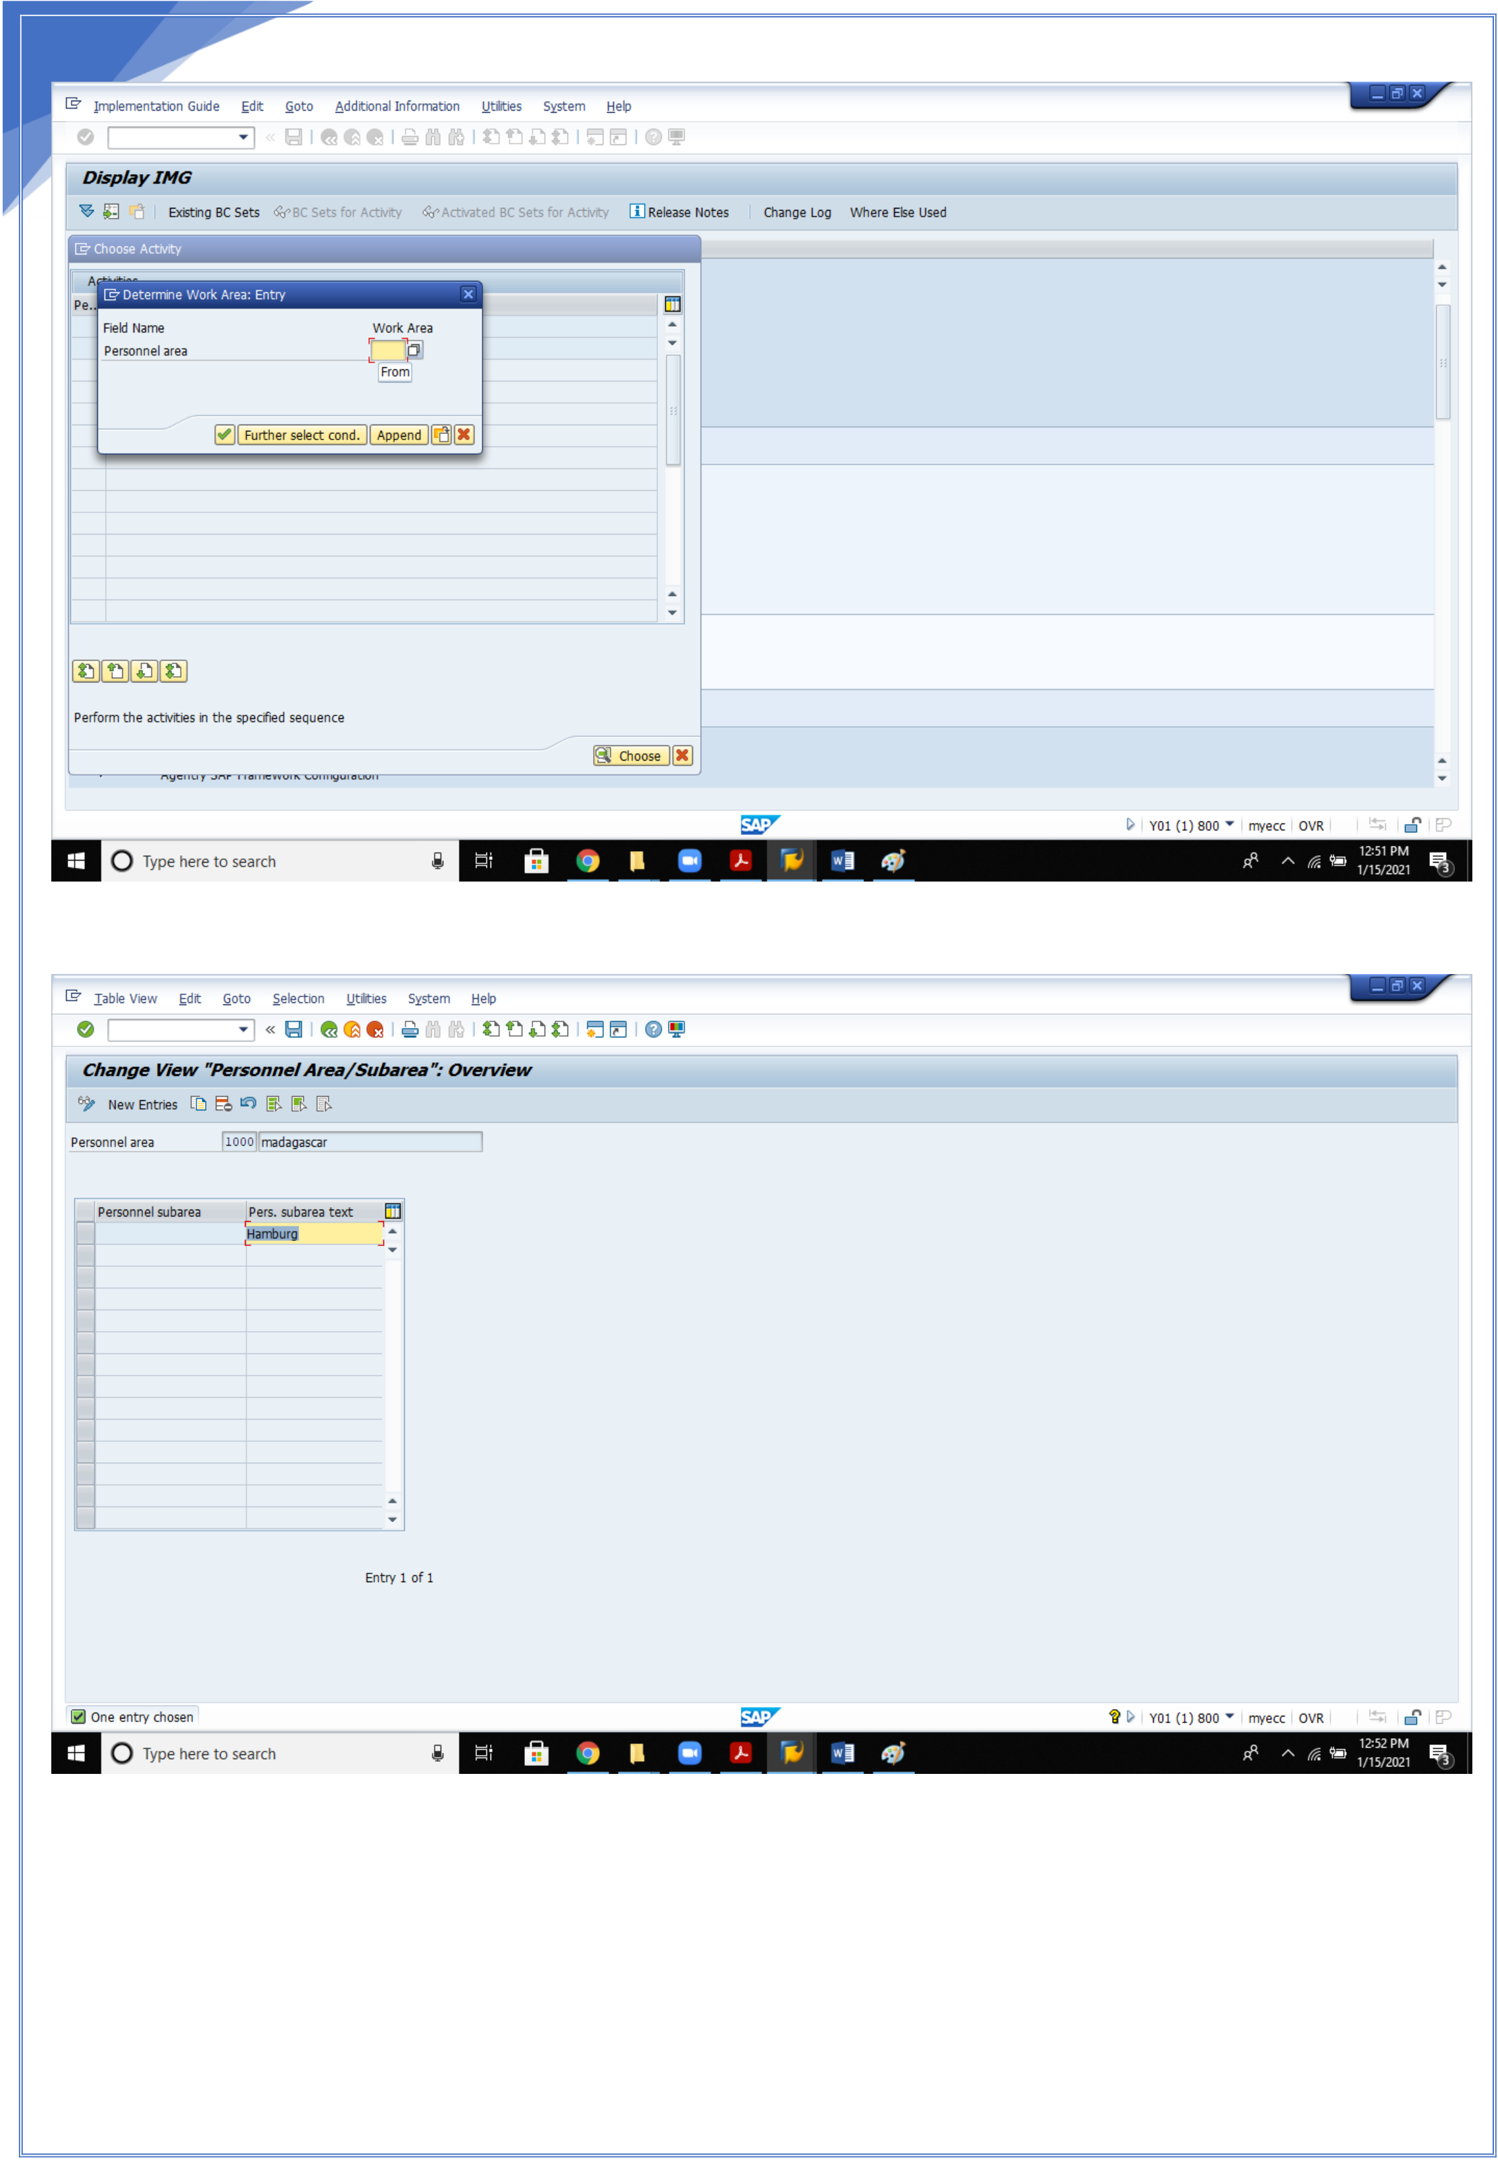

12

Update the personnel areas enter and save.

12

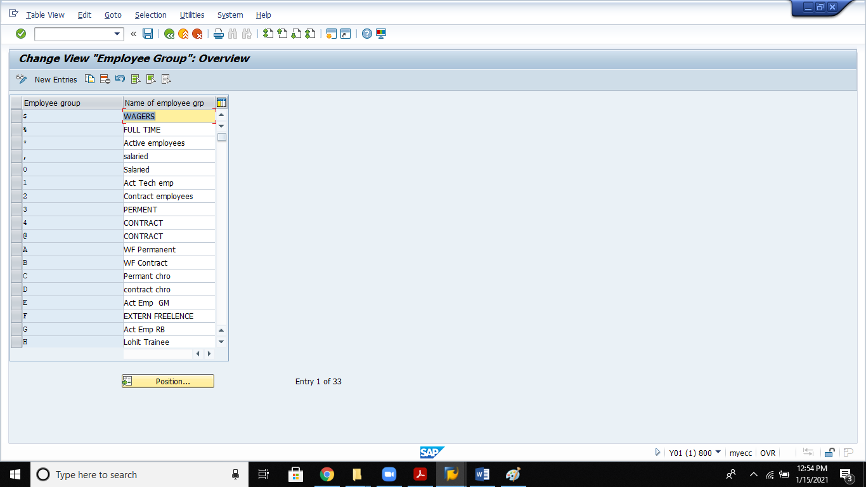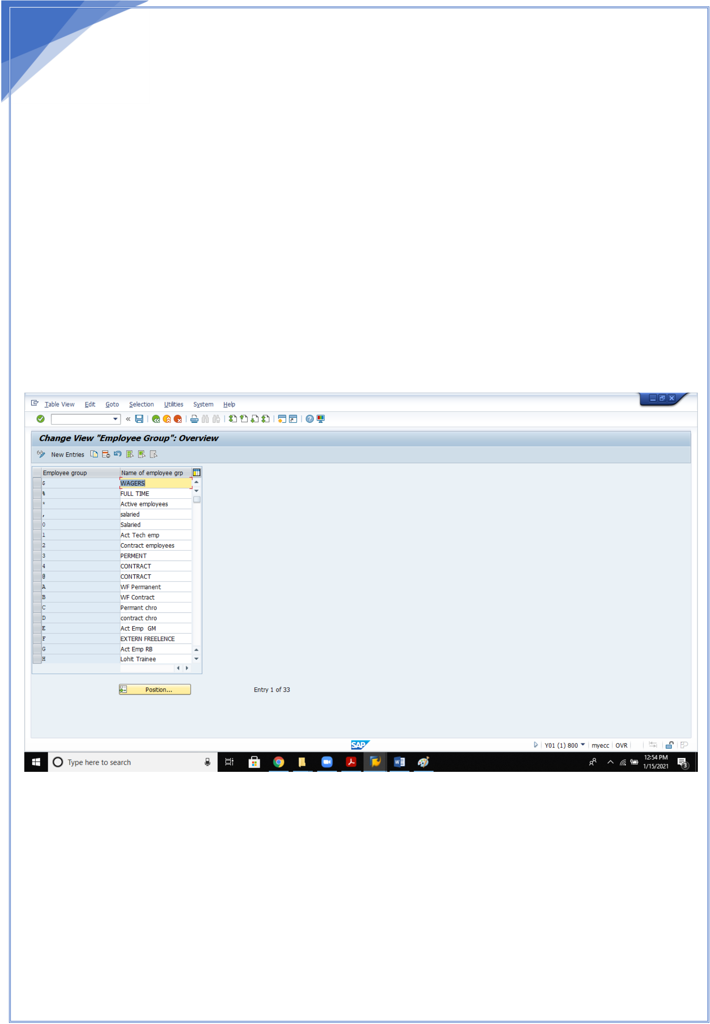

13   
 **5.Define Employee groups:**   
The employee group allows you to divide your employees into groups and allows you to define their relationship to the enterprise. The following essential organizational functions can be carried out using the employee group:   
 •generating default values when entering data; for example, for the payroll accounting area or for the basic pay of the employee   
 •generating a selection criterion for evaluations   
 •generating a unit for the authorization check   
Example   
You want to distinguish your employees between persons actively employed, pensioners and early retirees

13

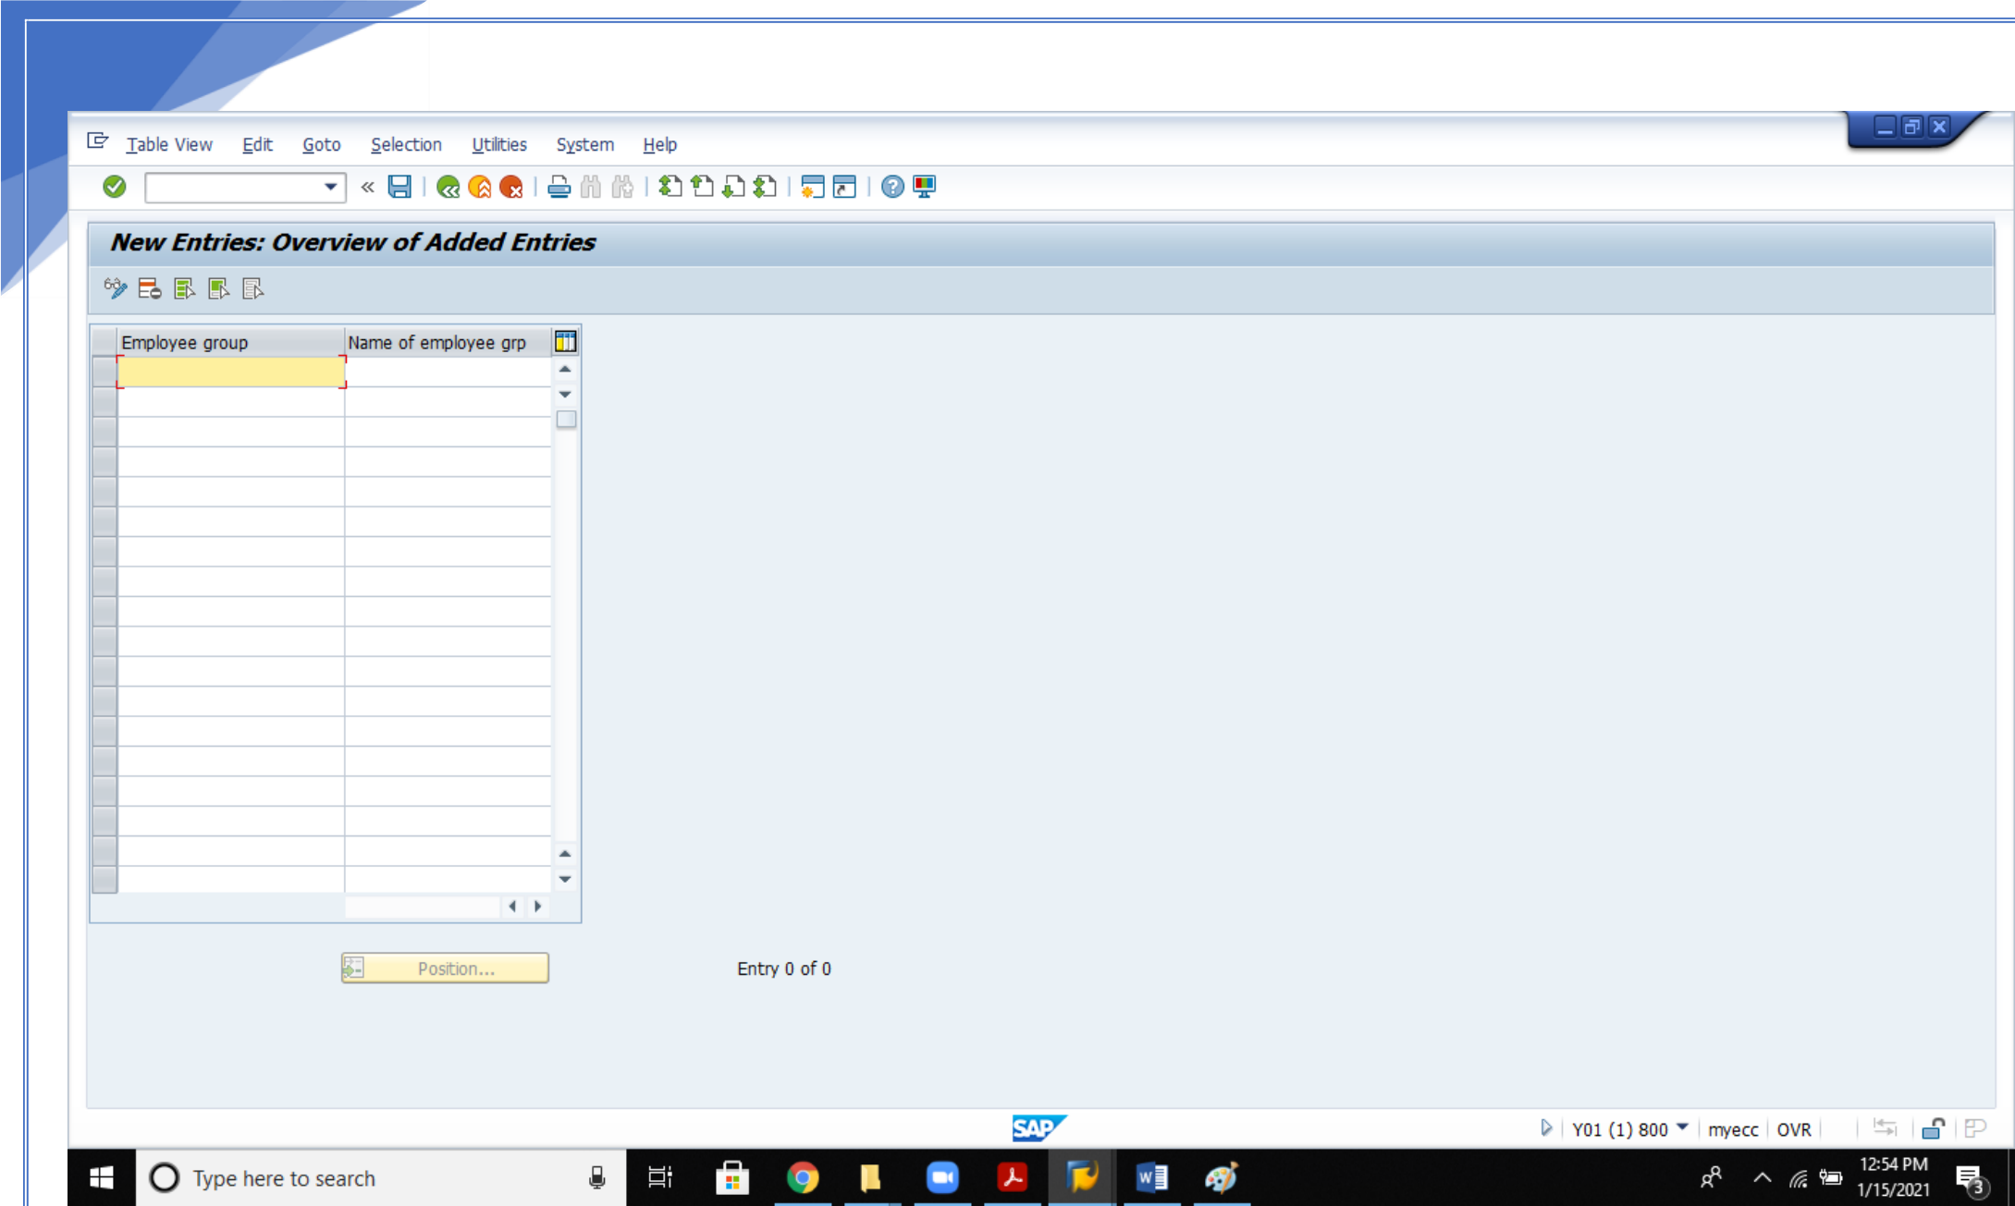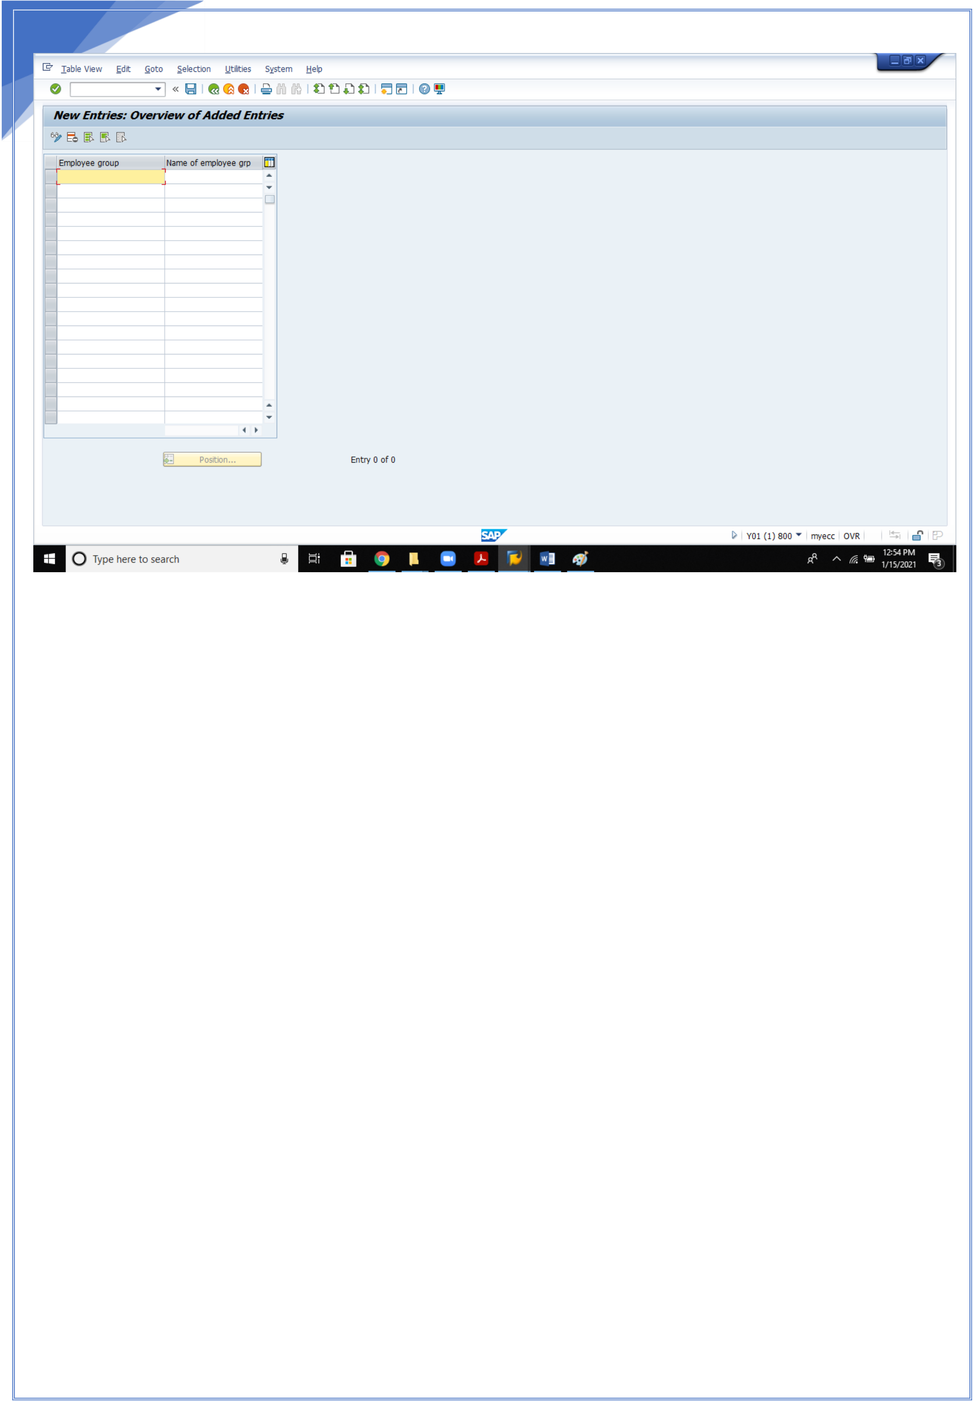

14

ENTER THE EMPLOYEE GROUP CODES AND DESCRIPTION, SAVE.

**6.Define Employee sub group:**   
The employee subgroup represents a subdivision of the employee group. When you define employee subgroups, you are essentially begun to set up your personnel structure. Features are allocated to this in later steps. These steps are dealt with at the spot where they are established in a business sense.

The following business subtasks are provided among other things: •specification of processing in payroll accounting   
•specification of validity of primary wage types   
•specification of validity of work schedules   
•specification of validity of pay scale groups   
•specification of validity of time quota types

14

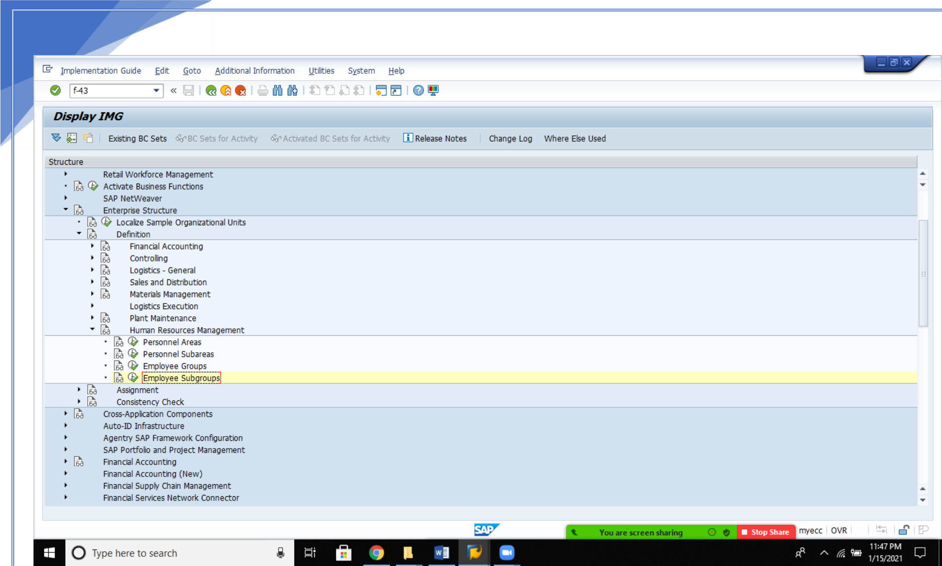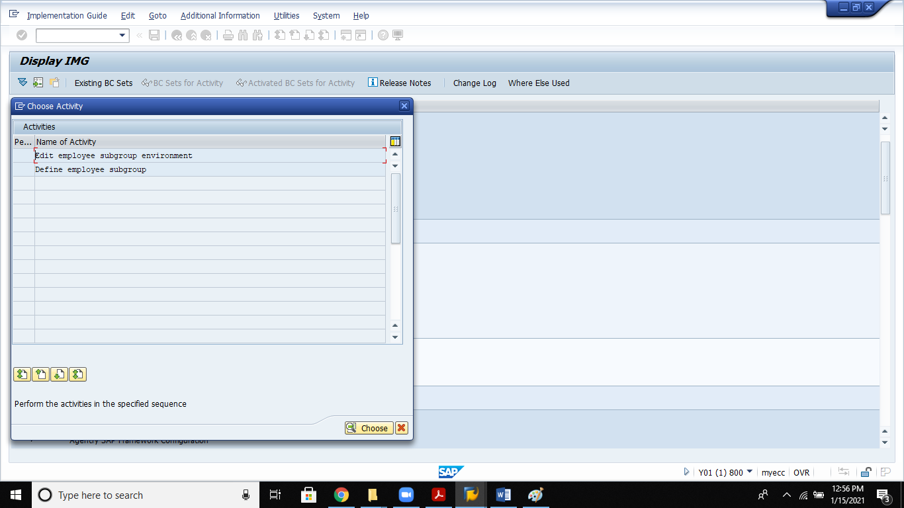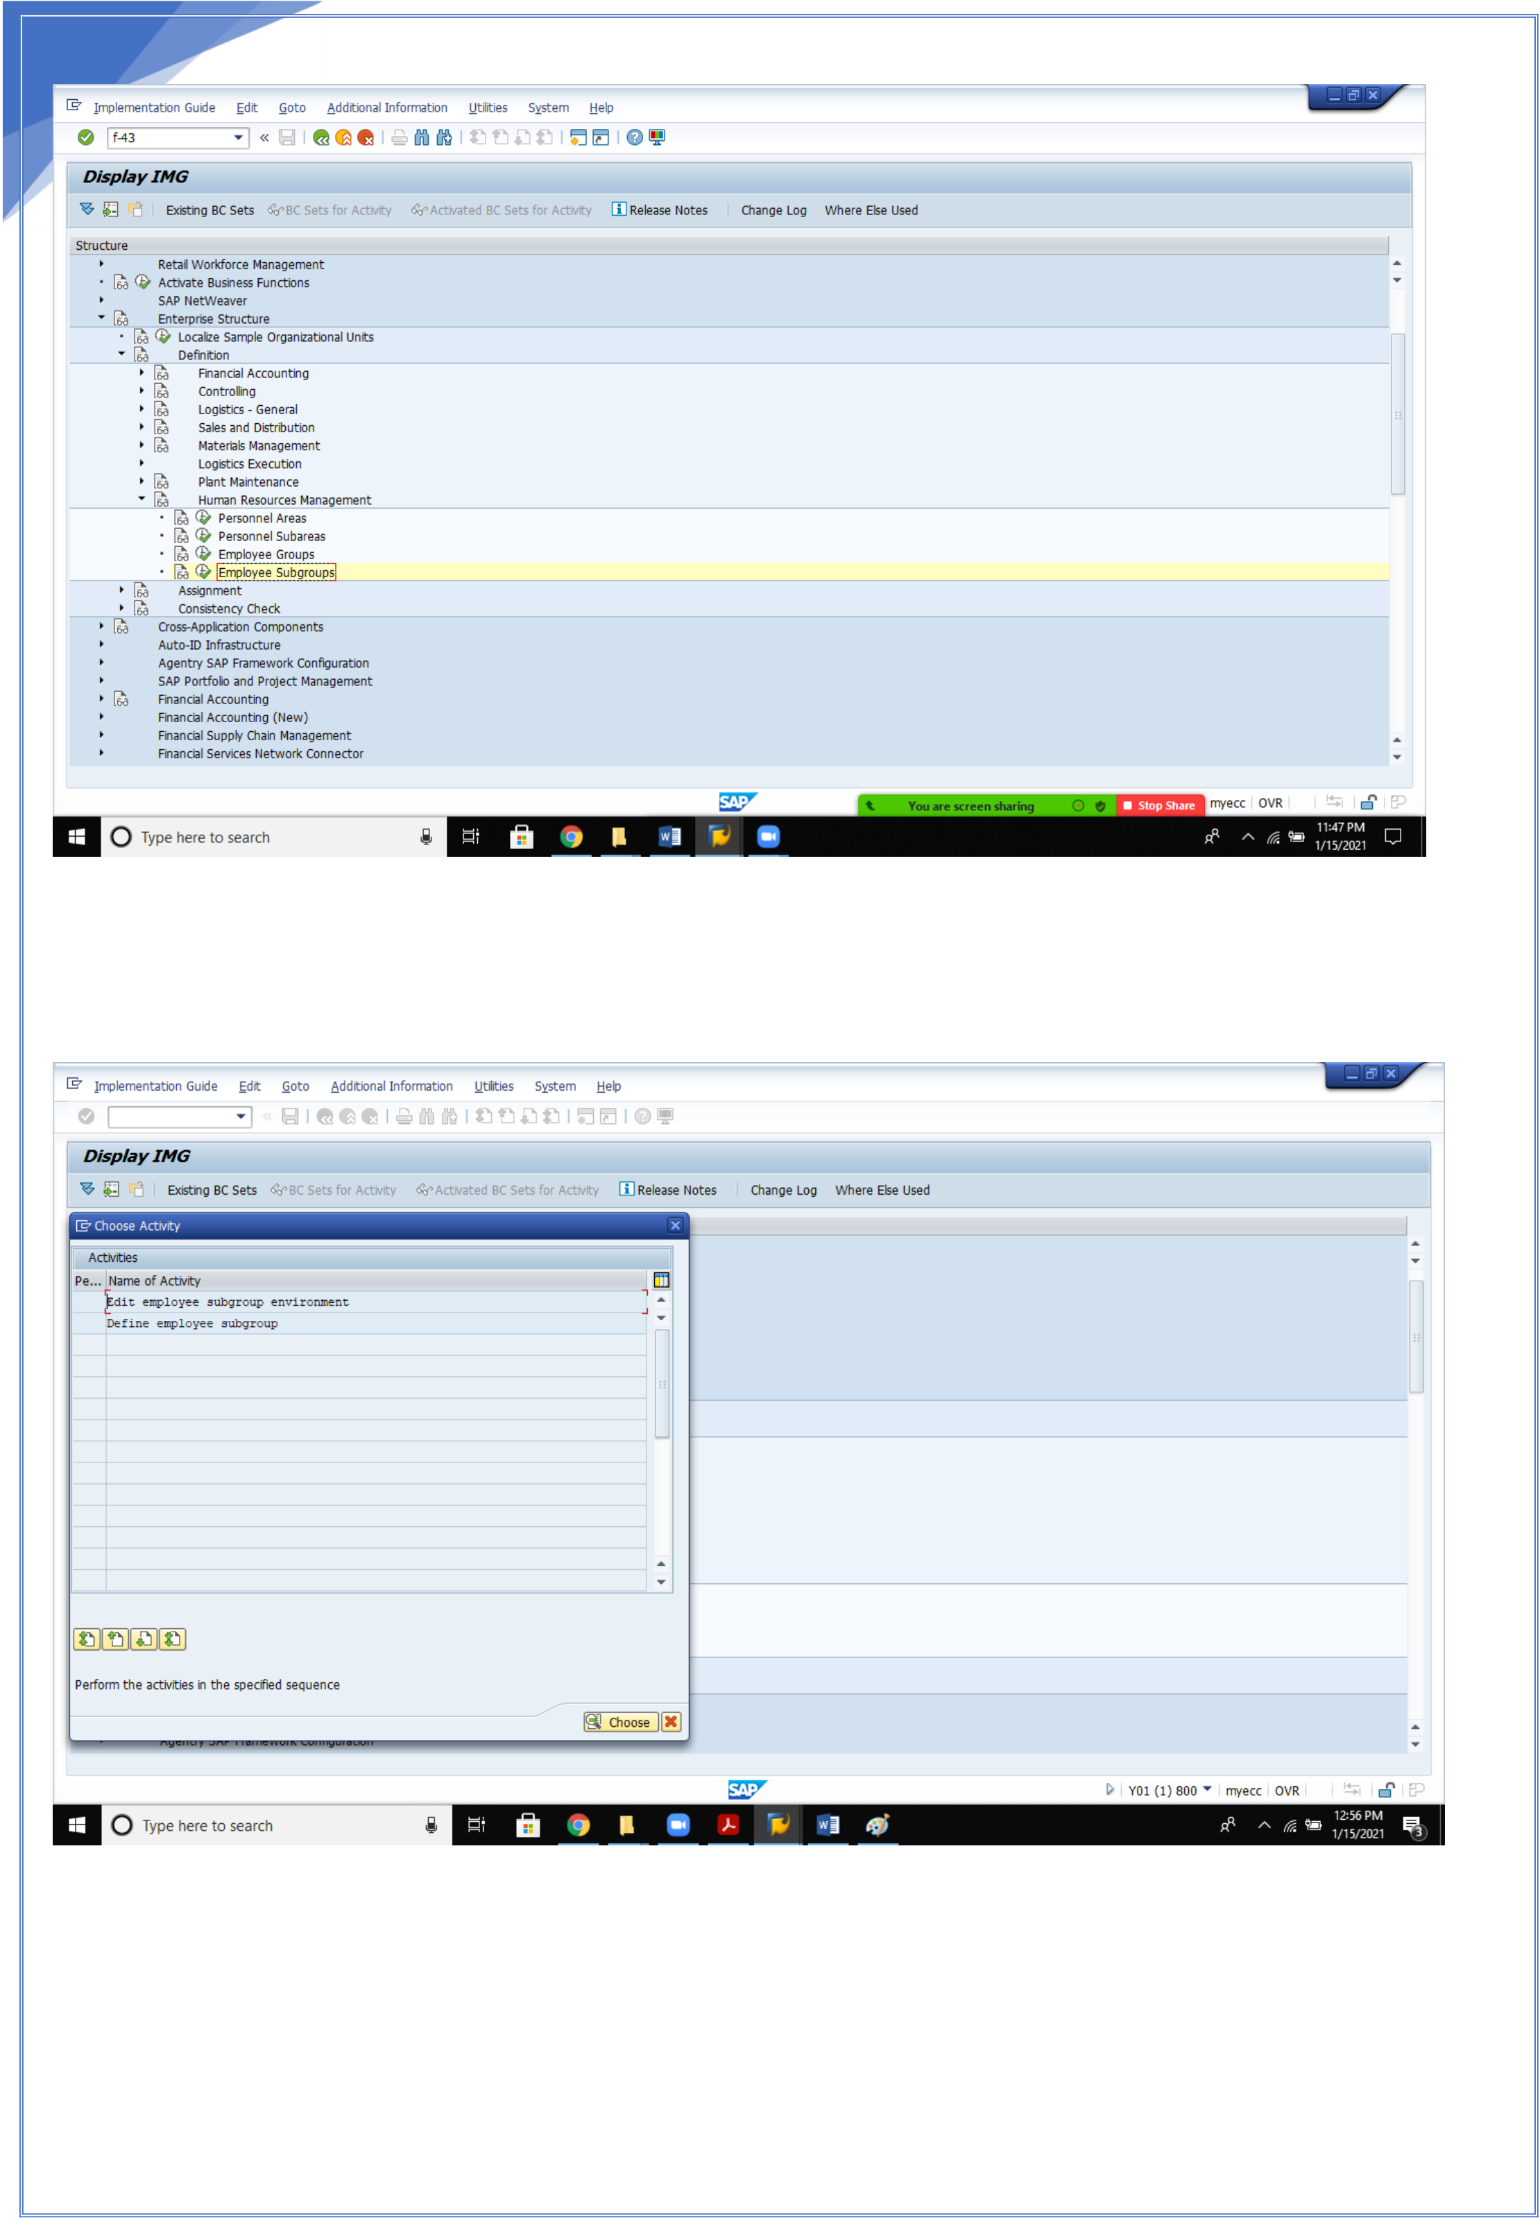

15

15

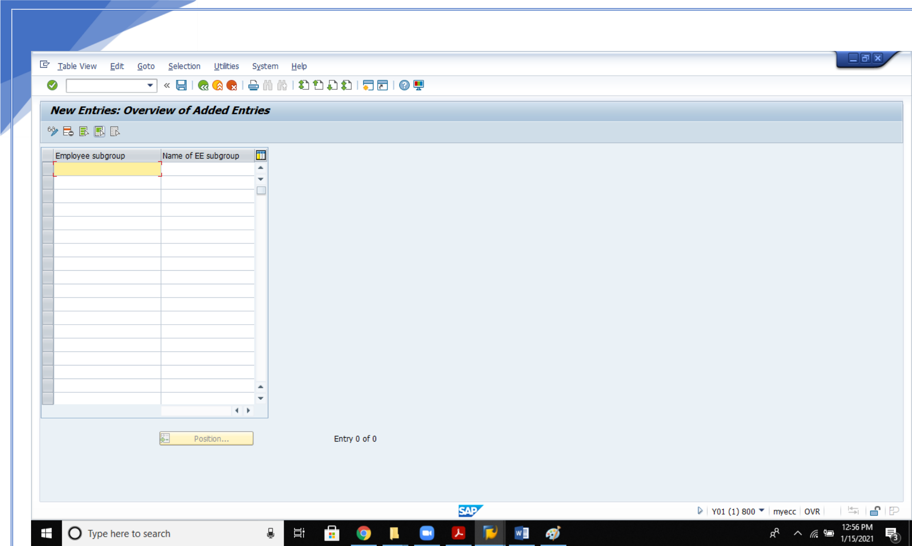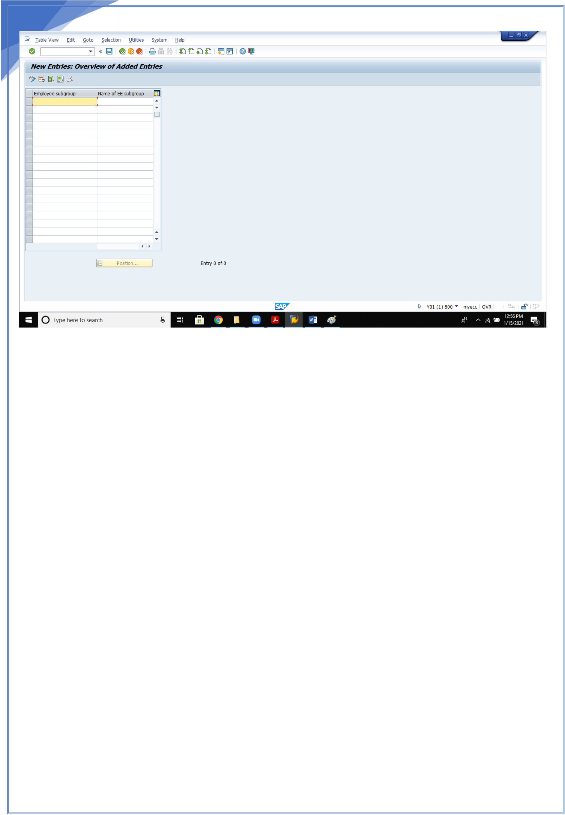

16

Enter the sub group codes, enter and save.

16

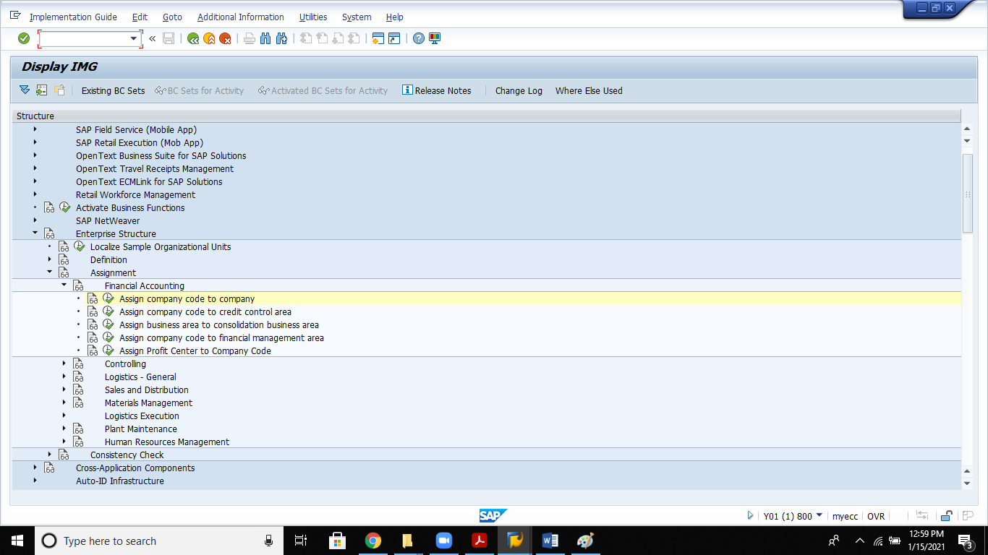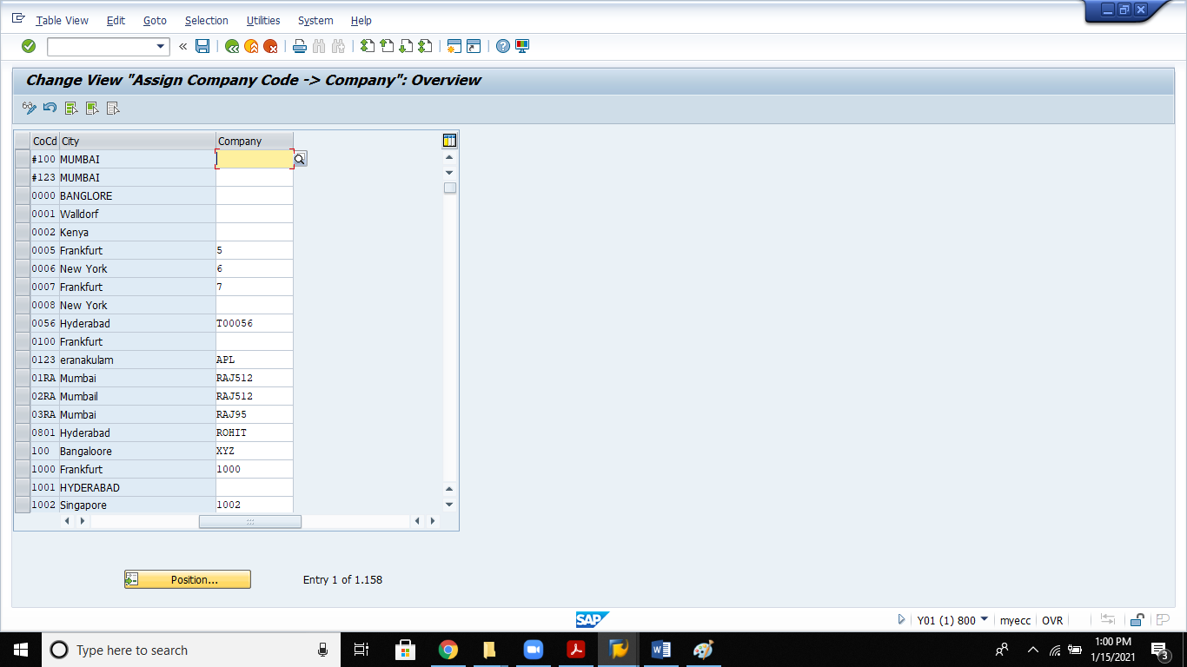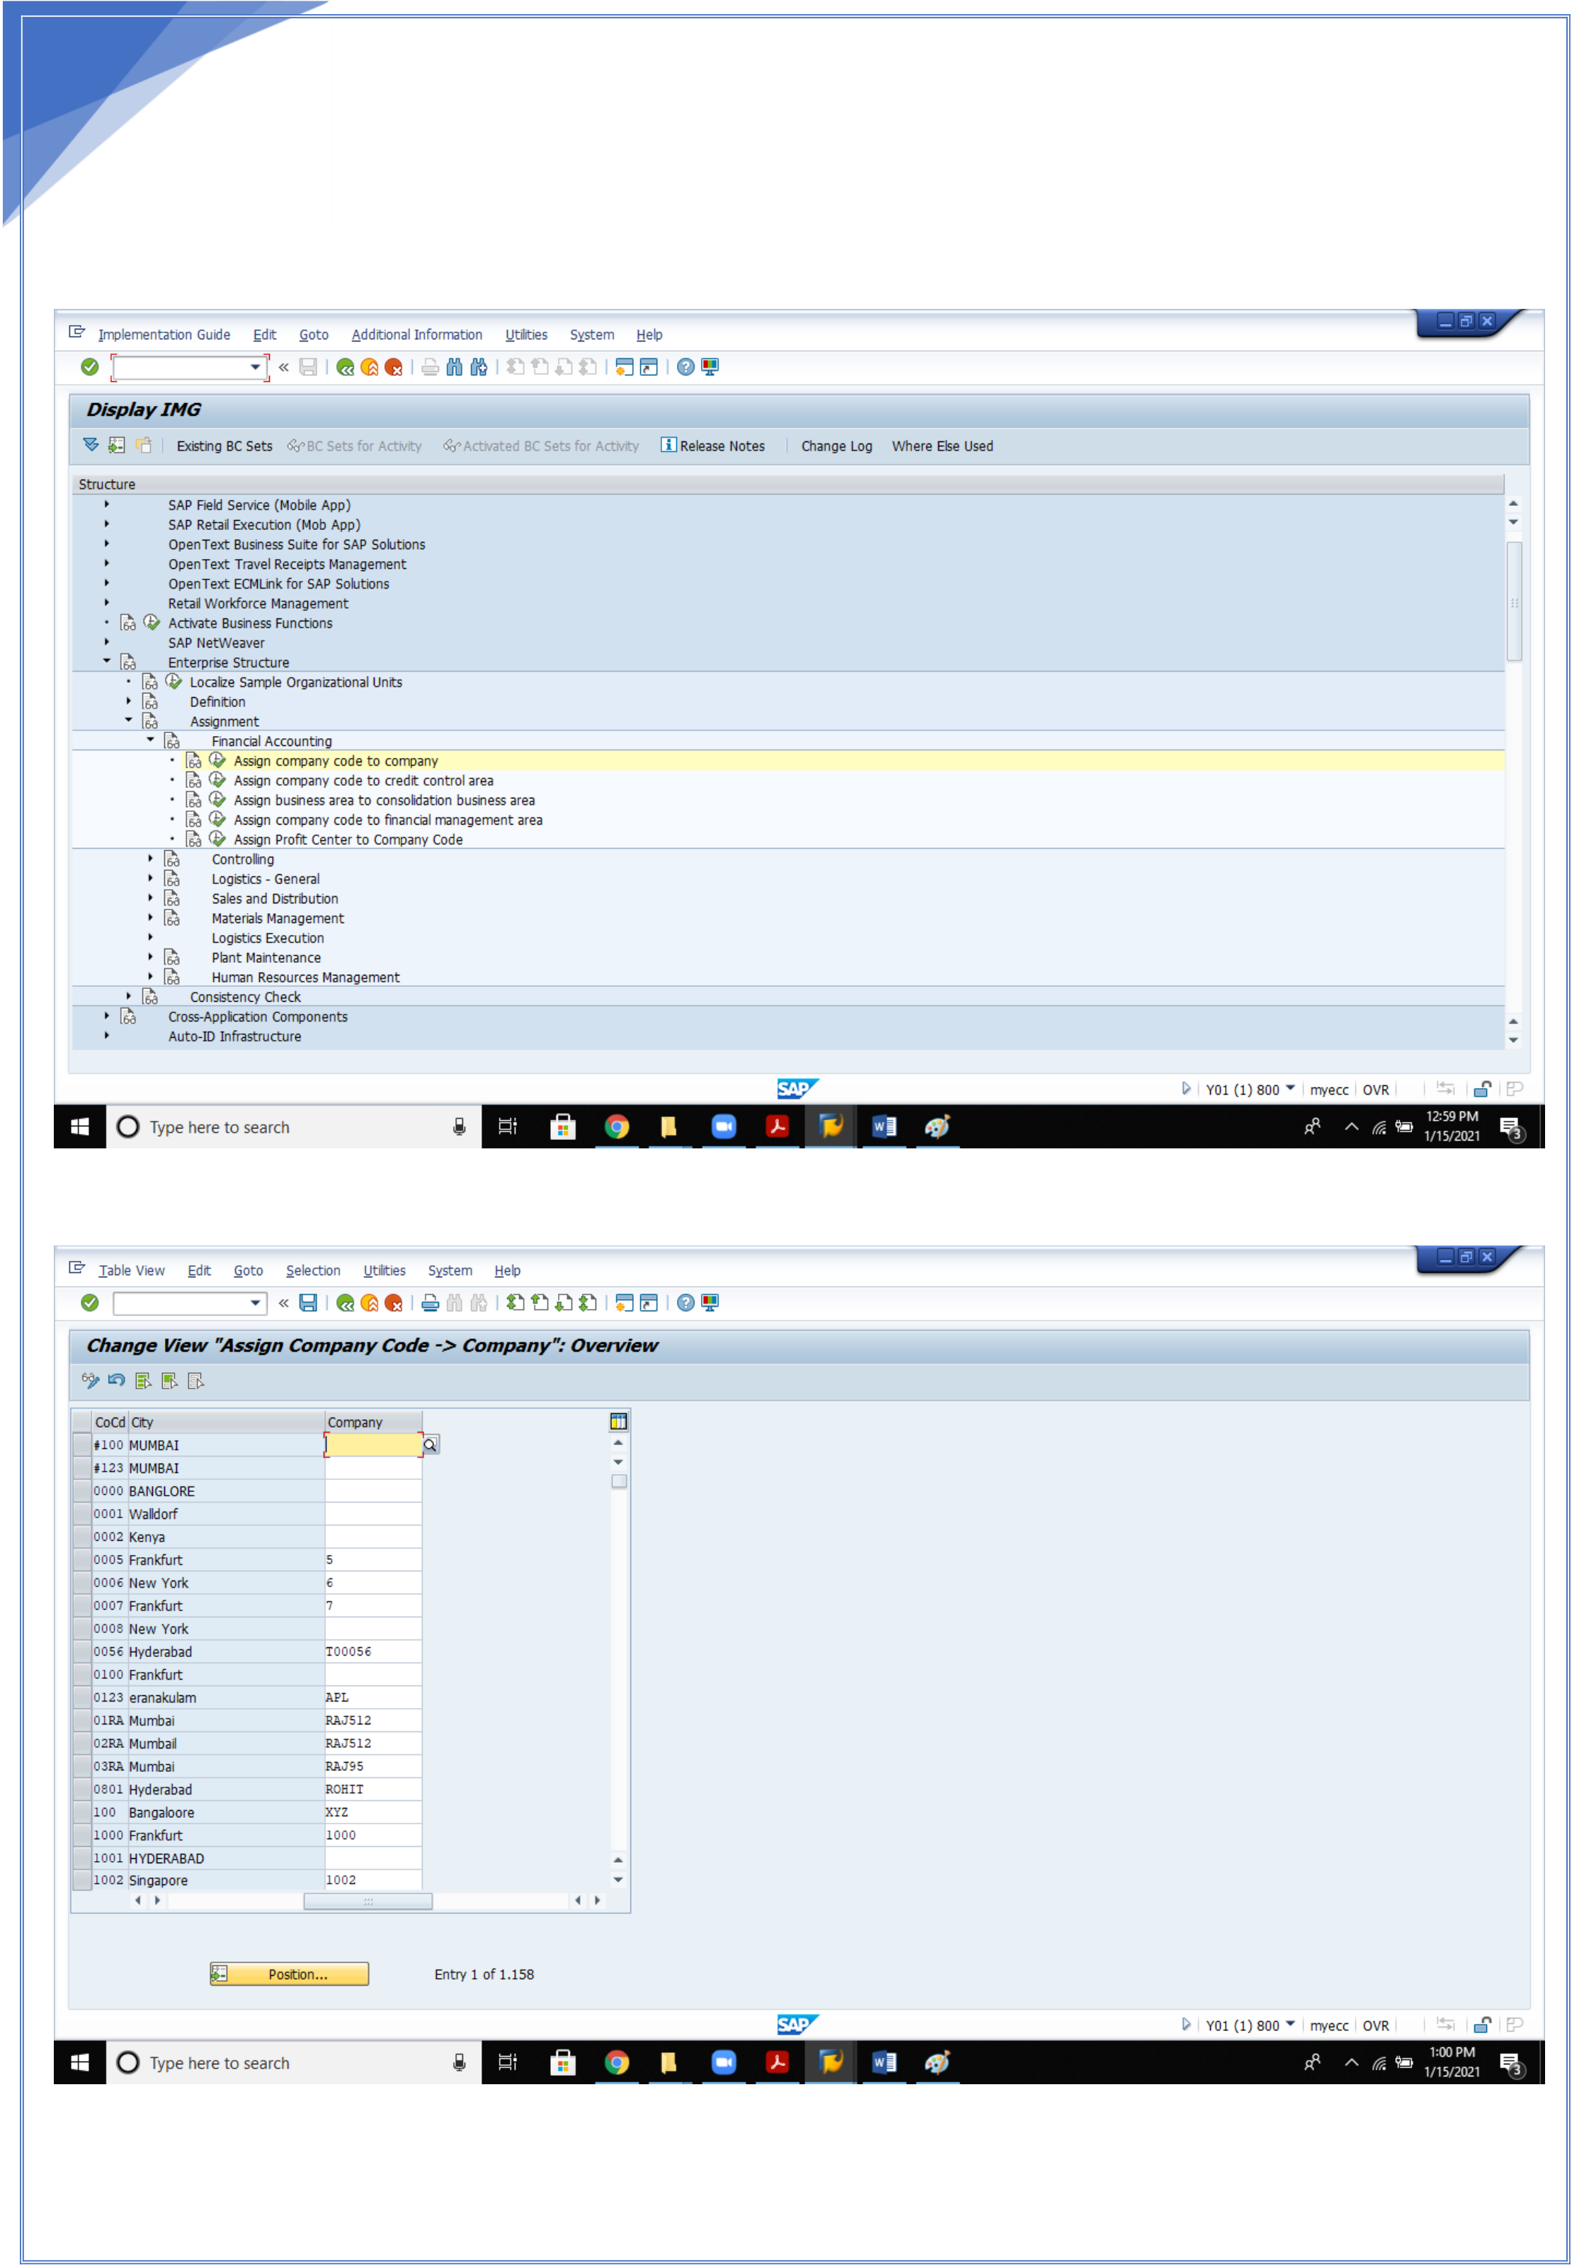

17   
 **ASSIGNEMENTS: 1.Assign Company code to company**

17

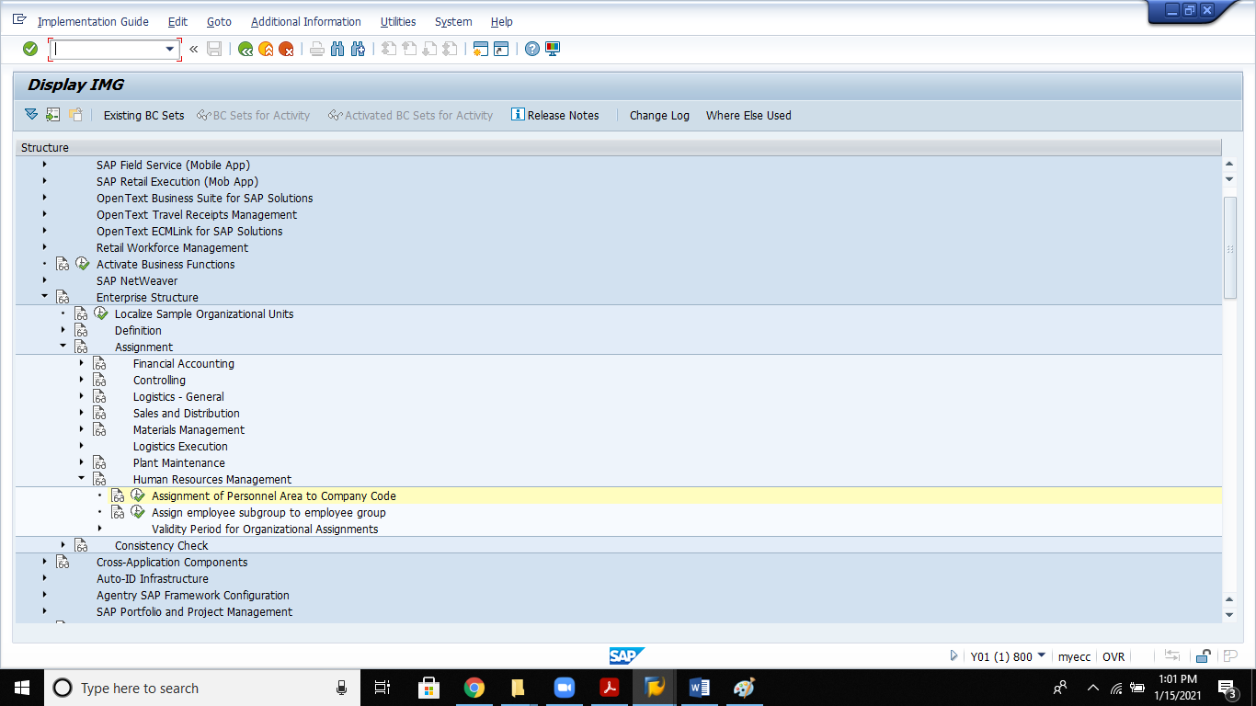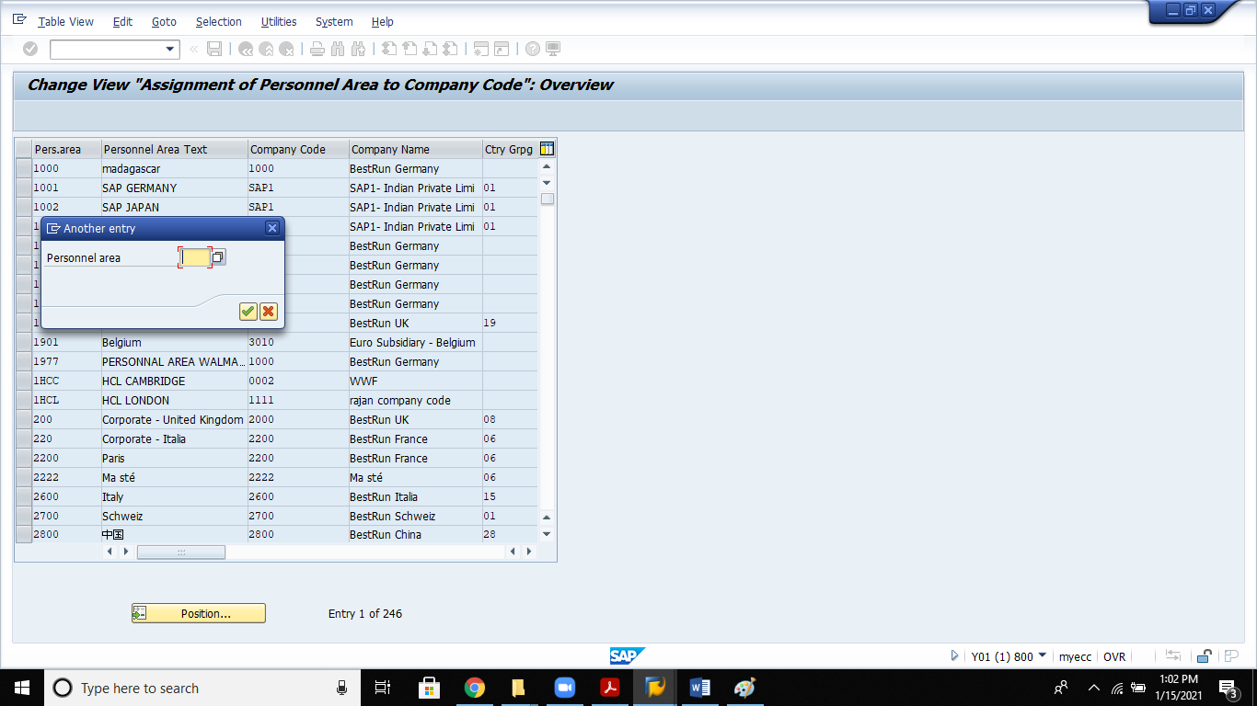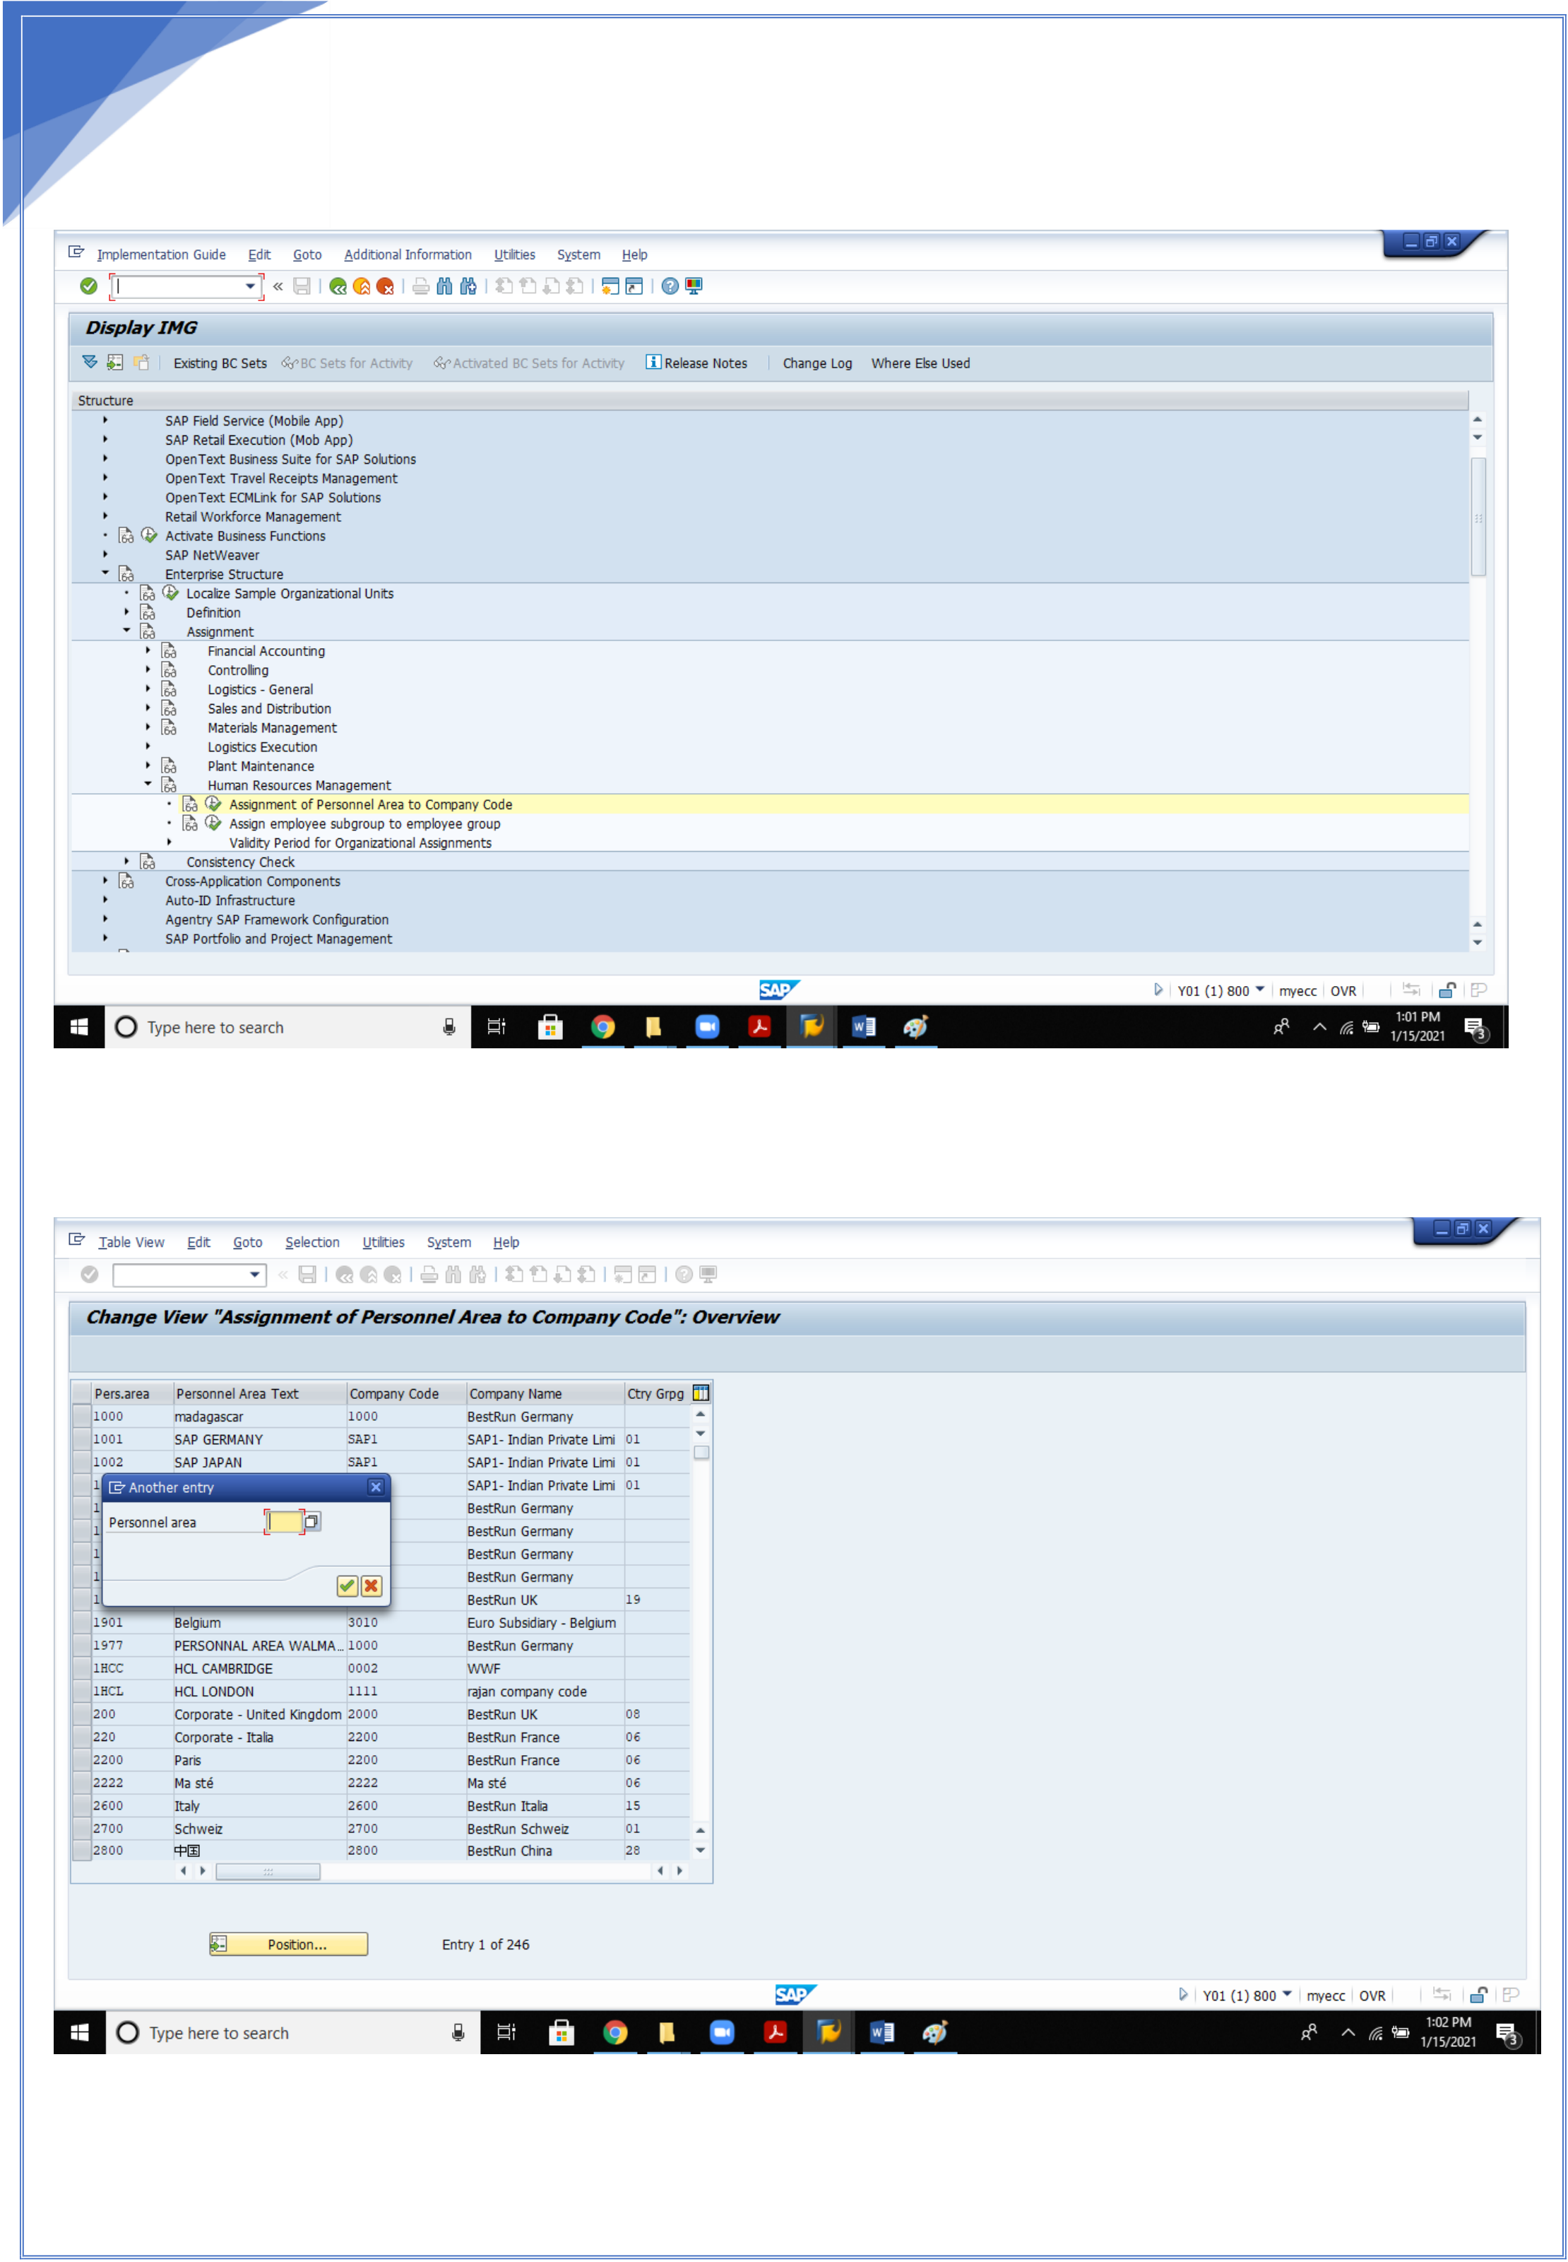

18

2. Assignment of personnel area to company code

18

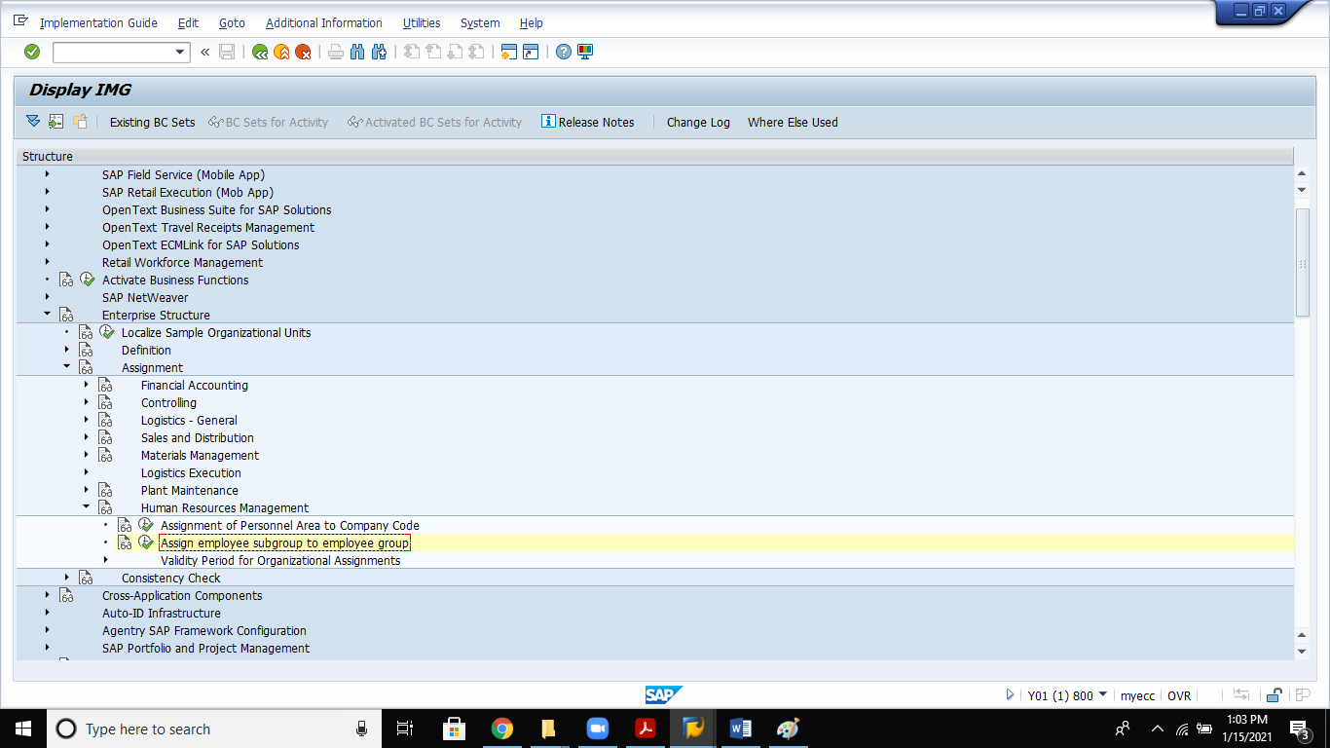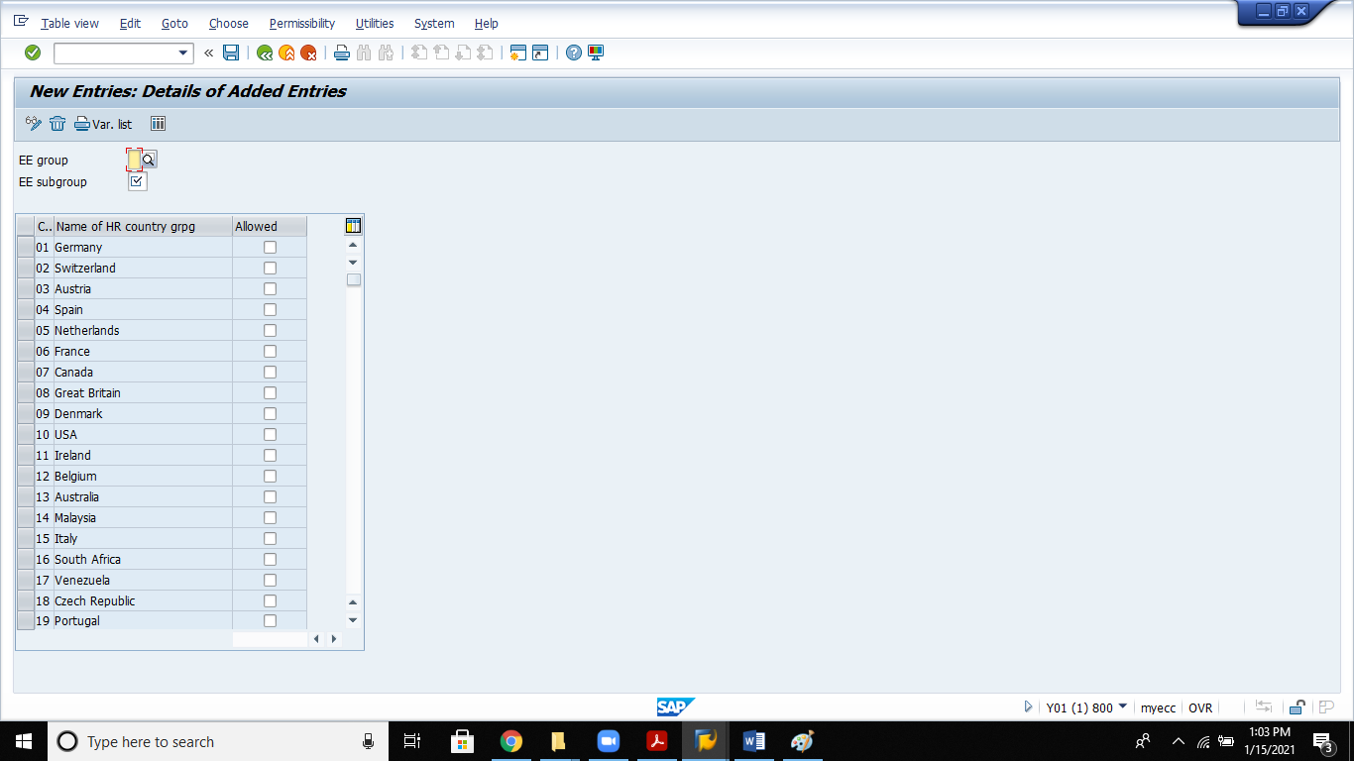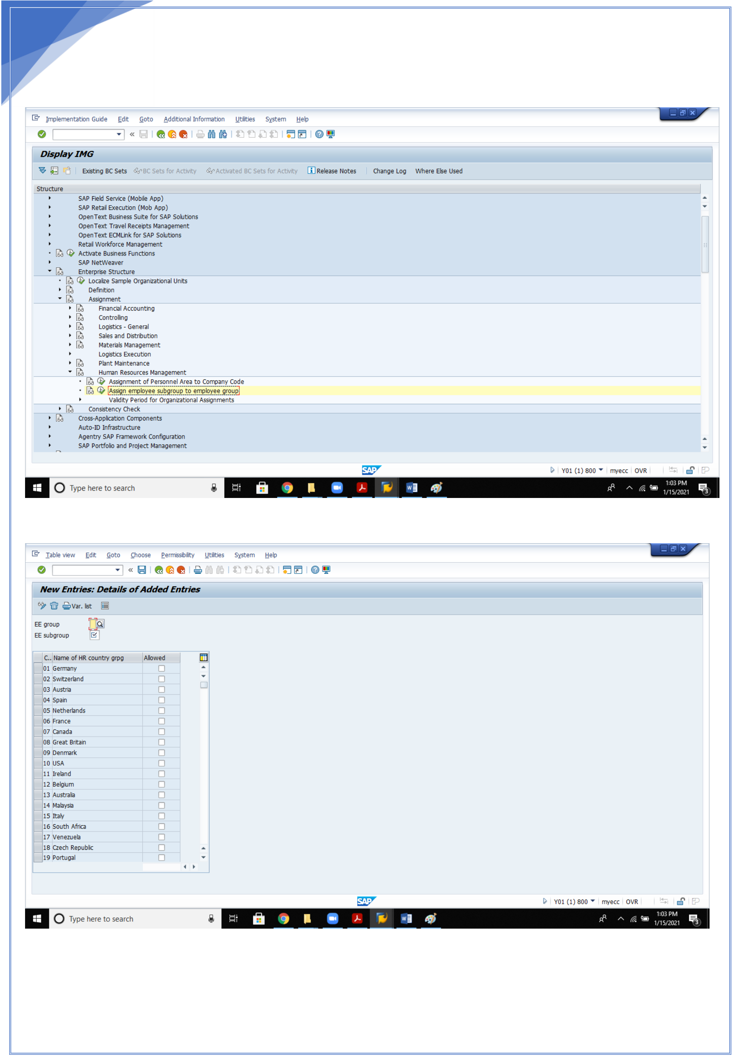

19

3. **Assignement of Employee group to Employee subgroup:**

Enter and save.

19

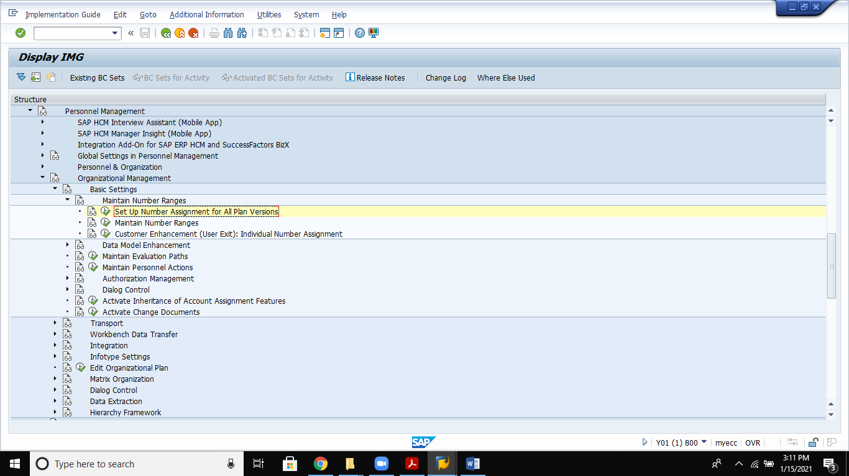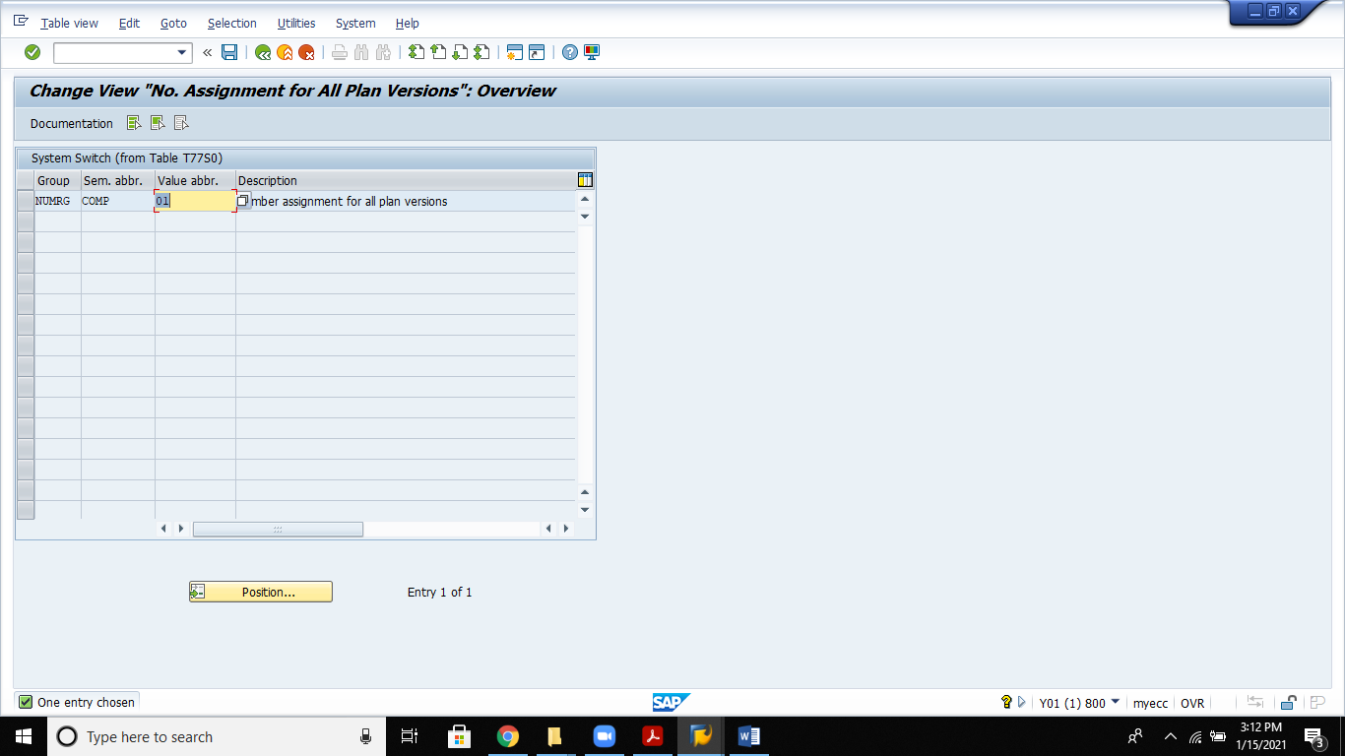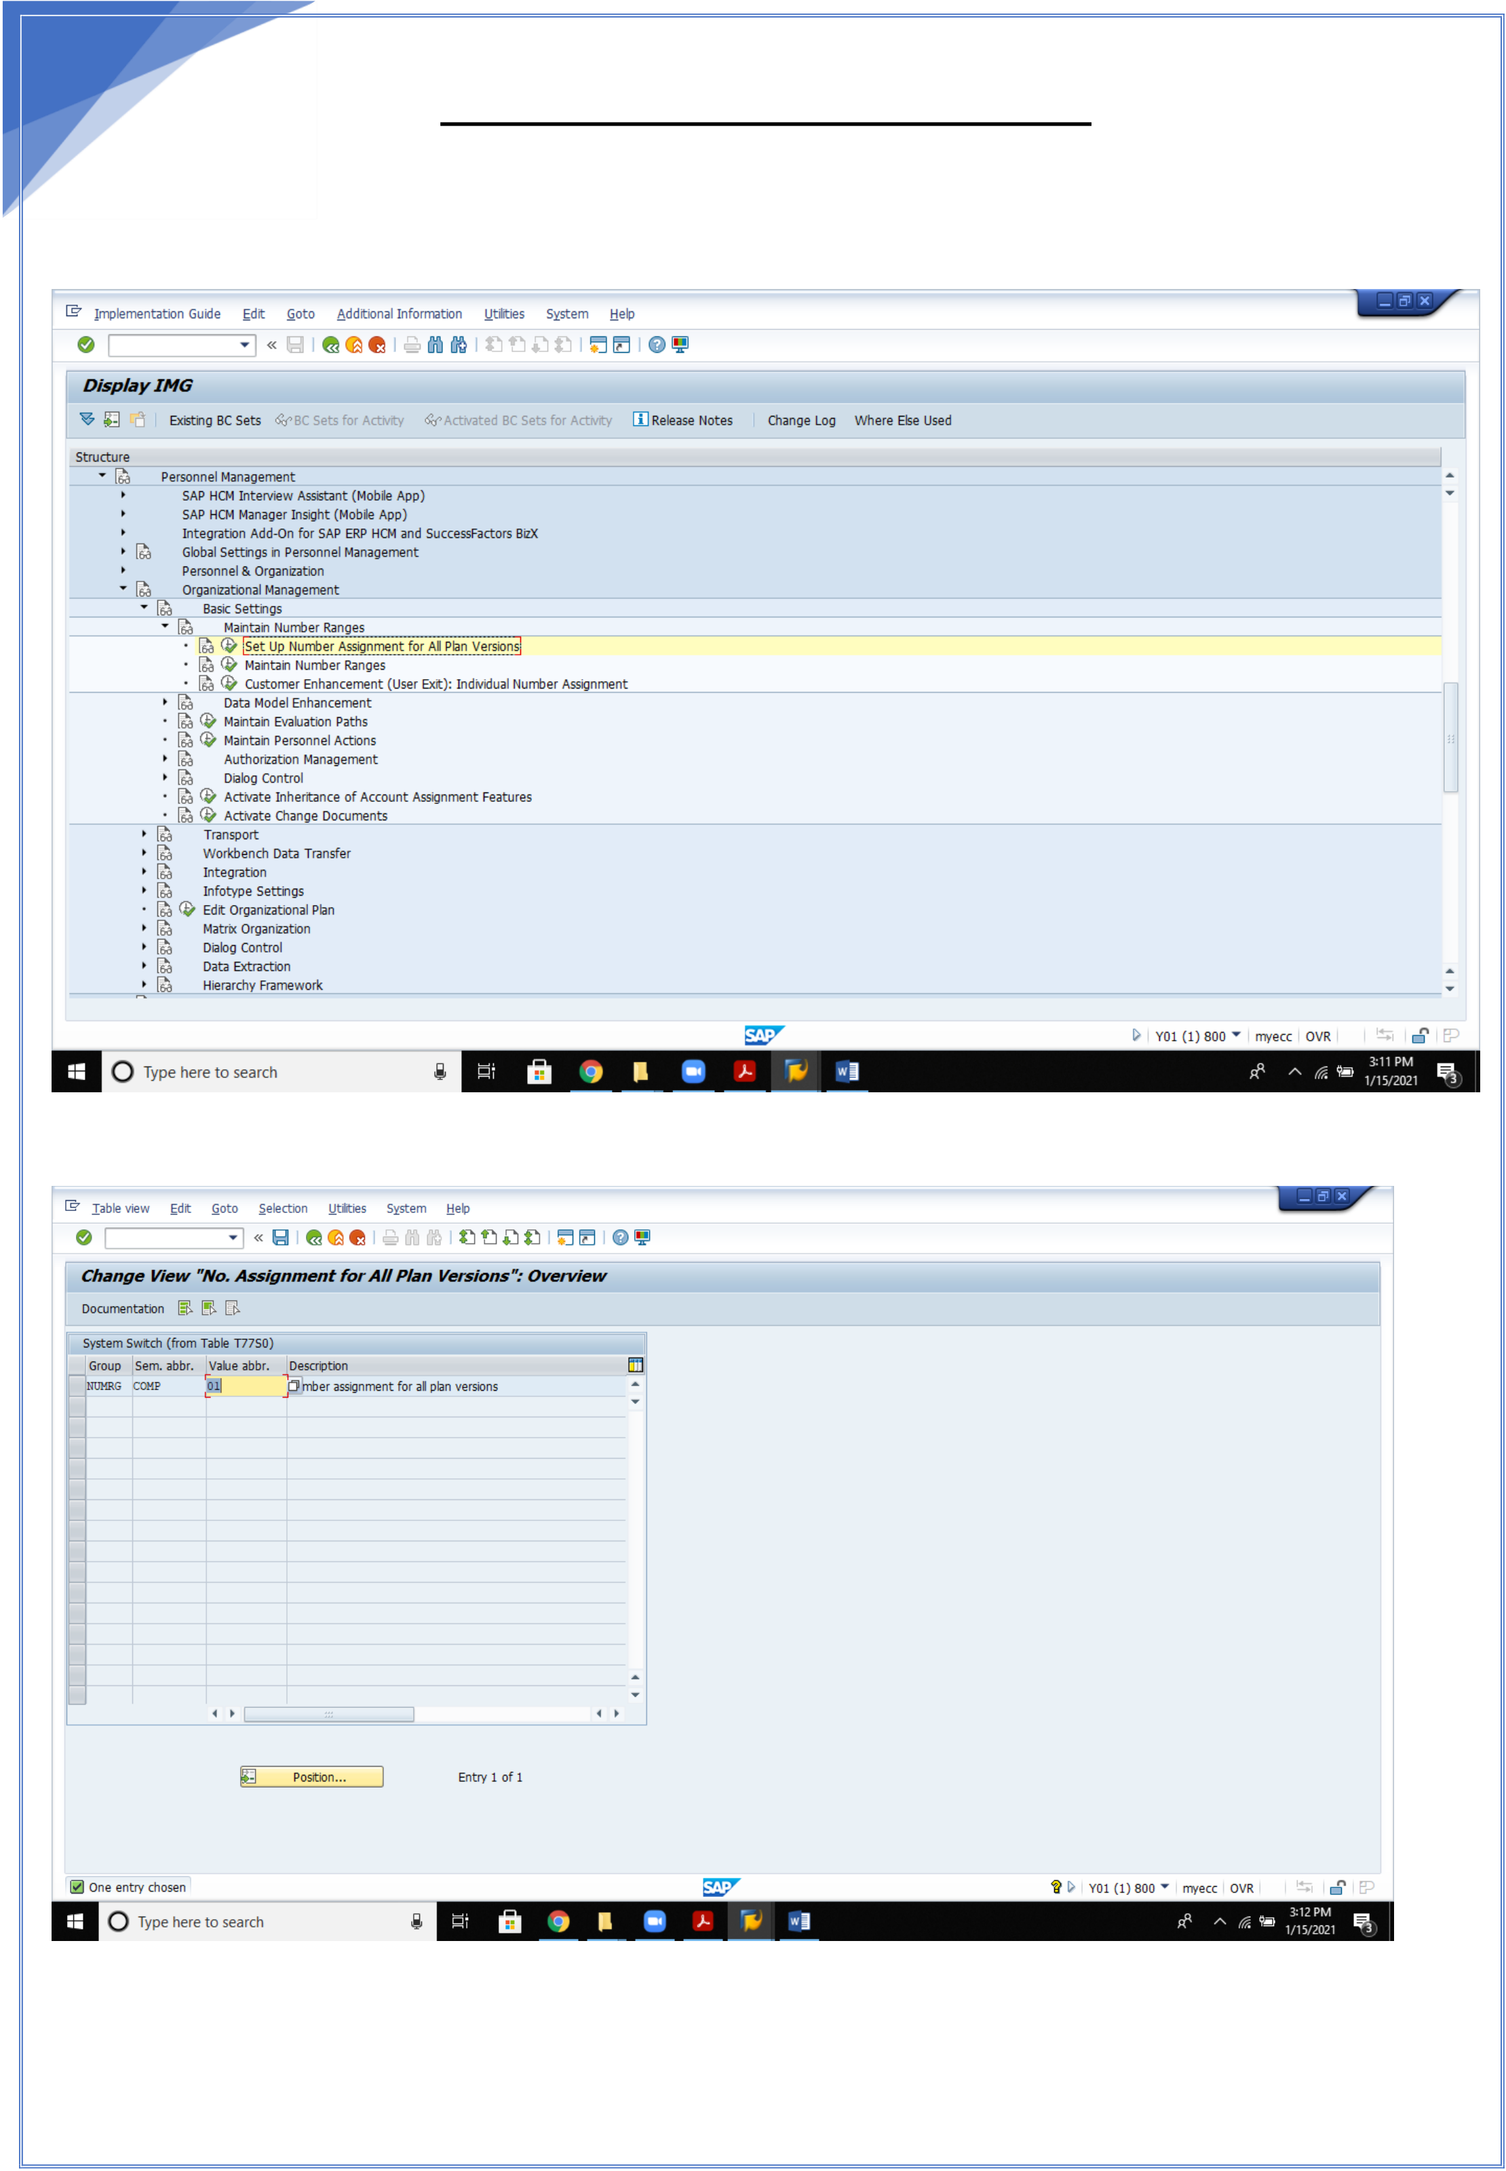

20   
 **ORGANISATIONAL MANAGEMENT**

1.**Set up number assignment for all plan versions**

See that value abbreviation as 01

20

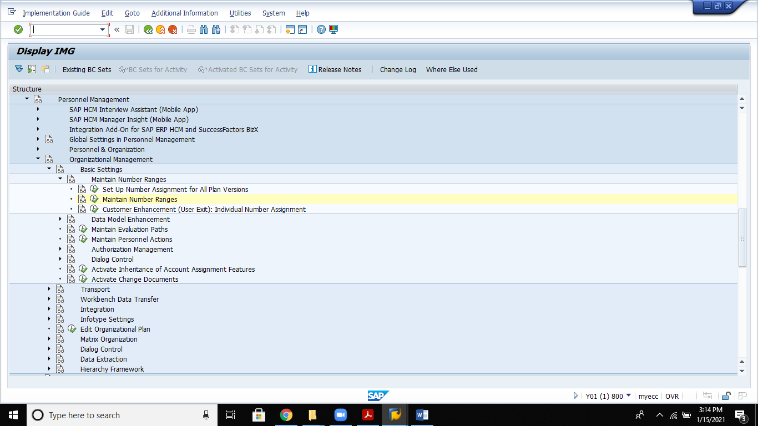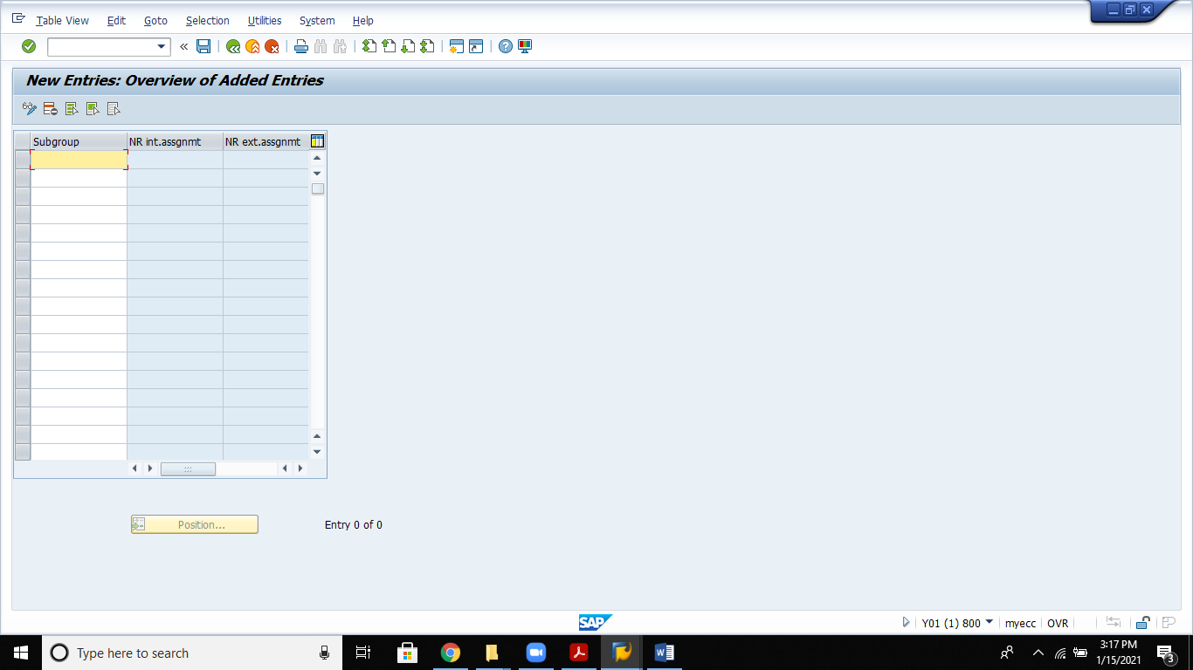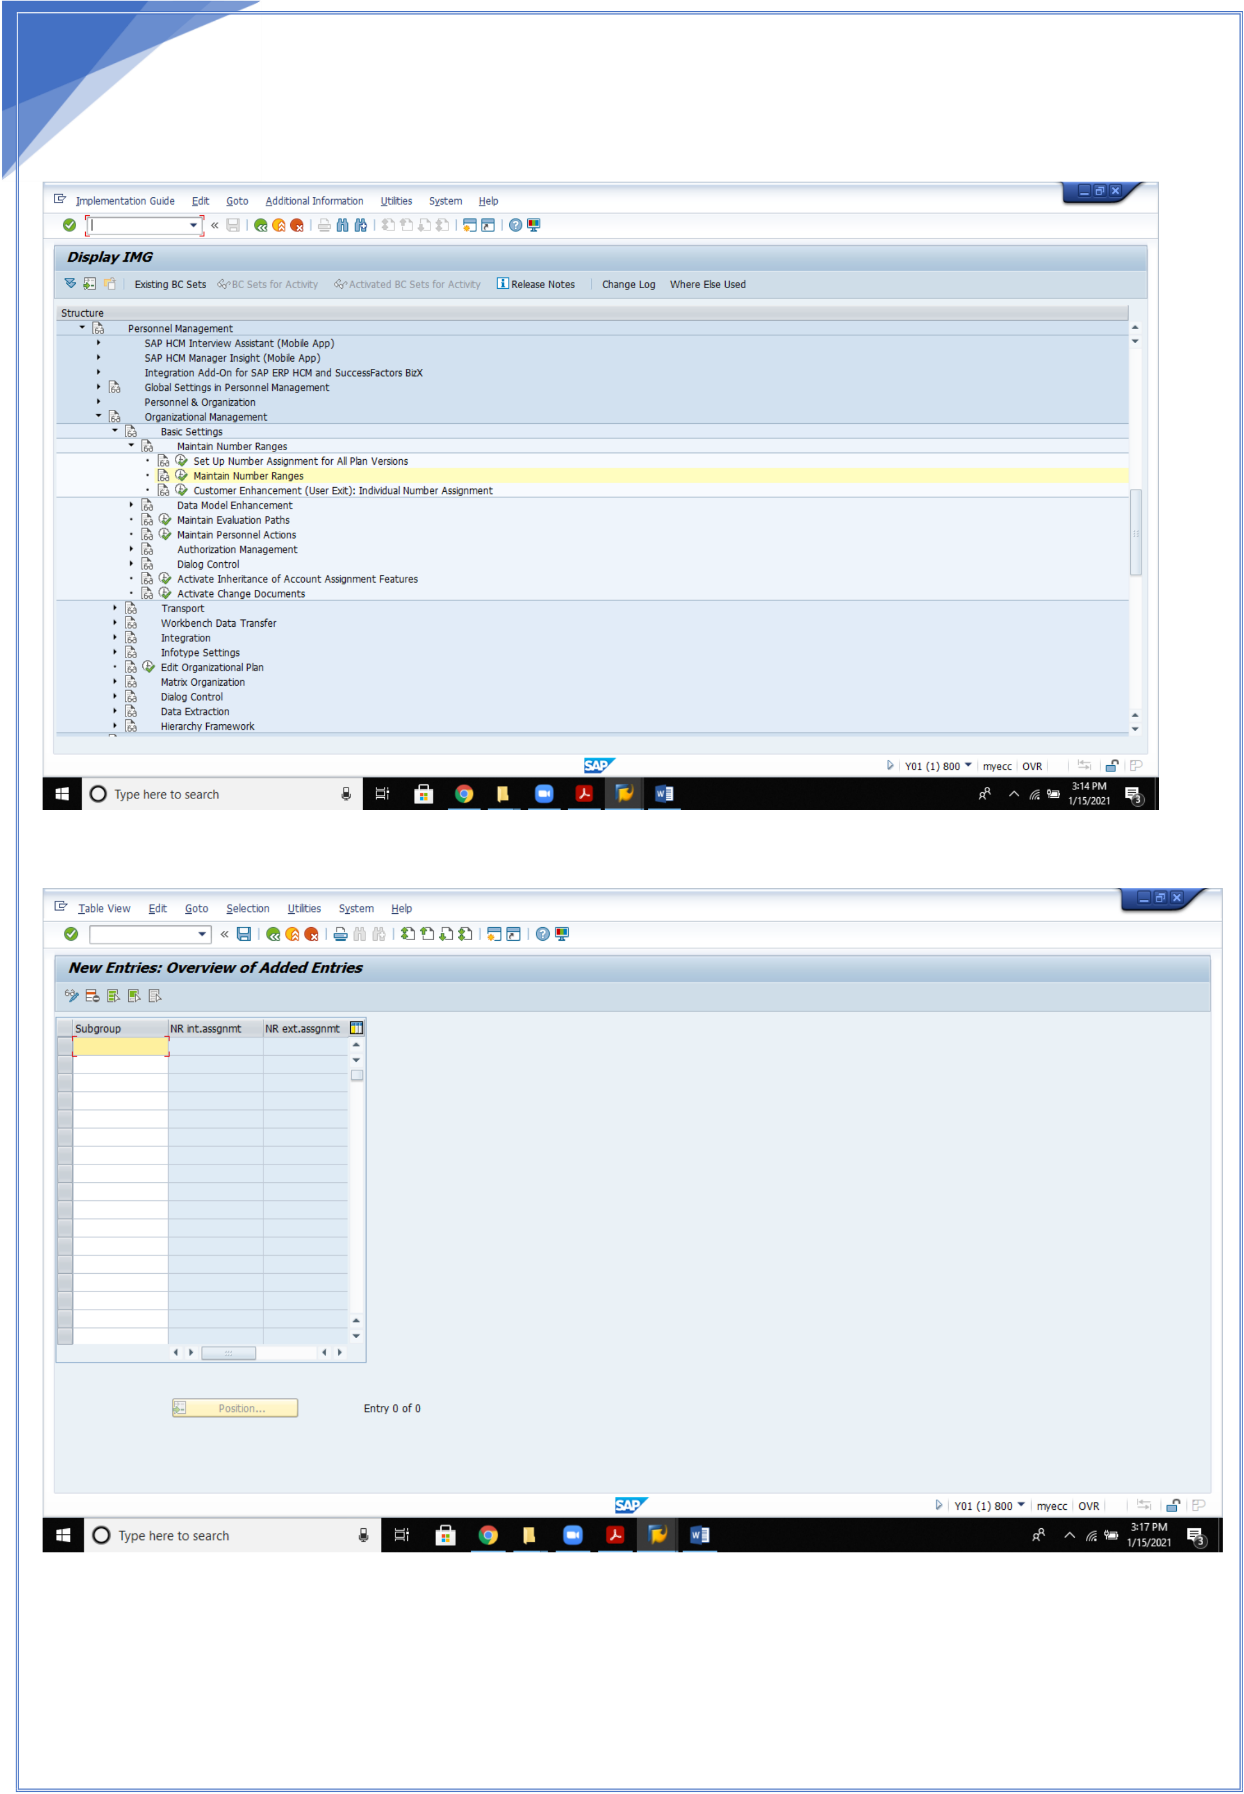

21   
 Enter and save.

2. **Maintain number ranges**

21

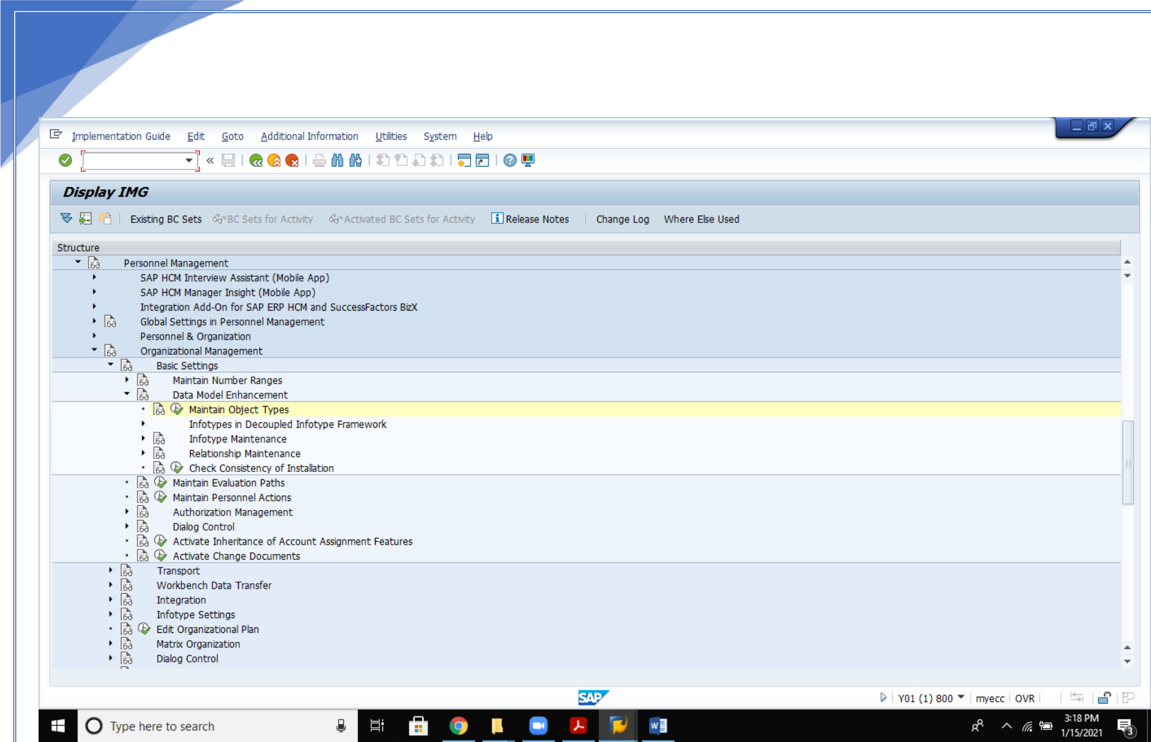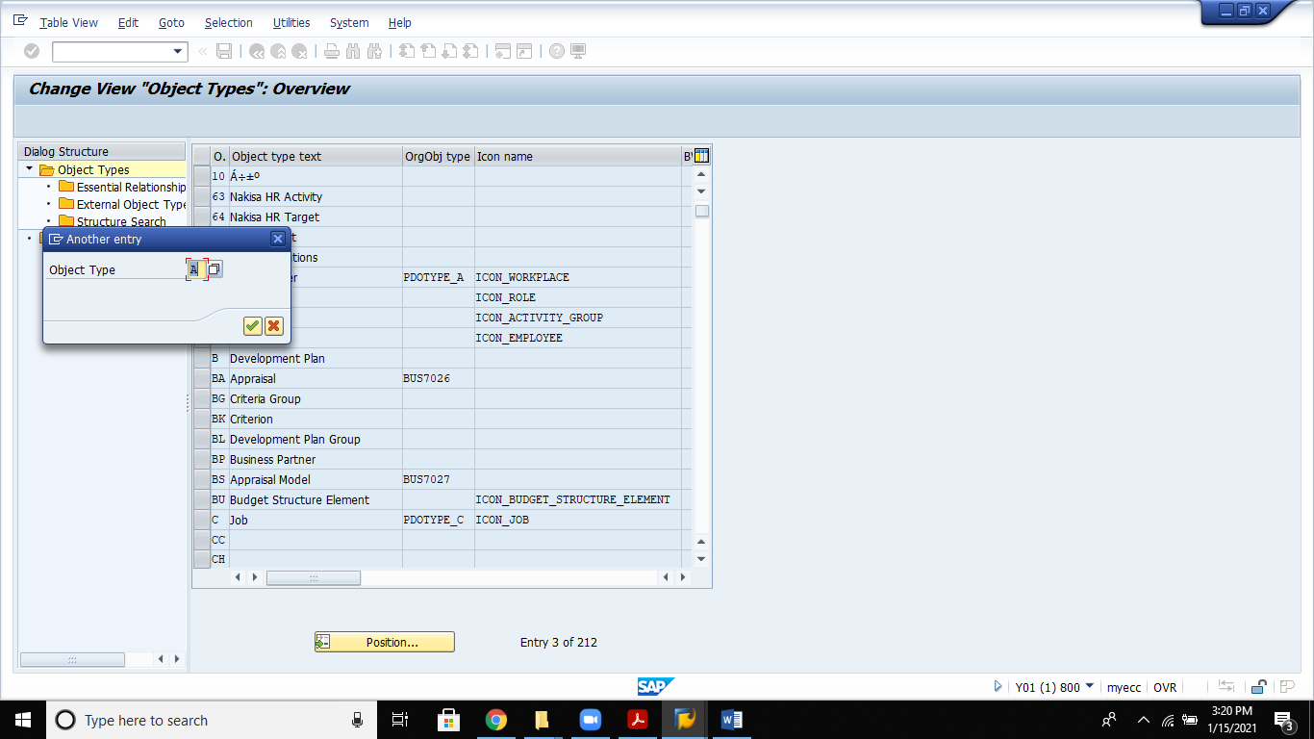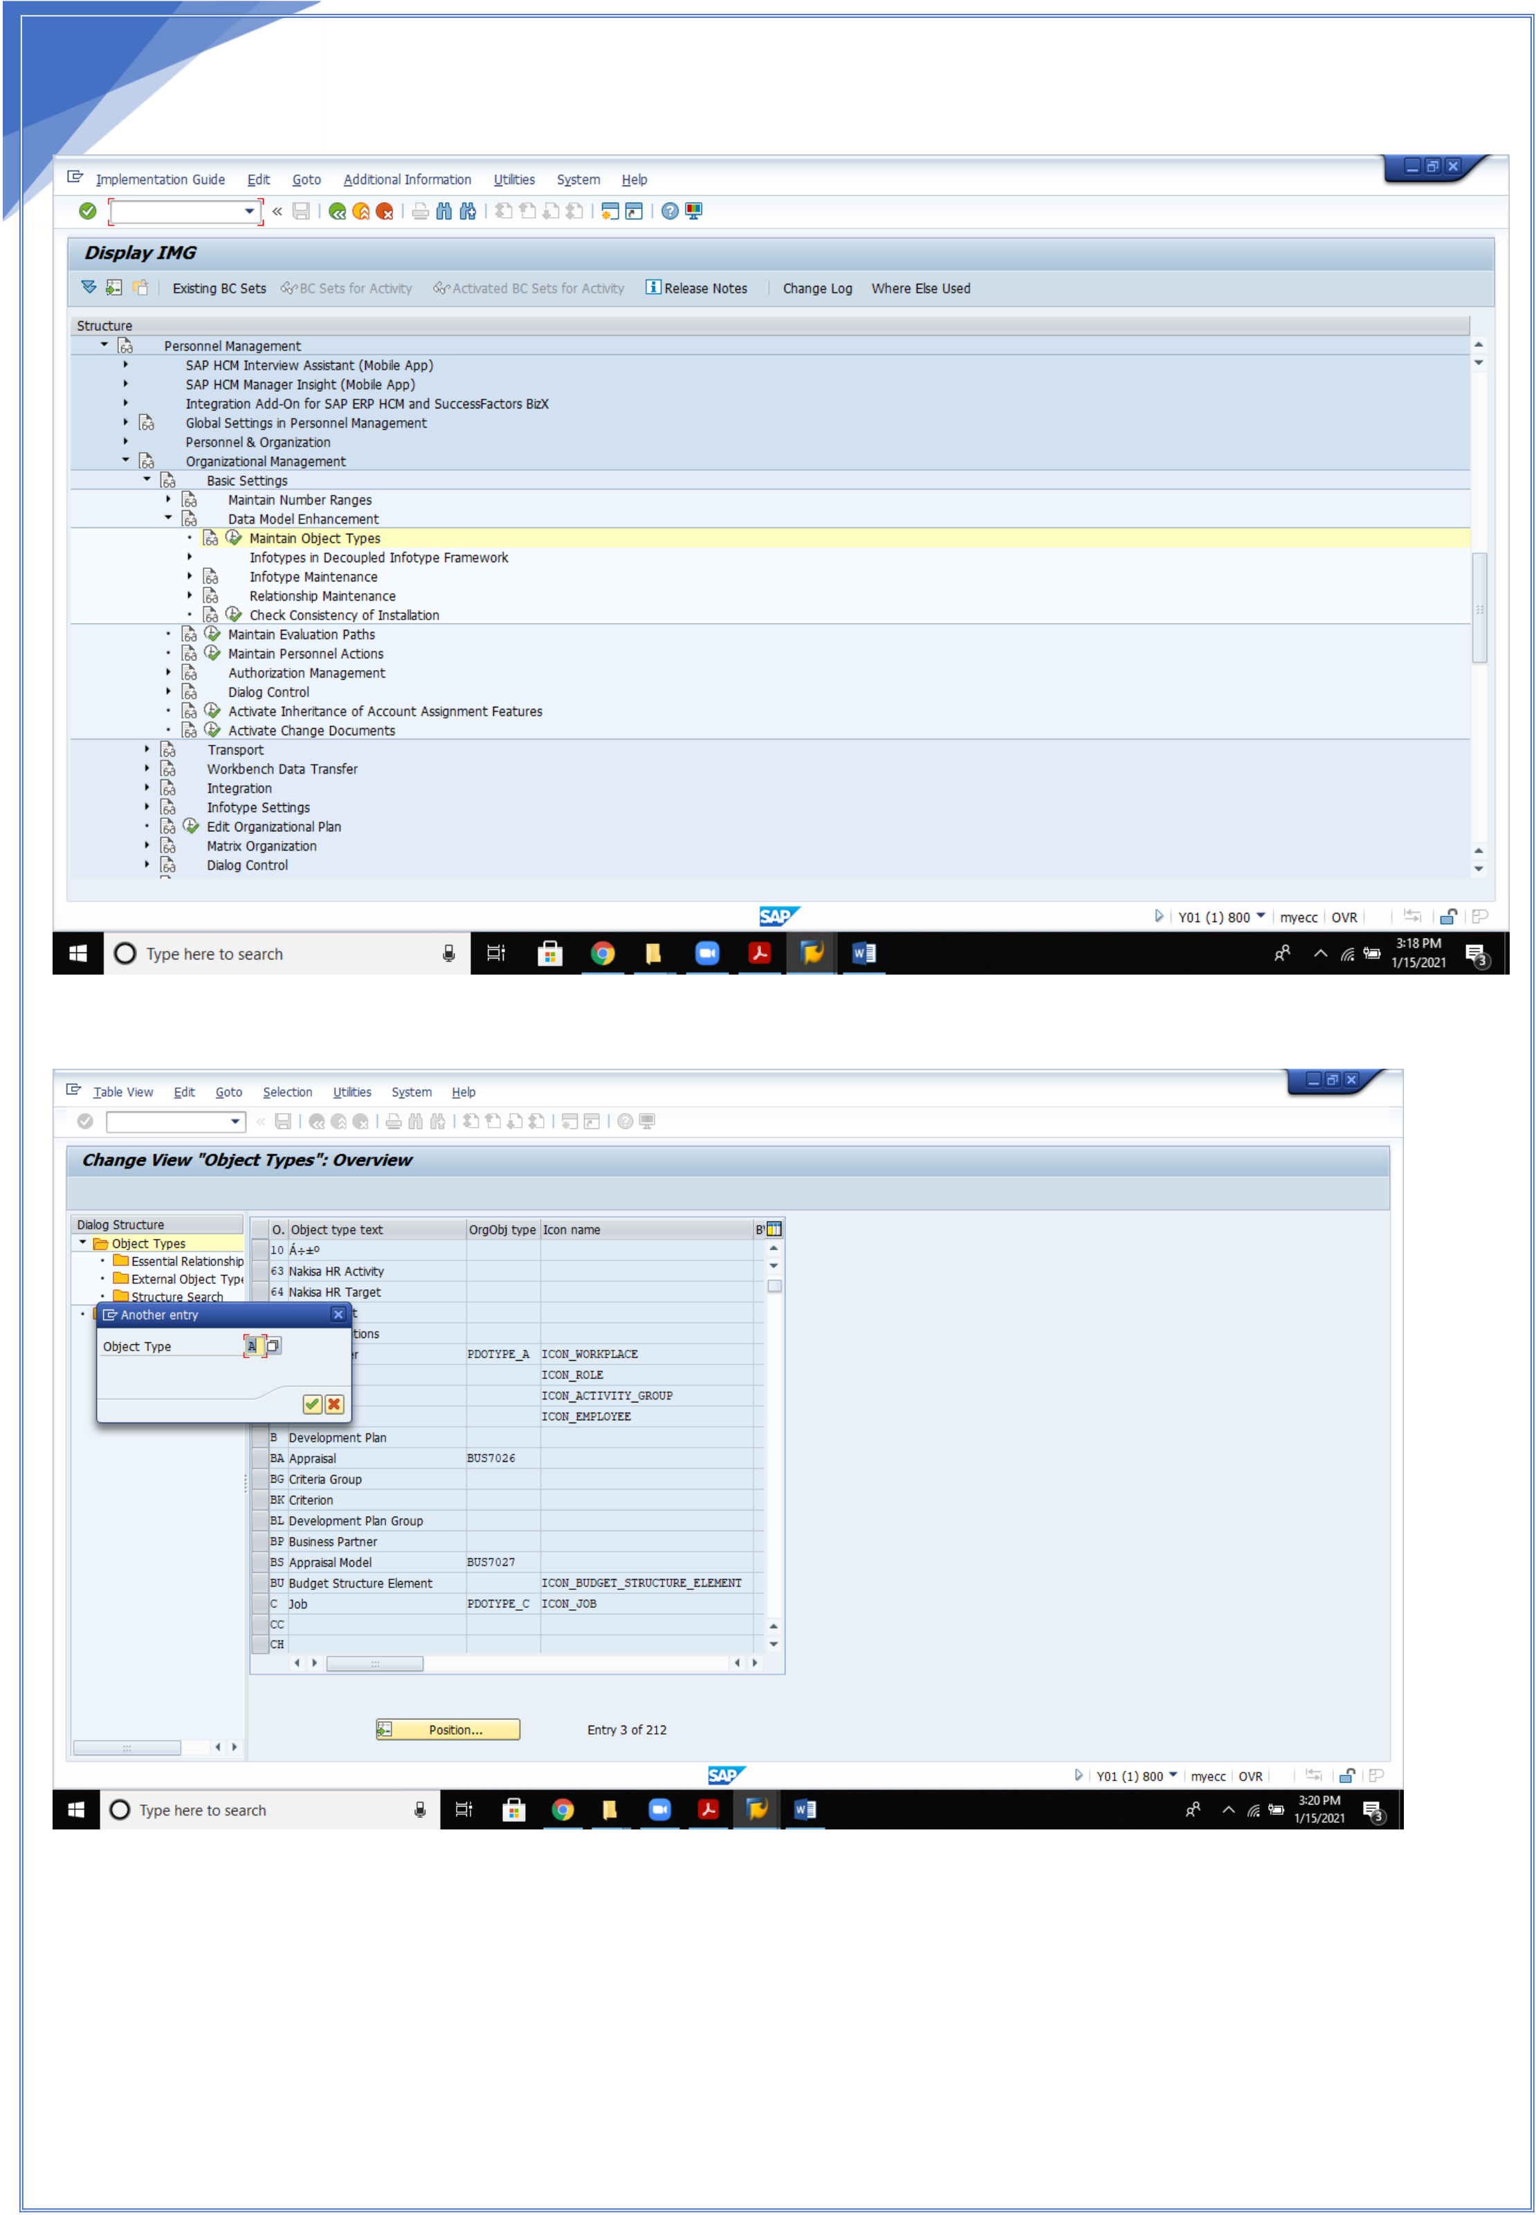

22   
3. Maintain object types

22

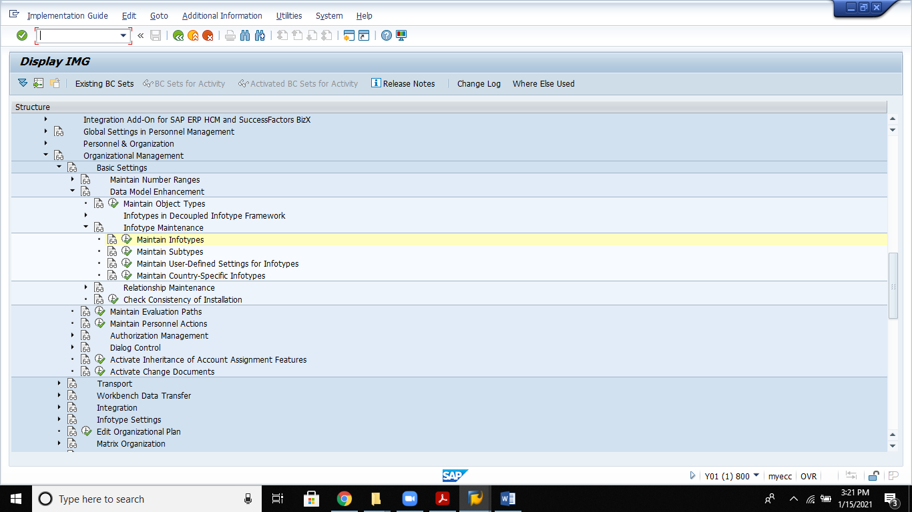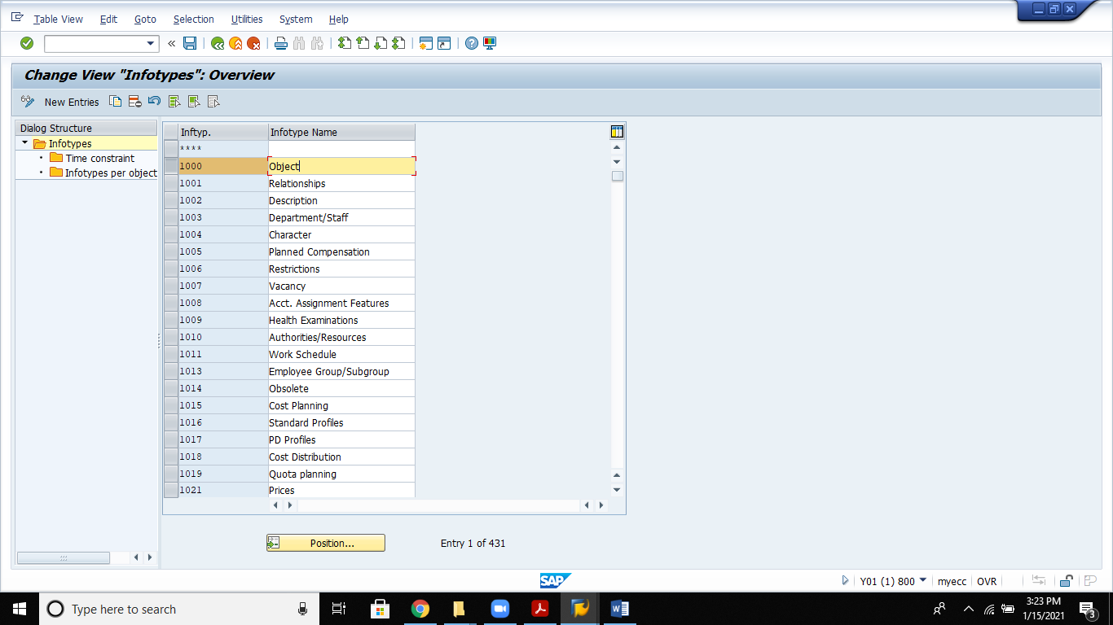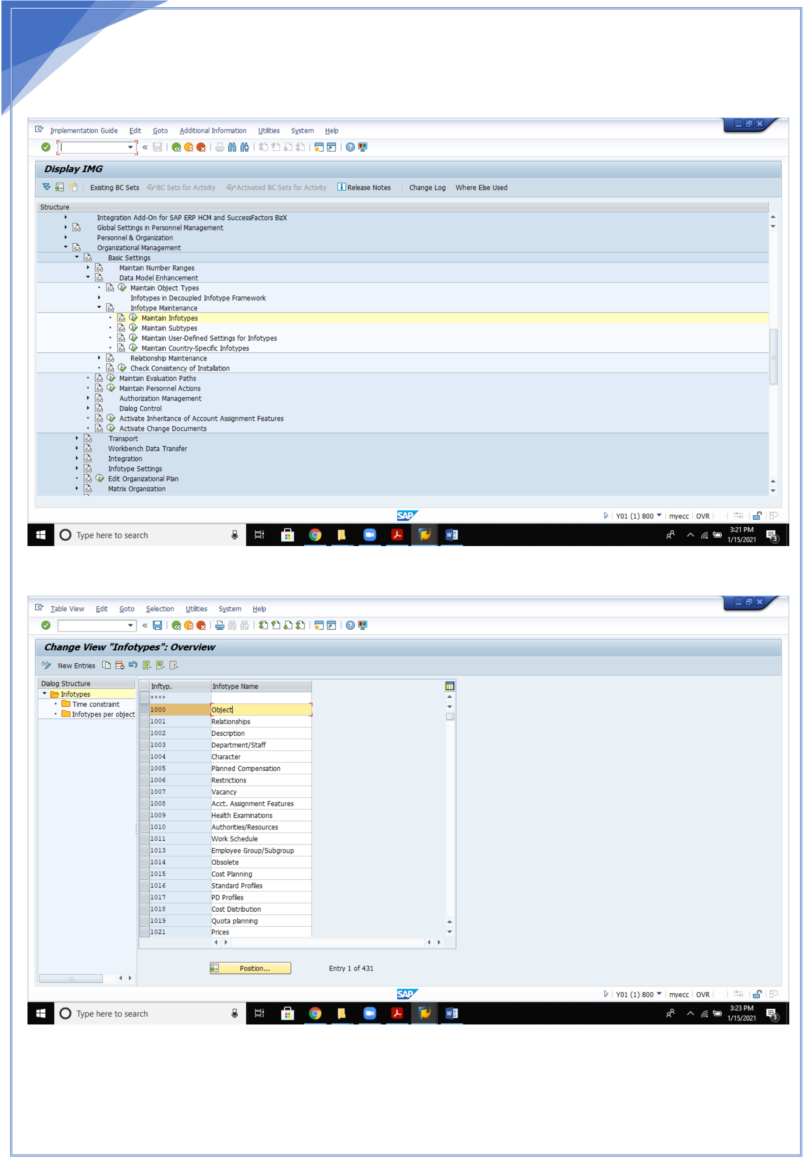

23

3. Maintain Info type:

23

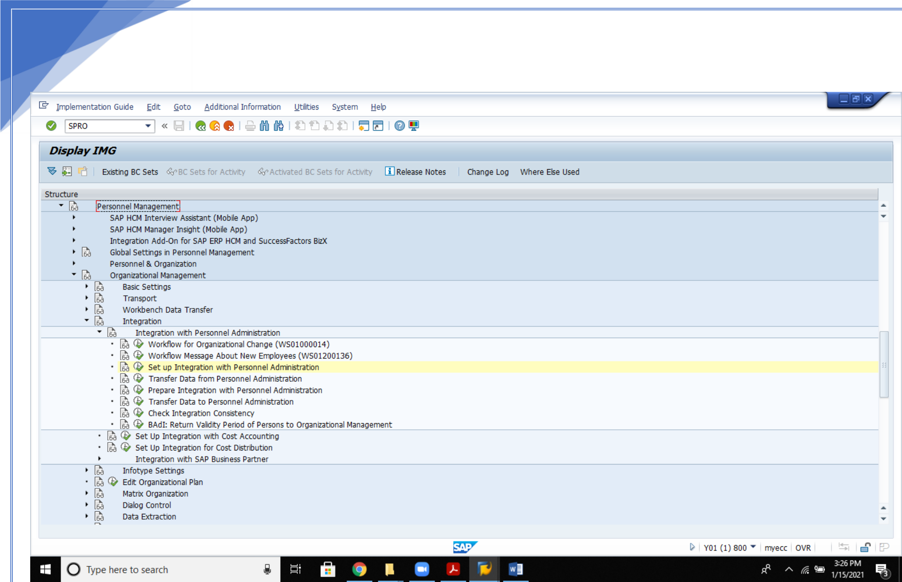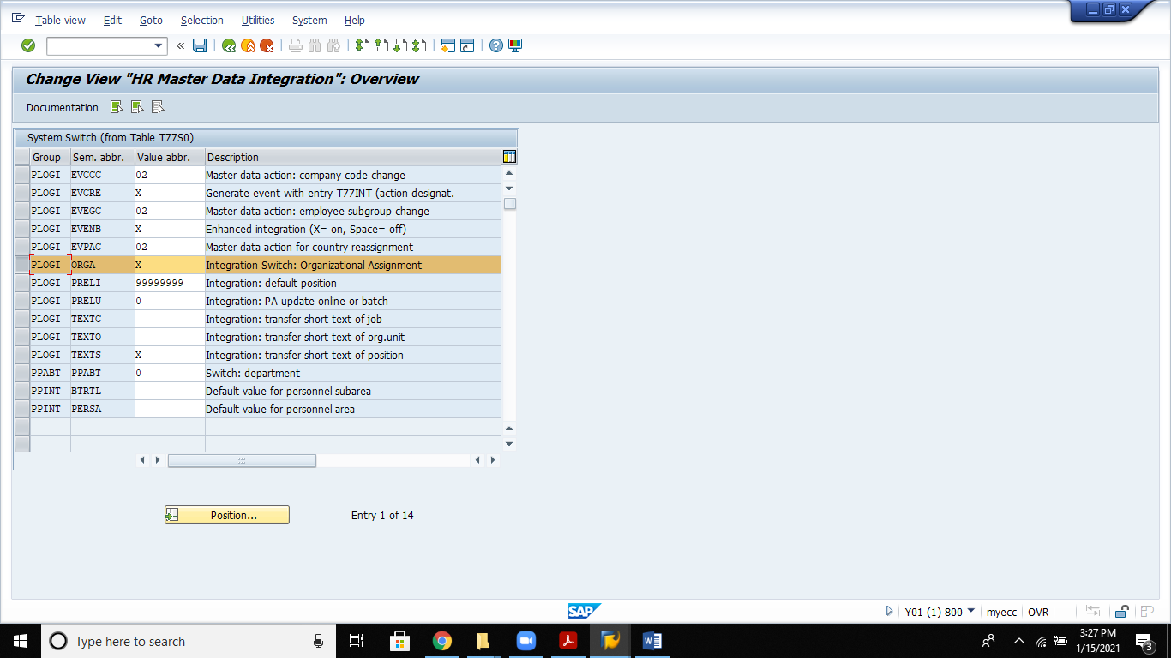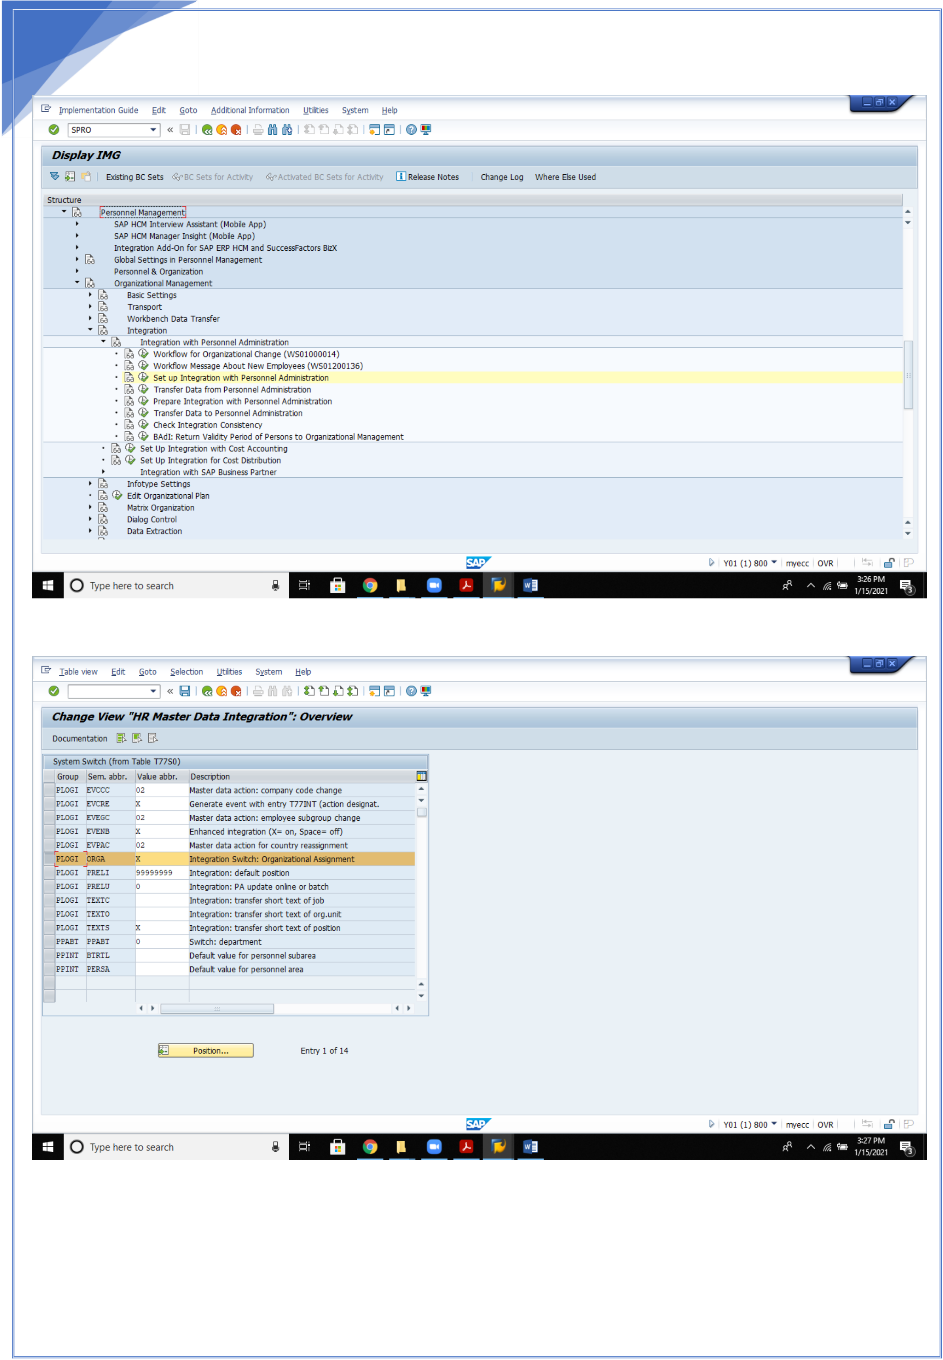

24   
4. **Set up integration with Personnel Administration**

24

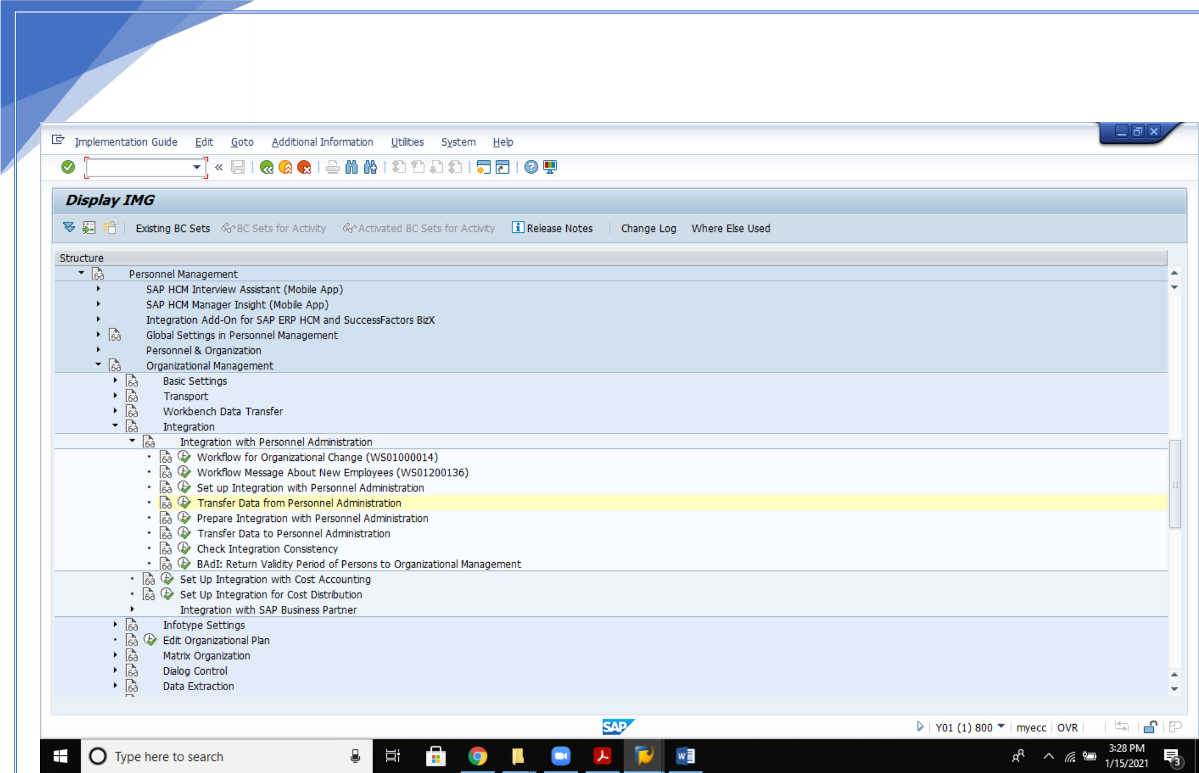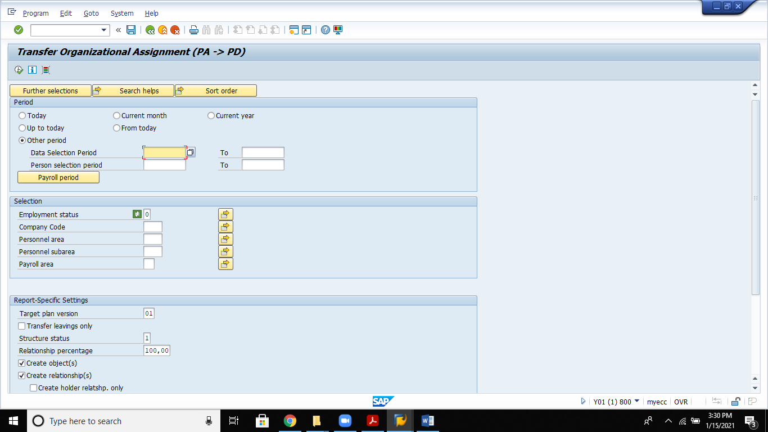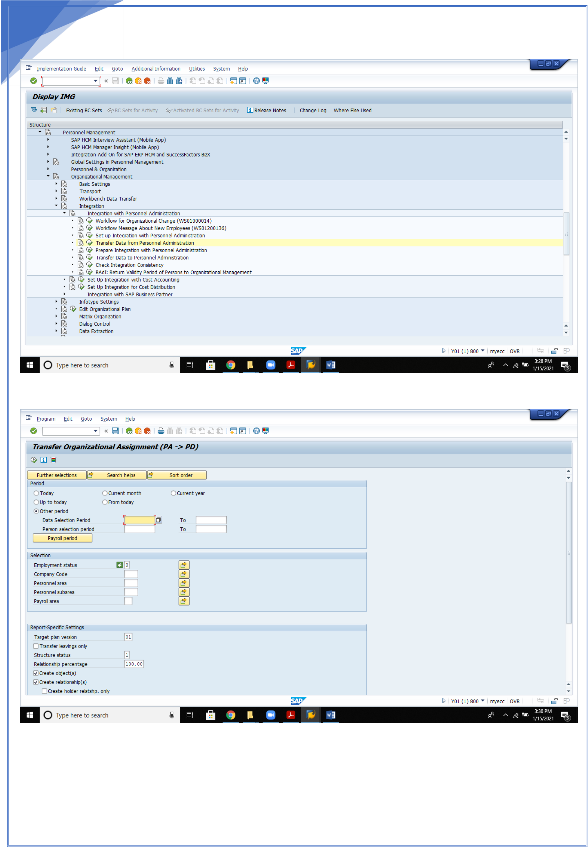

25   
5. **Transfer data from Personnel administration**:

25

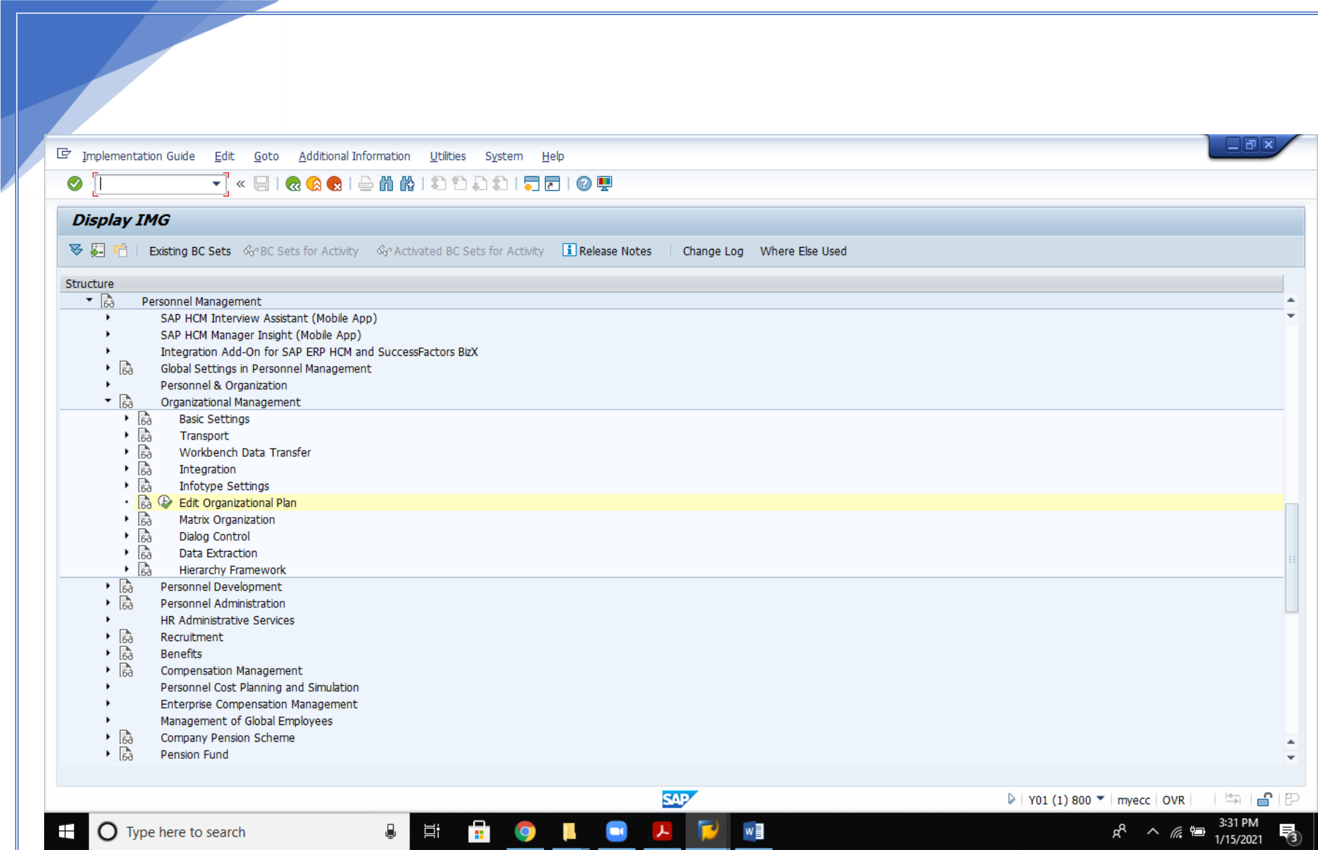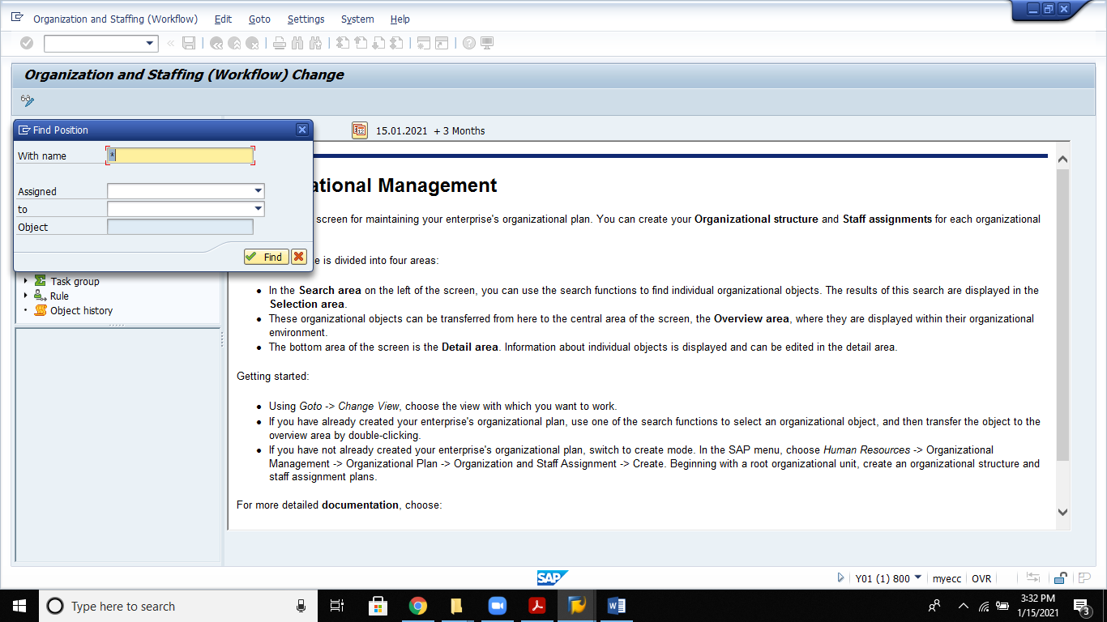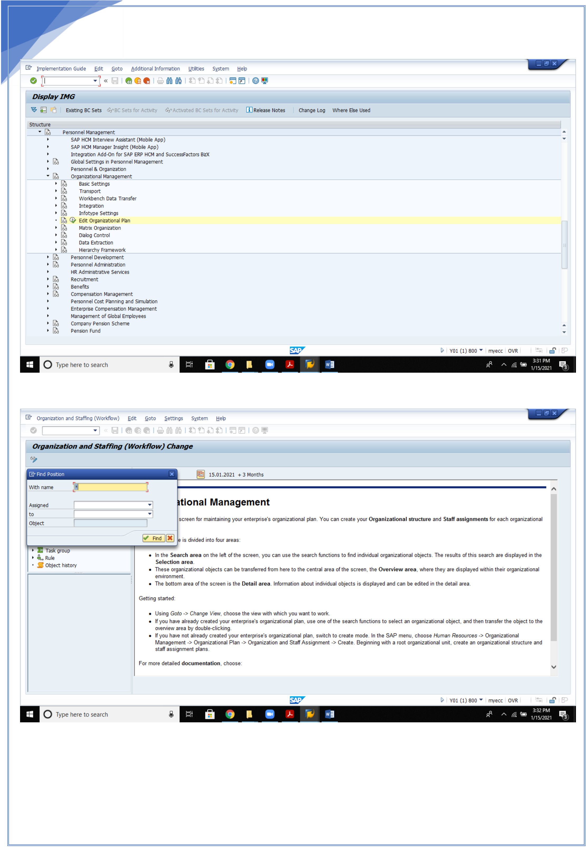

26   
 7.Edit Organizational Plan

26

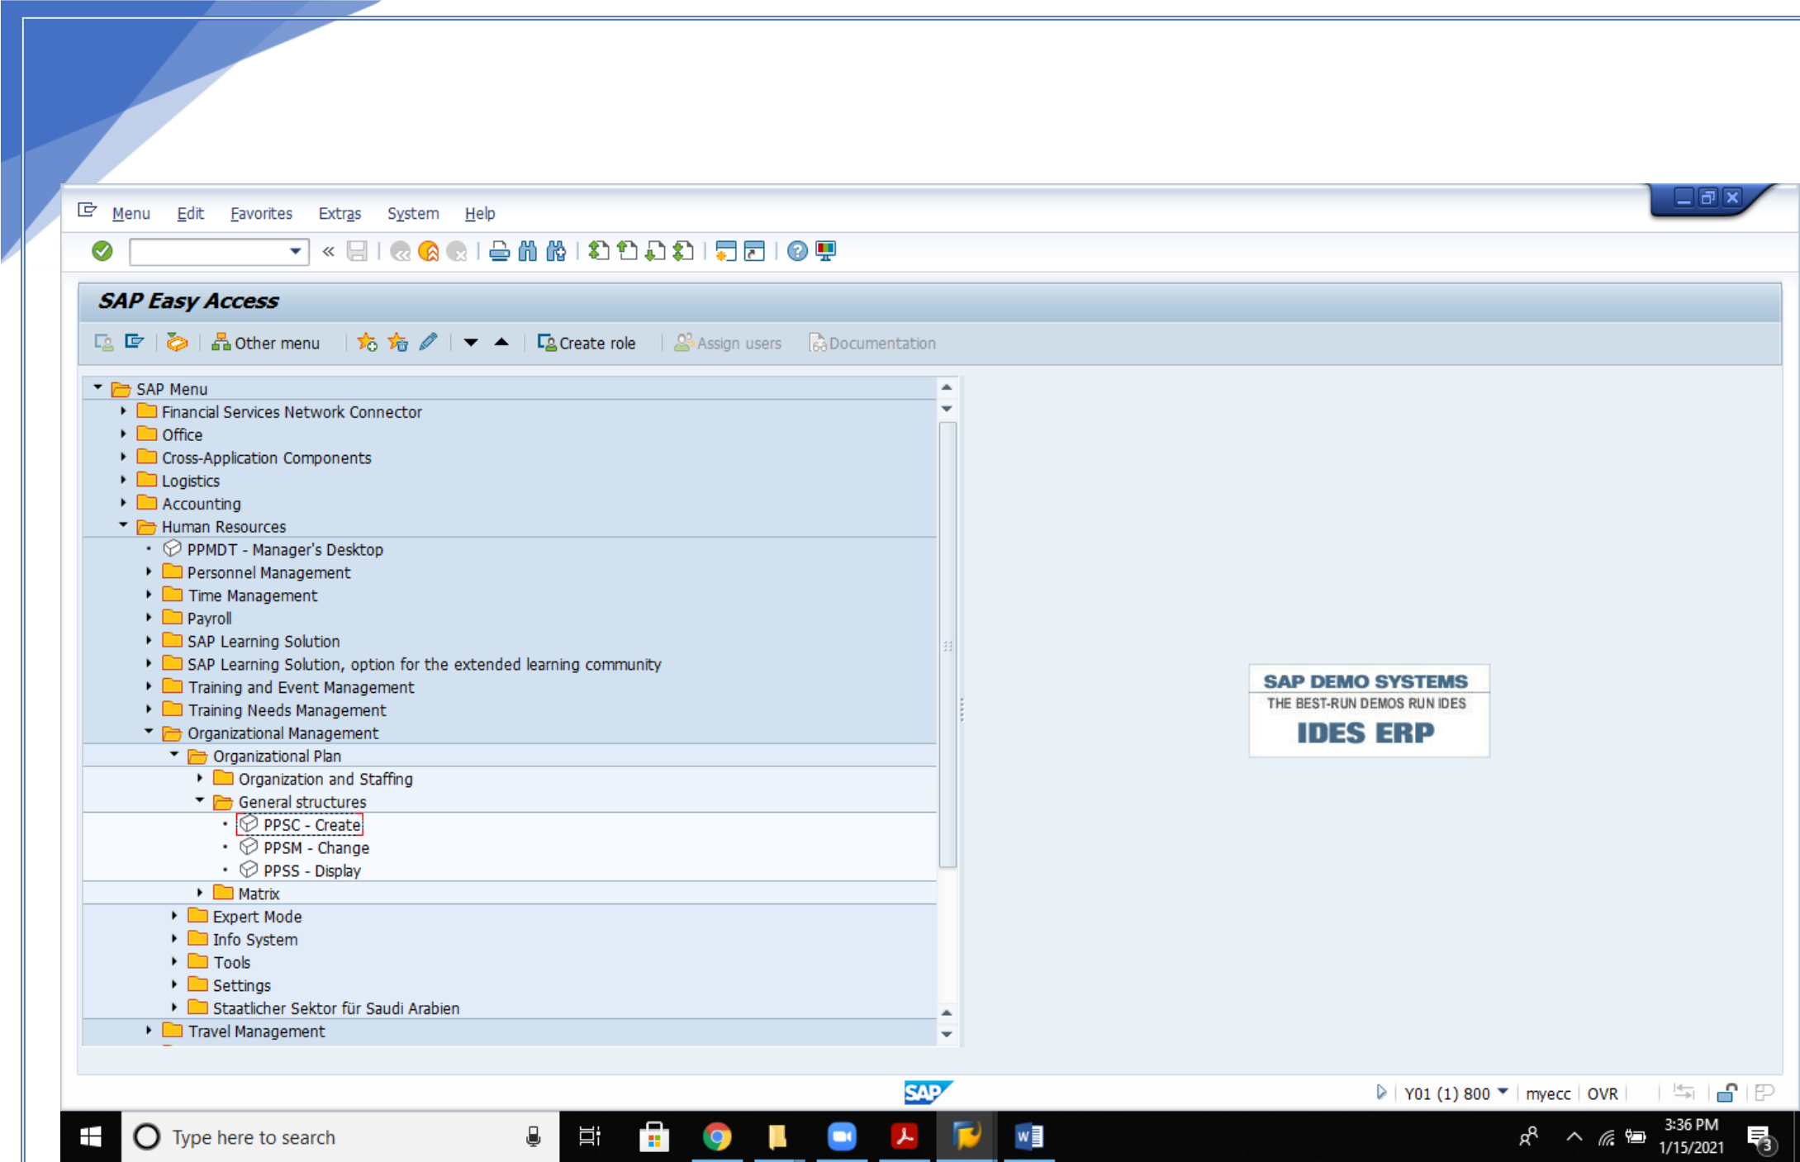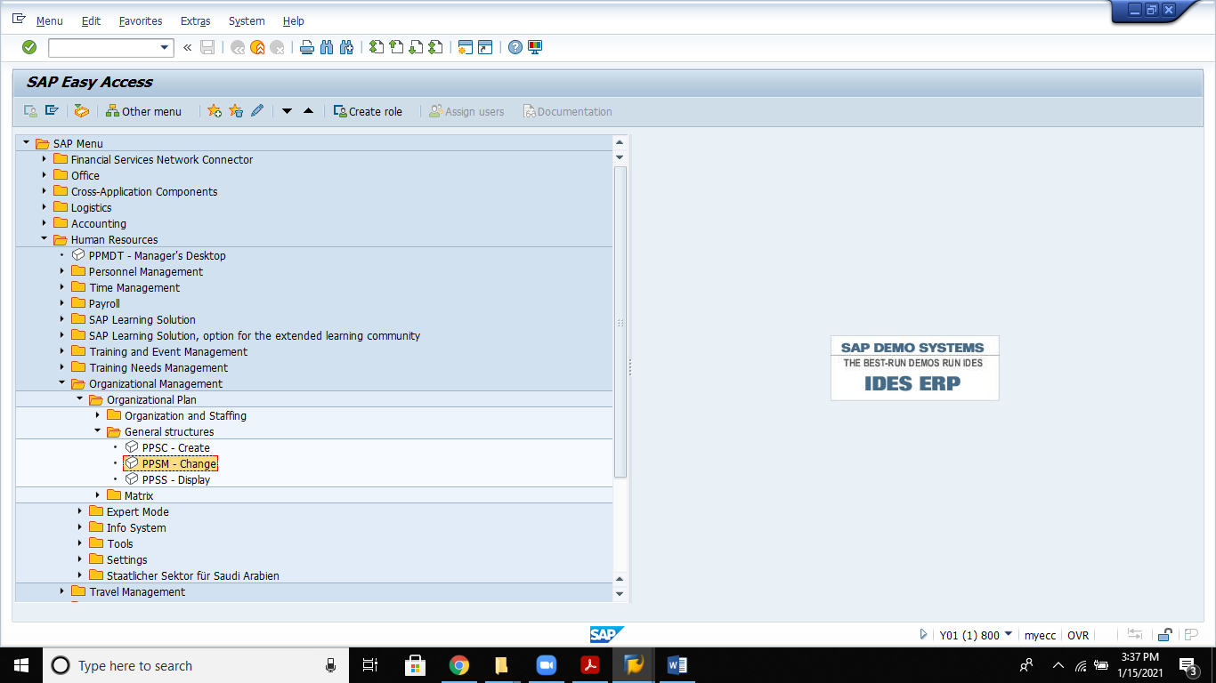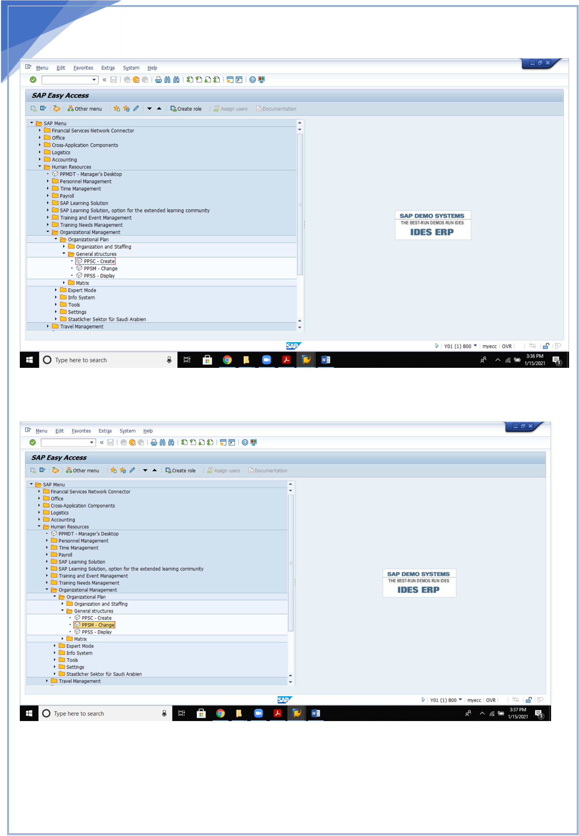

27   
 **8.Create General Structures:**

**9.Change structure**

**8.Display Structure**

27

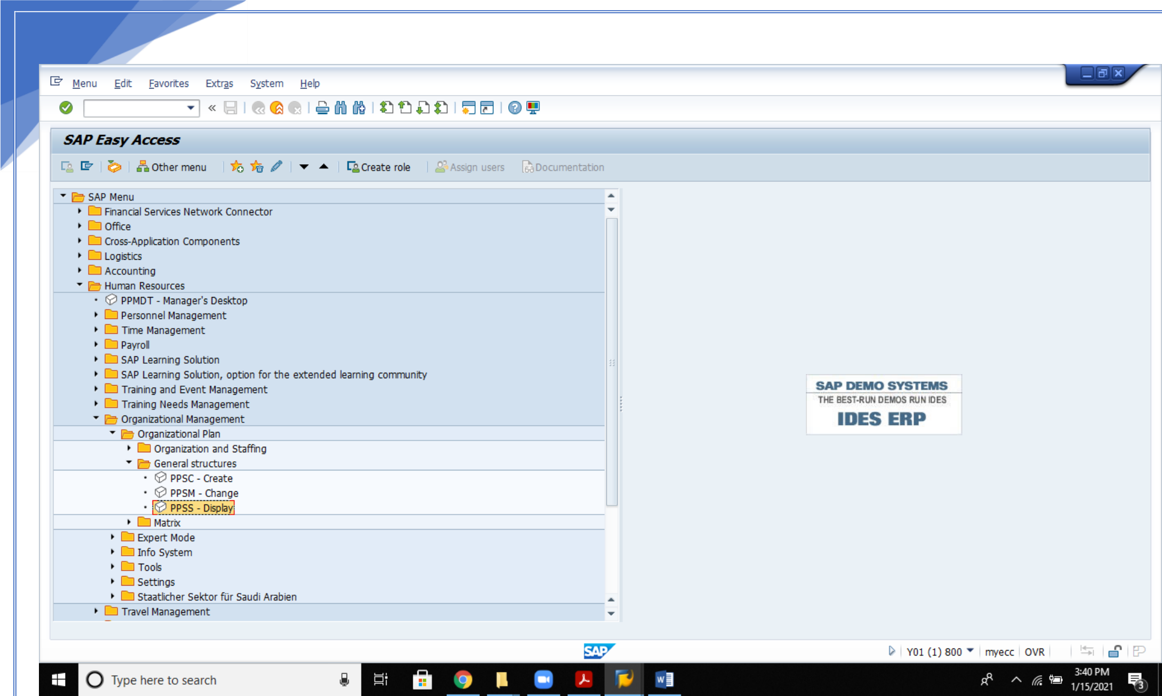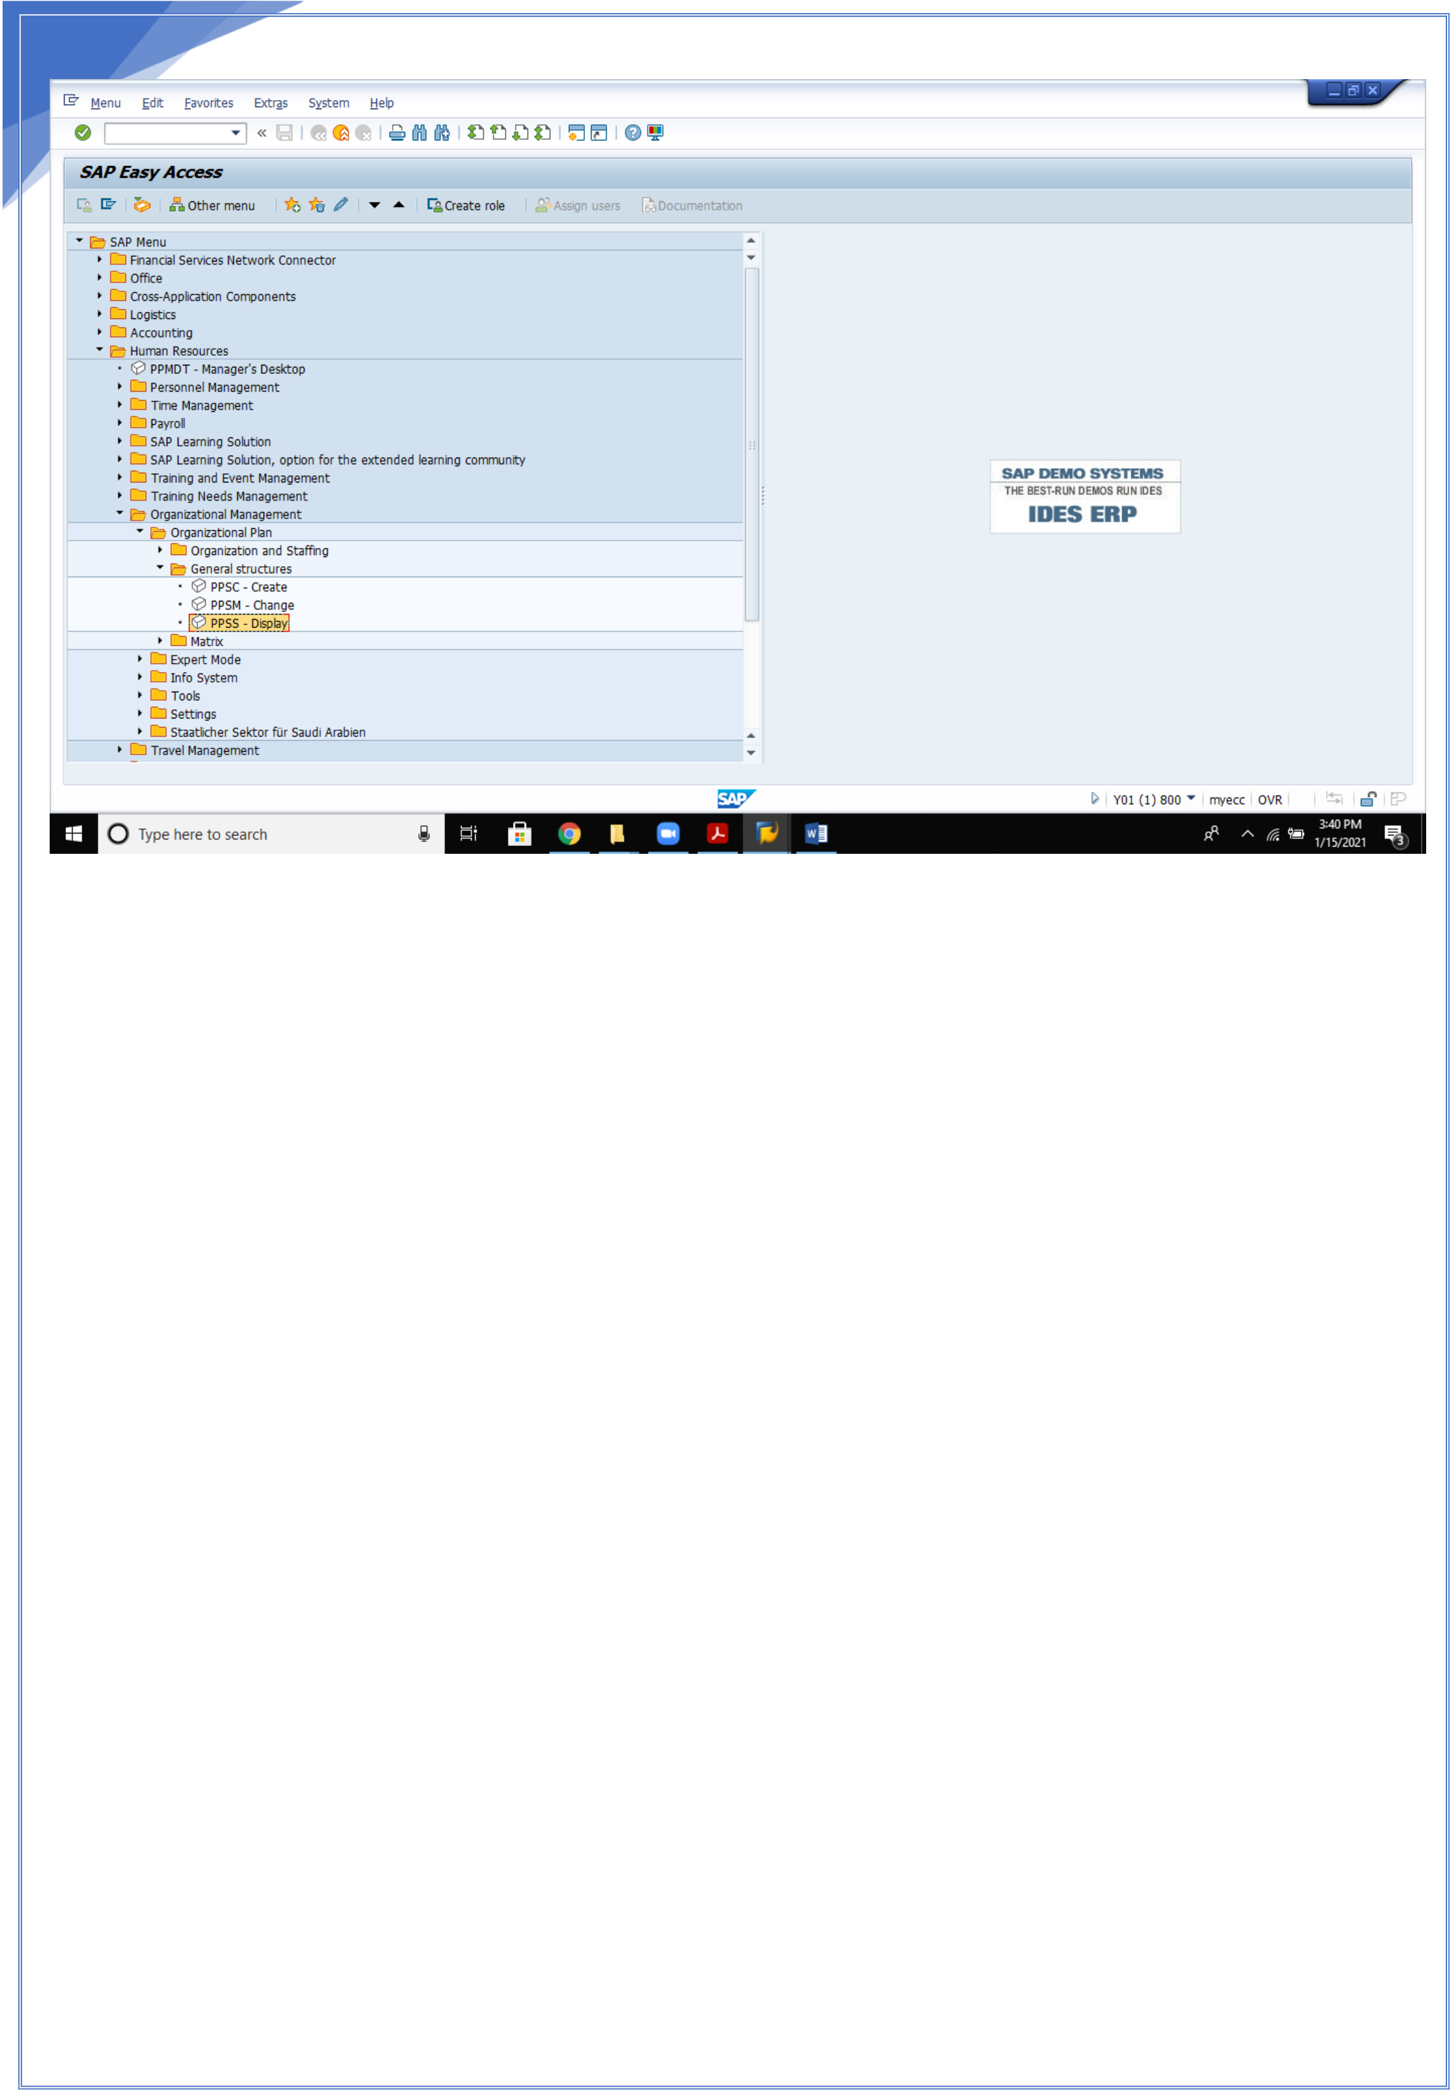

28

28



29

**SIMPLE MAINTENANCE**

In SAP HCM Structure can be created in 2 ways:

1.Expert Mode   
2.Simple maintenance

Expert mode is all about the organizational structure creation with the unique numbers

Simple Maintenance is all about organizational structure in a tree format

We work with object types

1.O – Organizational units   
2.S – Position   
3.C – Job   
4.A – Work center   
5.X – Cost center   
6.P – Person   
7.US- User

We will learn how to configure Structure and show relationships. There are standard relationships

For ex: A003, B003, B007…..

Further **Organizational units** are categorized into 4 sub units

a)**Root of the company**:   
 Name of the organization   
**b)Parent location:**   
 Main branch of the organization (Headquarter) **c)Geographical location**   
 Locations or branches of the organization   
**d)Sub- Geographical location**   
 Departments in the Geographical location

29

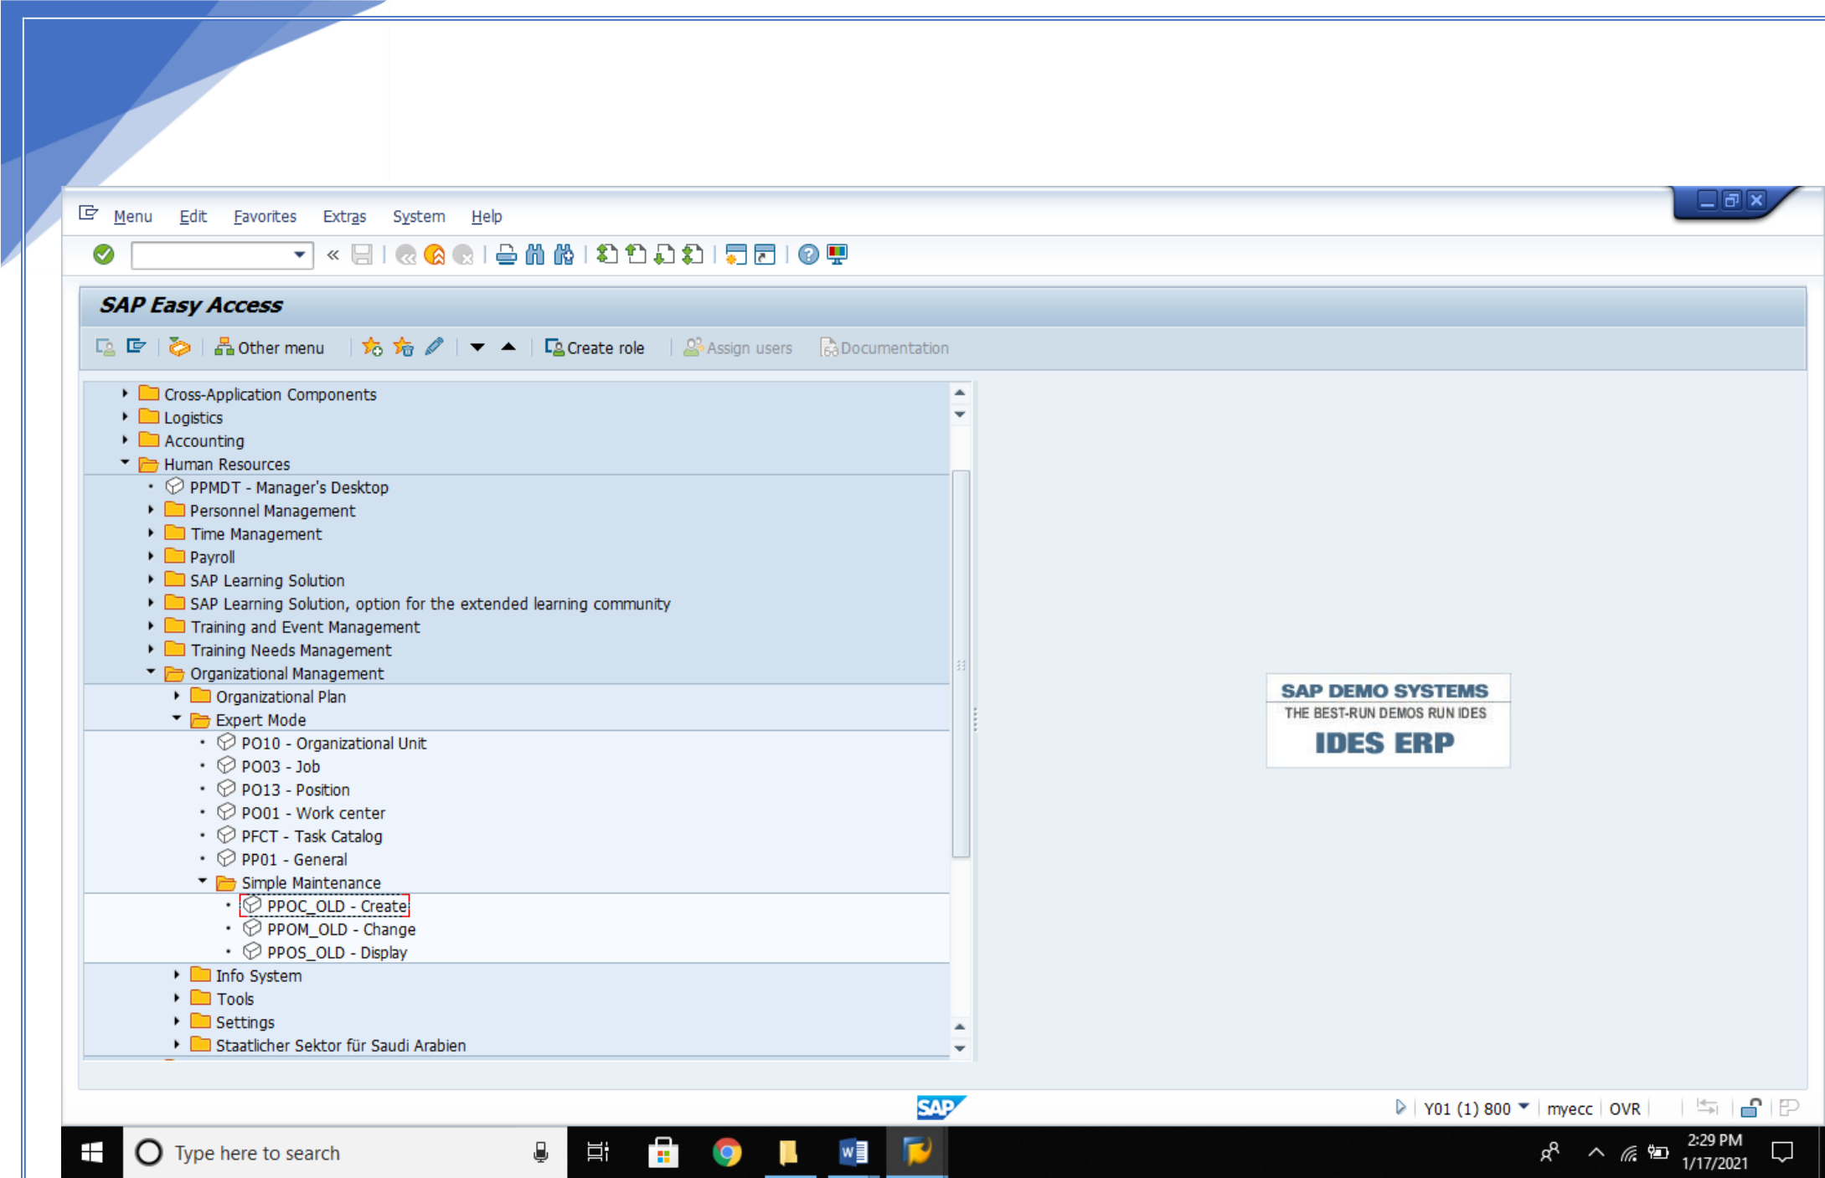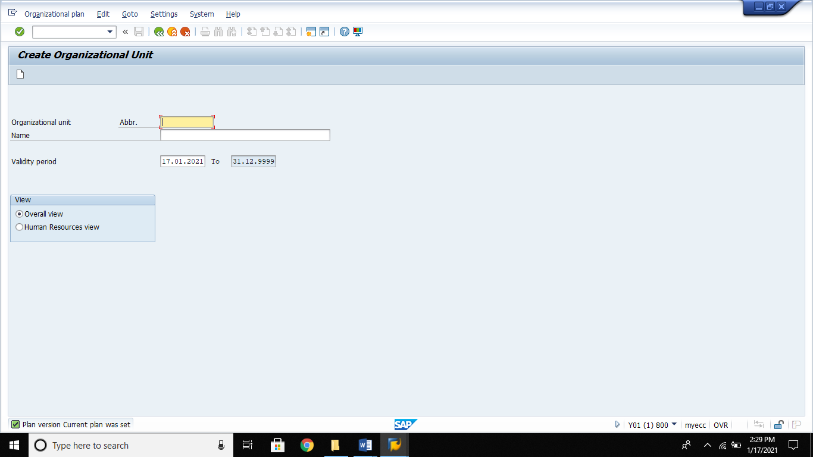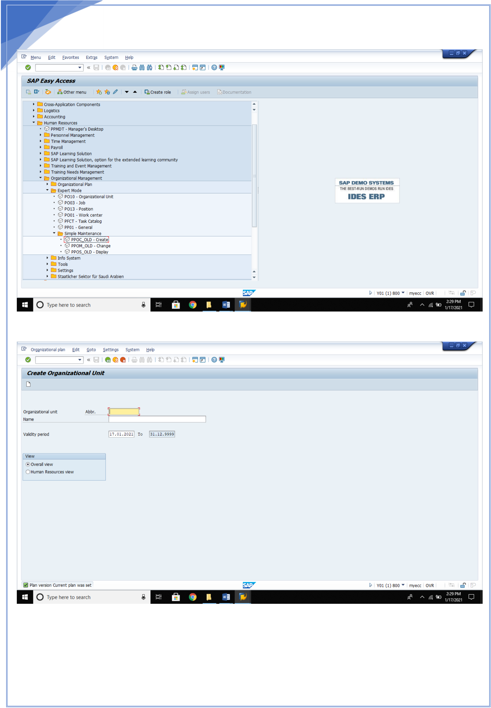

30   
 **1.Create Structure:**

Fill up the required details like organistational unit and name . Enter and save.

30

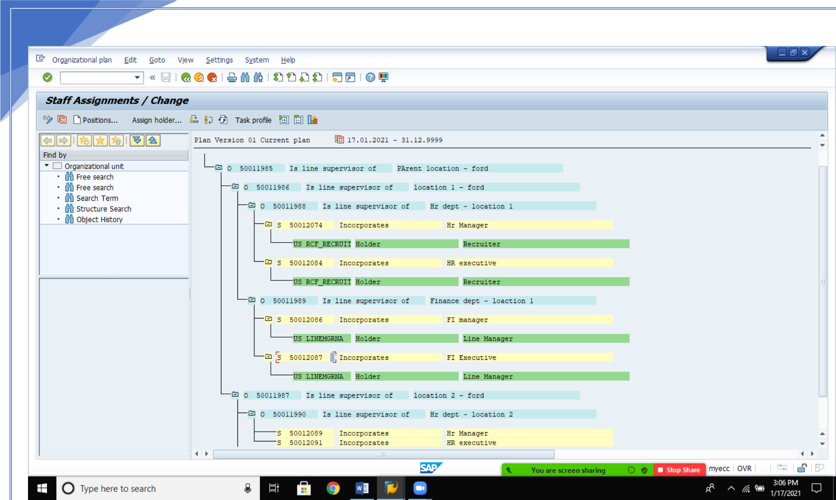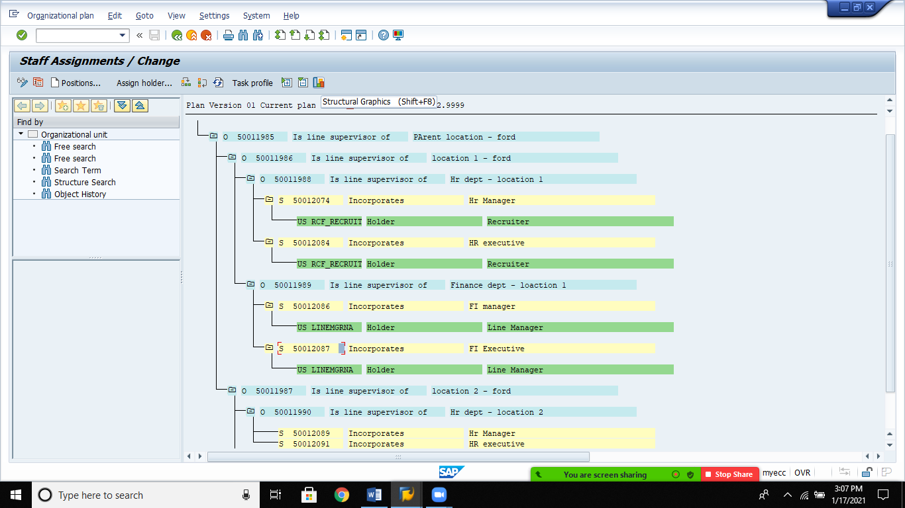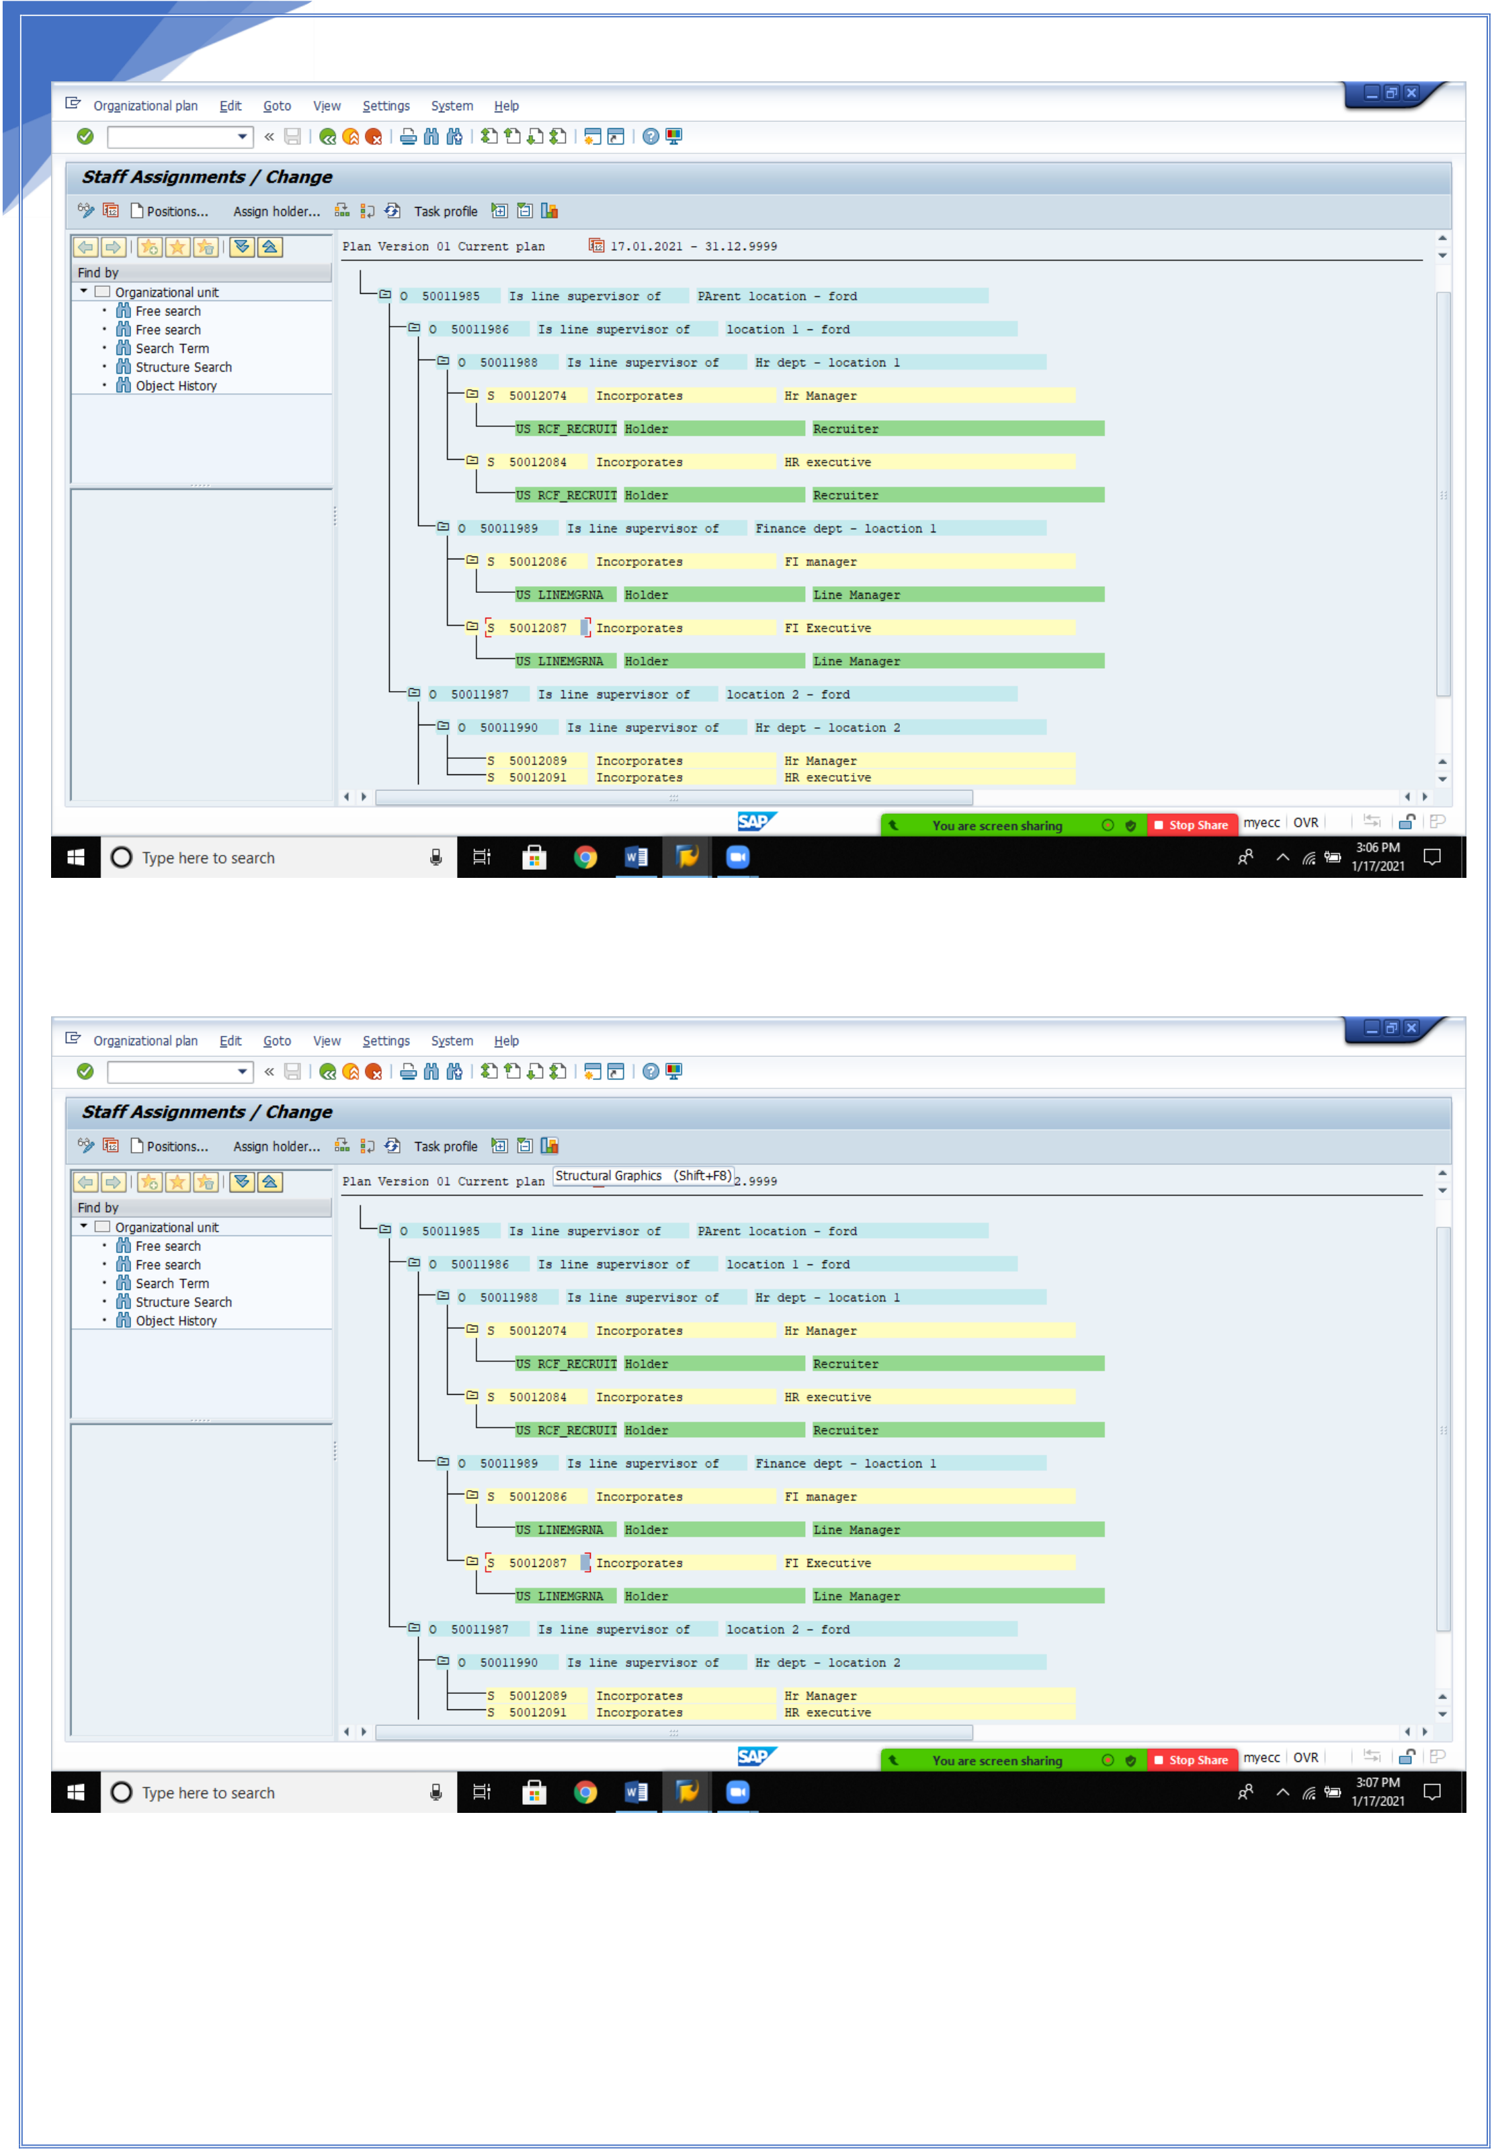

31

**.**

31

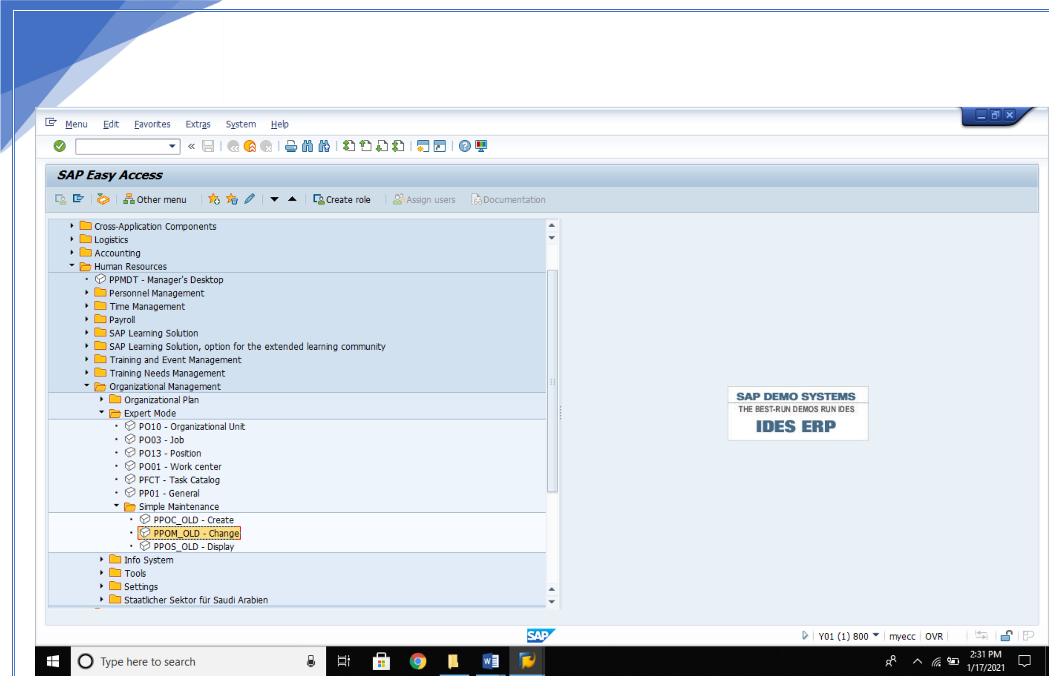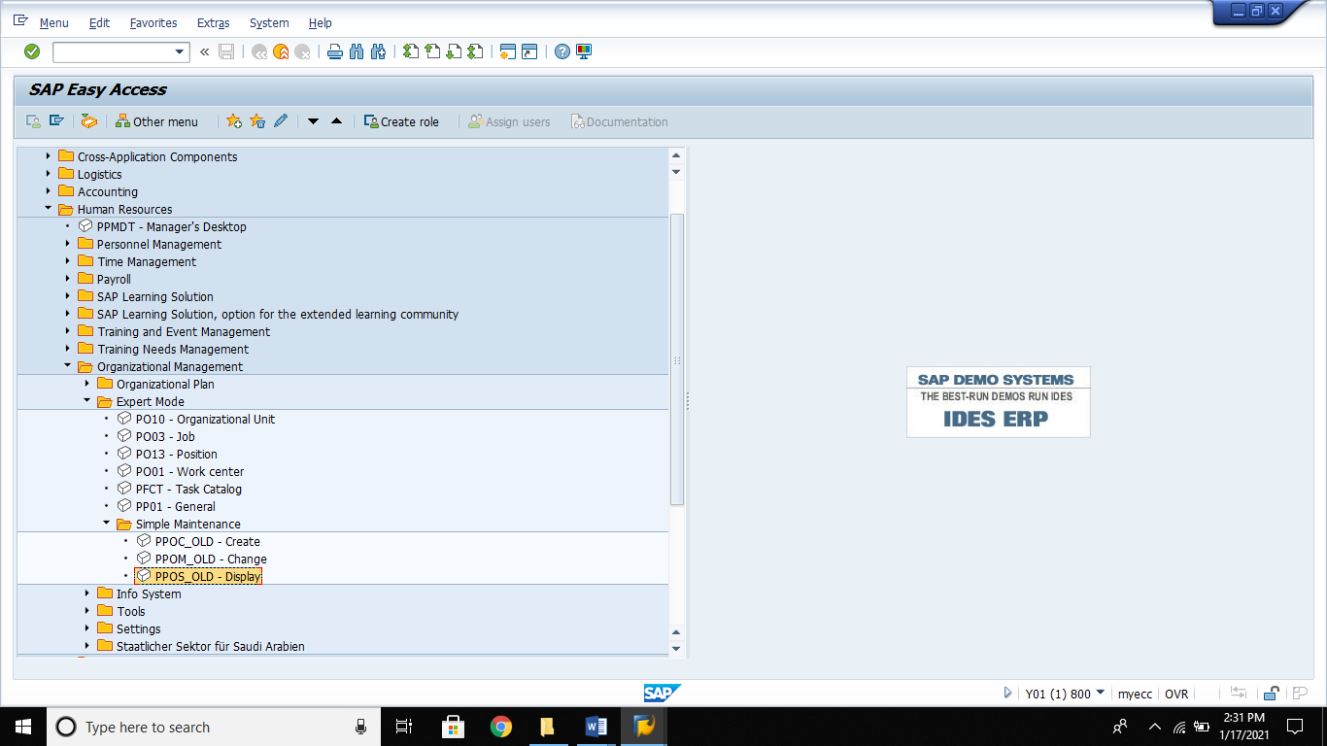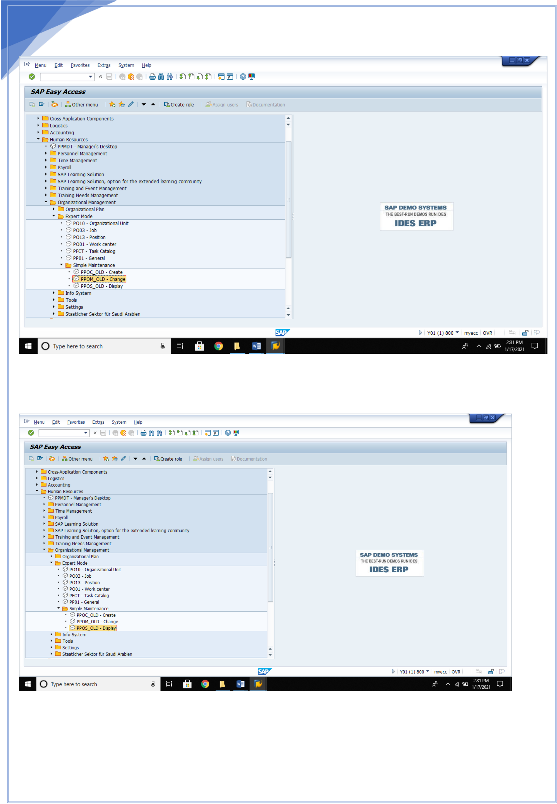

32   
 **2.Change structure**

**3. Display structure**

32